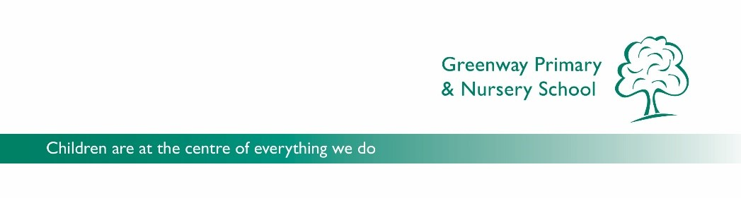

GREENWAY PRIMARY AND NURSERY SCHOOL
^{JOB DESCRIPTION}
^{Early Years Teacher}

This job description should be read in conjunction with the National Conditions of Employment for Teachers

Teaching and Learning

- To inspire children with enthusiasm and a love of learning.

- To actively implement the school’s commitment to the safety and well-being of children.

- To implement policies and procedures to promote high standards of behaviour and positive attitudes for all children

- To demonstrate excellent classroom practice, including thorough and effective assessment for learning.

- To have a thorough up to date knowledge of the National Curriculum

- To use AfL within daily teaching to adapt and modify planning to ensure all children are challenged and make good progress.

- To plan and work effectively and flexibly both independently and as part of a team.

- To liaise closely with the other Class Teachers to ensure the smoothest possible transition at the end of the year.

- To communicate and consult effectively with the parents of all children.

- To organise classroom and learning resources in order to create a rich and stimulating learning environment, to promote independence and support learning.

- To plan, prepare and develop teaching materials, teaching programmes, methods of teaching and pastoral arrangements.

- To confidently use ICT to enhance teaching and learning.

- To use a range of strategies for teaching and learning which promote positive classroom behaviour, embracing and following our therapeutic approach.

- To be responsible for the effective management of children and staff, encouraging the children to develop their self-confidence and independence.

- To assess, record and report on the development, progress and attainment of pupils in line with the requirements of the EYFS through the children’s Learning Journals

- To ensure that parents and pupils are well-informed about the curriculum, attainment and progress and are able to understand and contribute to areas for improvement

- To maintain the confidentiality of school records.

- To regularly monitor and input children’s progress in the school’s Early Years Tracker.

- Supervise the work of any support staff, including Early Years Practitioners and Higher-Level Teaching Assistants who are assigned to work within the class.

- To work collaboratively with all outside agencies in supporting children’s needs.

- To work co-operatively alongside the Senior Leadership Team.

Wider Professional Commitments

- To fulfil all professional duties as laid down in the Conditions of Employment of School Teachers.

- To participate in the Performance Management annual review procedures and to participate in further training and professional development and use the outcomes to improve the teaching and learning of pupils.

- To work as part of a professional team.

- To implement the aims, policies and stated ethos of the school.

- To fully support the life and work of the school

- To develop and maintain positive and effective relationships with parents and carers, Governors and our local community

- To be a Subject Leader for a curriculum area (unless an NQT)

Review of Duties

The specific duties attached to any individual teacher are subject to annual review and may, after discussion with the teacher, be modified as appropriate.

