**Presdales School**



**Midday Supervisory Assistant**

**Monday – Friday, 12.00 – 2.00 pm**

**£** **£5,516 + fringe**

**Term time only**

We are looking to appoint a Midday Supervisory Assistant to join our team to supervise students at lunchtime in the Dining Room.

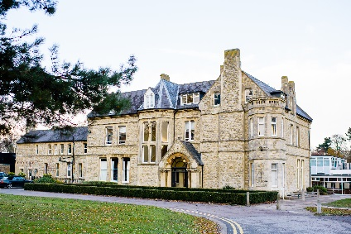Presdales School is a girls’ single sex comprehensive school in Ware for girls aged 11-18, with boys welcomed in the Sixth Form. We are a school, which values all students, irrespective of their age and ability and helps them to exceed expectations through high quality teaching and learning and the opportunity to take part in a wide variety of activities which will enrich their educational and personal development beyond the classroom.

We provide a caring environment where all students are supported, as well as challenged, to ensure that there is no limit to their potential. We prepare our students for a world that is constantly changing by encouraging them to be independent learners who are determined, confident and who never give up. Alongside academic excellence, there is a strong focus on enjoyment, excellent behaviour and respect for all.

*The school is committed to safeguarding and promoting the welfare of young people and expect staff to share this commitment. All posts are subject to a safer recruitment process which includes enhanced criminal records and barring checks, scrutiny of employment history, referencing and other vetting checks, including online searches.*

**Closing date for applications: 9.00 am, Monday 12th May 2025**

**Please submit a letter of application and a completed application form (available on the school website)**

You can post your application to the school, or send by email to [recruitment@presdales.herts.sch.uk](mailto:recruitment@presdales.herts.sch.uk)

*Presdales School is committed to ensuring inclusion, diversity and equality of opportunity. We welcome applications from all suitable candidates and encourage those from underrepresented groups, and/or with protected characteristics, to apply.*

*Please note that CVs will not be accepted*.