**Trotts Hill Primary School & Nursery**

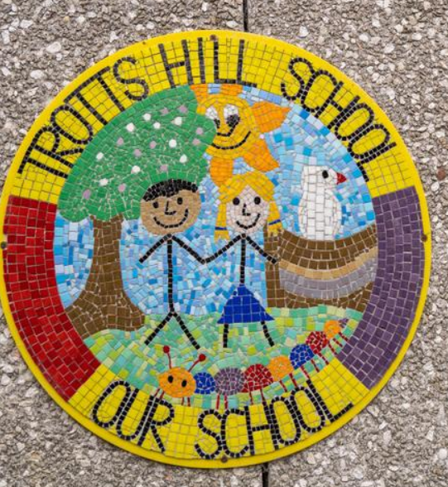

**Letter from the Headteacher**

Dear candidate,

I am delighted that you have expressed an interest in the post of Office Manager at Trotts Hill Primary School & Nursery.

Due to the retirement of our current Office Manager, we are seeking to appoint a passionate and resilient Office Manager with high aspirations to join our wonderful school. You may be an Office Manager currently, or an experienced practitioner and would like the exciting opportunity to continue your professional development at our school.

Trotts Hill is a welcoming and happy school where everyone is valued and respected. Staff place great emphasis on personal, social and emotional development by fostering caring attitudes, thoughtfulness, mutual respect, self-discipline and self-confidence. We have 235 children on roll and are oversubscribed with waiting lists in most year groups. Parent and pupil voice is very strong and the school strives to support and encourage individual growth within a nurturing community. We have a talented team of staff who are dedicated, ambitious and strive to enable each child to reach their full potential. Trotts Hill is an OPAL school (Outdoor Play and learning) and is in the top 1% of the country for play offer and outcomes at Keystage 2. We have a forest school and believe in developing each child as an individual, nurturing their strengths and talents. As our Office Manager you will have highly effective interpersonal skills and will work closely with our leadership team, site, teaching and support staff.

We set high expectations in terms of behaviour and attitudes to learning and these, together with our core values and PRIDE learning behaviours are reinforced throughout the day in every aspect of school life. We strongly believe that the culture, ethos and environment of a school influences the health and wellbeing of its pupils and their readiness to learn. When the school ethos is right, pupils place a higher importance on education, learning and positive behaviour. Our school rules and PRIDE learning behaviours (Perseverance, Resilience, Independence, Determination and Enjoyment) have been embraced by our whole community and are woven through all aspects of school life.

The curriculum at Trotts Hill school is vibrant and a whole school approach is taken towards its implementation. This goes beyond the teaching and learning in the classroom to all aspects of school life in order to support the development of physically, emotionally and socially healthy young people. We achieve this in partnership with our supportive parents and governing board.

We place a strong emphasis on inclusion and support children with a wide variety of needs. Our vision is for Trotts Hill Primary to be a place where each individual is cared for deeply, valued and respected – Where everyone in the school community has the opportunity to learn in an environment full of excitement and fun, so they can grow up to be lifelong learners and assets in the community, society and world they live in.

Please do not hesitate to contact the school office on 01438314189 to arrange a meeting with myself and to have a tour of Trotts Hill. I look forward to receiving your application.

Mrs Liz Evans