

Sandon JMI School

Class Teacher

Application Pack

2025

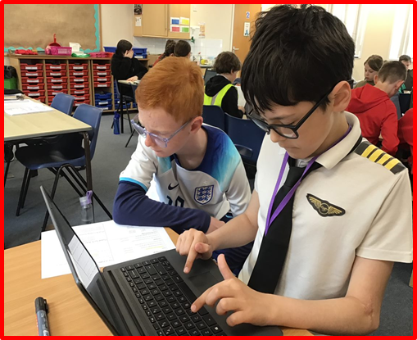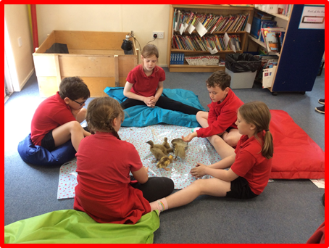

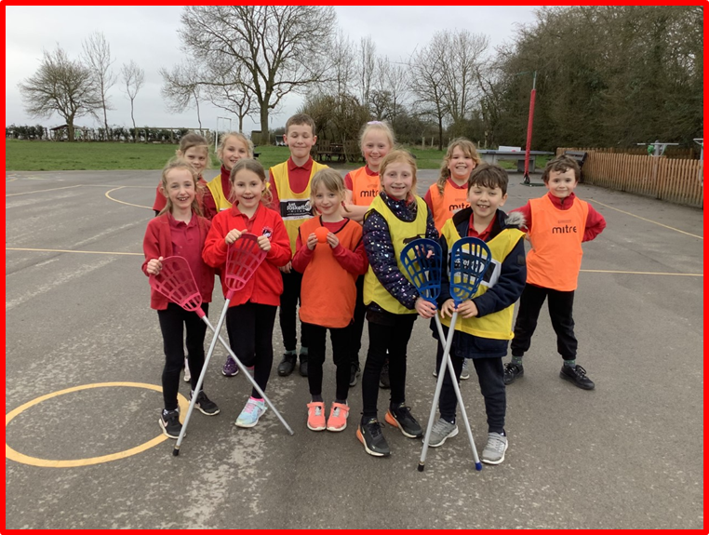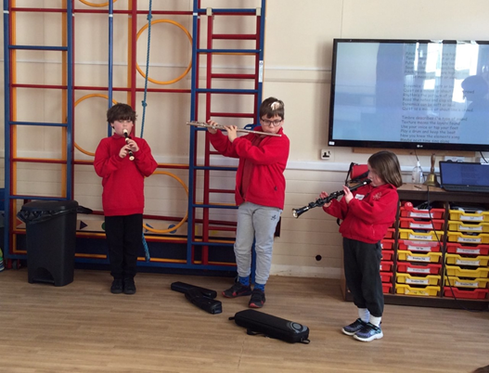

***“Our vision is to create a respectful learning environment where all pupils can access a broad and balanced, creative curriculum that challenges pupils and prepares them for the future.***

***We will nurture and challenge all learners to be responsible, resilient, independent learners with a growth mind set. Our inclusive curriculum and our 8 core values will help prepare them to be successful citizens of the future”***

***Niki Ellement - Headteacher***

logo2

Dear Applicant,

Thank you so much for showing an interest in the Class Teacher position at our school. We are a small rural village school with under 60 pupils. There are three classes in our school: Reception, Year 1 & 2, Year 3 & 4 and Year 5 & 6. We have a rural setting in the heart of Sandon in Hertfordshire. Our pupils come from the villages of Sandon, Wallington, Rushden and surrounding Hertfordshire towns and villages.

Children have only one chance at receiving a high quality of education and we believe here at Sandon that it is the job of our whole school community to ensure that we achieve this. We have an ambitious and dynamic vision for our school that ensures that our curriculum offer is engaging, exciting and inclusive. We believe in developing the whole child in order to enable all of our pupils to reach their full potential.

Our school community is underpinned by 8 core values:

* Kindness
* Respect
* Ambition
* Courage
* Resilience
* Discipline
* Determination
* Teamwork

We have high expectations of our pupils and as a result behaviour is excellent. We work together to embed a culture of success, high aspiration and reflection in which children can thrive and achieve. We want our students to have the confidence and knowledge to not just live but prosper in a modern, ever-changing society. We aim to equip them with the skills to succeed and the understanding that will enable them to make the most of the opportunities that they are given.

We are forward thinking in all we do. Our children study a modern and innovative curriculum and our staff have access to excellent CPD. We always strive to improve.

As the headteacher of this small, unique school, I would welcome and encourage school visits, where I will give you a tour of the school so that you can see our wonderful school in action. Please do contact [admin@sandon.herts.sch.uk](mailto:admin@sandon.herts.sch.uk) to request a school visit.

I hope that you will find this information pack helpful and if you think you are a suitable applicant that you will apply for the position of Class Teacher at our wonderful school.

Warmest Regards,

Mrs Niki Ellement

**Headteacher**

We are looking for teachers who:

* Have a proven record of being an excellent, inspirational teacher;
* Are excited to help develop a creative, progressive curriculum;
* Have high expectations and provide an inclusive learning environment for all pupils to succeed;
* Are passionate about school improvement;
* Have the flexibility and initiative to make valuable contribution to the wider school life;
* Are willing to organise extra-curricular activities involving the community;
* Are looking for the opportunity to develop further as a professional within a supportive environment;
* Show commitment to reflecting on teaching and learning strategies/keeping abreast of new initiatives/educational news
* Provide a range of opportunities in the planned curriculum for personal development;
* Are dedicated to making a real difference to all learners;
* Are ambitious;
* Have experience of subject leadership and are motivated and driven to rapidly improve subjects that they lead
* Have high regard for safeguarding practices, e.g. the KCSIE and are confident in how to safeguard children
* Are forward thinking and adaptable

In return we can offer:

* Polite, enthusiastic pupils who are well behaved and motivated;
* A well-resourced environment with extensive outdoor space;
* A beautiful rural setting;
* Friendly, supportive and professional staff and governors;
* Excellent CPD opportunities;
* An exciting, vibrant, happy place to work;
* An inclusive, friendly school at the heart of the Sandon Village Community

The Application and Selection process

The vacancy is for an EYFS/KS1 Class Teacher to start at the beginning of the Autumn Term 2025 and is initially a fixed-term position of one academic year.

The salary band: MPS (Dependent on experience)

Hours of Work: Full Time

Key dates are: Closing date for applications: **Friday 13th June 2025 at 9am**

Interview and assessment: **Tuesday 17th June 2025**

During the interview day, candidates will be given activities to assess performance against the person specification.

Shortlisted candidates will be provided with further details of the interview process and arrangements.

Please submit your application using the application form together with a supporting letter. **Do not enclose a CV**.

The supporting letter should indicate how you meet the criteria within the person specification. The selection panel will also take into consideration the qualifications and skills of each applicant as well as experience and personal attributes.

Please return your applications via Teach in Herts.

We encourage you to visit our school. To arrange a visit or if you have any questions please contact the school email via [admin@sandon.herts.sch.uk](mailto:admin@sandon.herts.sch.uk) or phone 01763 287238

The Governing Body and Hertfordshire County Council are committed to safeguarding and promoting the welfare of children and young persons. The Class Teacher must ensure that the highest priority is given to following guidance and regulations to safeguard children and young people. This position requires an enhanced DBS check.

logo2

***Job Description – Class Teacher***

**Job Title:** EYFS/Key Stage 1 Class Teacher

Subject Leadership responsibilities to be discussed further at interview

**Responsible to:** Headteacher

**Salary band:** MPS (Dependant on experience)

**Hours of Work:** Full Time

**Job Purpose:** Responsibility for pupil achievement within a class, through effective teaching and learning. Contributing to the monitoring and development of an aspect of pupil learning across the school or curriculum area.

**Main duties and responsibilities**

1. To know, understand and value each child as an individual (for example, learning stage, background, interests, strengths and weaknesses).
2. To be responsible for promoting and safeguarding the welfare of all pupils at the school.
3. To share and promote the school ethos within the context of a whole school team, supporting liaison and a collegial relationship amongst the staff of the school.
4. To be directly responsible for the quality of pupils learning to include:

* Work is planned effectively in the short, medium and long term
* Lessons have clear objectives and success criteria and provide for the differentiated needs of learners and to ensure curriculum coverage
* A range of effective teaching and learning strategies are implemented including inclusive practices to meet the needs of all learners and ensuring that excellence and enjoyment is achieved
* Work is matched to pupils’ attainment and abilities
* The class is well organised and resources are used effectively
* The classroom environment is stimulating and well cared for
* High expectations are evident in the pupils’ work and behaviour
* Children are well motivated and challenged
* Teaching is engaging and creative

1. To plan, prepare and evaluate, in consultation with colleagues, the learning activities of each child in accordance with the aims and objectives of agreed school policies and the National Curriculum programmes of study.
2. To provide opportunities and resources for scaffolding learning and progression in all curriculum areas.
3. To be directly responsible for the quality of pupils learning to include:

* Their attainment and progress in knowledge, understanding and skills
* The skills they need to be effective learners
* The attitudes that are promoted including motivation, co-operation and willingness to work collaboratively.

1. To implement the schools agreed policies and guidelines.
2. To embrace and model the whole school's vision and ethos.
3. To have high expectations of standards of work and achievement of all children.
4. To regularly observe, assess and record the progress of each child’s learning development and to communicate such observations to parents, colleagues and other agencies as appropriate.
5. Analyse relevant data to promote the highest possible aspirations for learners, targeting expectations and actions to raise their achievements and to prevent under achievement
6. To ensure that Provision plans and EHCPs are implemented and kept up to date. To contribute to the Assess, Plan Do, Review process. Liaise with the SEN Co-ordinator, Senior Teacher and HT.
7. To be directly responsible and accountable for the standards that a class of children achieve and to ensure that they demonstrate competence, equal to their abilities, across the curriculum.
8. To provide a classroom environment that is stimulating, interesting and lively and within which all resources are stored and maintained in a safe and healthy manner.
9. To work with colleagues, being prepared to offer and receive help and to participate fully and regularly in meetings to discuss matters relevant to the school as appropriate.
10. To regularly review the effect of his/her professional practice in all aspects of teaching, to strive to develop professional expertise and knowledge and to improve and enhance teaching performance and enrich the learning experience with a class and across a group of learners. To participate fully in the staff Performance Management process.
11. To be responsible for co-ordinating at least two areas of the curriculum, or an aspect of development across the whole school. Monitor and develop this area to ensure appropriate opportunities are offered for learner aspirations to be met. Play a role in the development and application of priorities, policies and activities to further the achievement of whole school aims.
12. To maintain high standards of behaviour and discipline within the classroom and throughout the school.
13. To share responsibility with others for the whole school issues such as display, health and safety and safeguarding.
14. Where appropriate to oversee the work of others and work collaboratively, within and beyond the classroom, with support staff (including directing their day to day work), teachers, other professionals, parents, agencies and communities to enhance teaching and learning and to promote the positive contribution and well-being of learners.
15. To support the Head teacher in the furtherance of the school's vision and aims.
16. Support and implement practices and policies that encourage mutual tolerance and respect for diversity in all aspects of employment. Contribute to the development of the ‘whole school’ through full involvement in school based activities and associated community activities. Contribute positively, consistently and effectively to the on-going development of the school.
17. To lead at least one extracurricular After School Club per academic year.

*logo2*

**Person Specification – EYFS/KS1 Class Teacher**

This acts as selection criteria and gives an outline of the type of person and the characteristics required to do the job.

Essential: - without which a candidate would be rejected.

Desirable: - used to help in shortlisting.

|  |  |  |
| --- | --- | --- |
|  | Essential | Desirable |
| Qualifications | * Qualified teacher status * Degree level qualification * Previous experience of working in a lower or primary school. | * Evidence of recent   in-service training |
| Experience | * Evidence of excellent classroom practice with the ability to create a class atmosphere that is achievement orientated * Previous experience of teaching EYFS and KS1 * Ability to provide a high quality, scaffolded education that demands high standards from all children * Ability to communicate and work effectively with all stakeholders (staff, parents/carers, Governors, etc.). * Evidence of the ability to raise standards in own classroom. | * Experience of working in a small school * Evidence of the ability to effectively lead and develop a core or foundation subject * Evidence of inspiring colleagues through subject leadership and raising standards * Experience of whole school curriculum development, including embedding the intent, implementation and impact of the intended curriculum * Experience of leading after school clubs/wider school initiatives * Experience of working in mixed- age classes |
| Knowledge and skills | * Full knowledge and understanding of the National Curriculum * Full knowledge and understanding of the EYFS statutory framework * A good understanding of how pupils learn and how to scaffold learning to meet the needs of all learners * Good oral and written communication skills * Ability to work as part of a team * Excellent inter-personal skills * High expectations for learning and learners * Excellent behaviour management skills * Excellent planning and organisational skills * An understanding of the importance of parental involvement * Knowledge of key performance indicators and the ability to use them to monitor attainment and progress * Awareness and knowledge of SEND needs * An understanding of how a pupil’s learning is affected by their intellectual, emotional and social development, and the stages of child development. * An understanding of the importance of safeguarding and child protection | * Experience of working with pupils with SEND and adapting learning to meet the needs of such learners * Understanding and experience of how outdoor learning has a positive impact on children’s learning * Ability to engage in professional dialogue about the curriculum, school organisation, procedures and policies. * Leadership skills |
| Personal qualities | * Organised and hardworking * Shows initiative and drive * Enthusiastic * Excellent interpersonal & communication skills * Flexible/adaptable/resilient * Team player * Good attendance and punctuality * Have a professional attitude, are great role models and really want to make a difference * Reflective and committed to own personal improvement * A sense of humour | * Aspirations to lead and empower others * Self-confidence * Ability to relate well to other professionals * A flexible approach * Enthusiasm for whole school/wider school initiatives |

