**Presdales School**



**Design & Technology Technician**

**Term time only**

**15 hours per week (days to be agreed)**

**Salary H4, £25,183 - £26,409 (FTE) + fringe allowance**

We are currently looking to appoint a Design Technology Technician in Product Design to provide technical support for the teaching of Design Technology.

The D&T department at Presdales is staffed by 4 full time teachers and consists of 3 workshops, a multi-purpose design room, a wood preparation room and a food area. All students study D&T up to the end of KS3 and as an option at GCSE and A level where we offer courses in Design & Technology, Product Design, Fashion & Textiles and Food & Nutrition. Every year we have A Level Product Design students who are successful in securing university courses, such as Product Design, Architecture and Interior Design.

The successful applicant will work with and around students and assist in Product Design practical lessons at times.  Applicants should have a practical background and confidence to use a variety of workshop equipment.  Training will be provided where appropriate certification is required.  The successful candidate will be flexible, quick to learn and have good communication skills.  They should be keen to work as part of a team in a busy environment and be prepared to act on their own initiative.

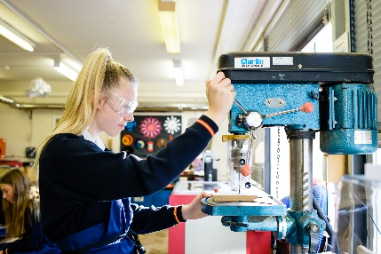Presdales School is a girls’ single sex comprehensive school in Ware for girls aged 11-18, with boys welcomed in the Sixth Form. We are a school which values all students, irrespective of their age and ability and helps them to exceed expectations through high quality teaching and learning and the opportunity to take part in a wide variety of activities which will enrich their educational and personal development beyond the classroom.

We provide a caring environment where all students are supported, as well as challenged, to ensure that there is no limit to their potential. We prepare our students for a world that is constantly changing by encouraging them to be independent learners who are determined, confident and who never give up. Alongside academic excellence there is a strong focus on enjoyment, excellent behaviour and respect for all.

*The school is committed to safeguarding and promoting the welfare of young people and expect staff to share this commitment. All posts are subject to a safer recruitment process which includes enhanced criminal records and barring checks, scrutiny of employment history, referencing and other vetting checks, including online searches.*

**Closing date for applications: 9.00 am, Monday 16 June 2025**

Please submit:

1. A letter of application
2. A completed application form (available on the school website)

*Presdales School is committed to ensuring inclusion, diversity and equality of opportunity. We welcome applications from all suitable candidates and encourage those from underrepresented groups, and/or with protected characteristics, to apply.*

You can post your application to the school, or send by email to [recruitment](mailto:recruitment)@presdales.herts.sch.uk

Please note that CVs will not be accepted