
Parkgate Infants & Nursery School
Northfield Gardens
Watford
Herts
WD24 7RL
Tel. 01923 221984
e-mail : admin@parkgateinfants.herts.sch.uk
Headteacher Mr Gwyn Pritchard B(Ed) Hons, NPQH, NPQEL
___________________________________________________________________
Job Description

Teaching Assistant
Grade: H2

Main purpose

To work with teachers to support teaching and learning, providing general and specific assistance to pupils and staff under the direction, guidance and direct supervision of the classroom teacher.

Key responsibilities

- Work with individuals or small groups of pupils in the classroom under the direct supervision of teaching staff and provide feedback to the teacher.
- Support pupils to understand instructions support independent learning and inclusion of all pupils.
- Support the teacher in behaviour management and keeping pupils on task.
- Support pupils in social and emotional well-being, reporting problems to the teacher as appropriate.
- Prepare and clear up learning environment and resources, including photocopying, filing and the display and presentation of pupils work and contribute to maintaining a safe environment.

Teaching Assistants in this role may also undertake some or all of the following:
- Record basic pupil data.
- Support children’s learning through play.
- Assist with break-time supervision including facilitating games and activities.
- Assist with escorting pupils on educational visits.
- Support pupils in using basic ICT.
- Invigilate exams and tests.
- Assist pupils with eating, dressing and hygiene, as required, whilst encouraging independence.

The duties and responsibilities listed above describe the post as it is at present. The post holder is expected to accept any reasonable alterations that may from time to time be necessary.

Job Context

- The job is one of a set of teaching assistant jobs whose evaluated pay grade is determined by the level of responsibilities.
- Work will follow the learning patterns appropriate to the school day and year group under the direction, guidance and direct supervision of the classroom teacher.
- Carries out allocated tasks under the supervision of a teacher, problems generally referred.

Knowledge, Skills & Abilities

- Working at or towards national occupational standards (NOS) in Supporting Teaching and Learning (core and relevant optional units as required) reflected in the level 2 NVQ and Level 2 certificate in supporting teaching and learning on the Qualification and Credit Framework or equivalent experience
- Carries out allocated tasks under the supervision of a teacher, problems generally referred.
- Communicates with pupils to support learning and development and encourage acceptable behaviour. Exchanges information with staff, parents/ carers.
- Knowledge and compliance with policies and procedures relevant to child protection and health and safety.
- Setting up and use of educational equipment and/or keyboard skills.

Supervision

- The jobholder will usually be managed by a member of the school's senior management team or by a more senior teaching assistant.
- Day to day direction/ supervision will usually come from the class teacher or individual covering the class in the absence of the class teacher.
- The post holder will follow detailed instructions and/or is closely supervised with little scope for discretion; problems are generally referred.
- Responsible for the supervision of practical learning activities of individuals or small groups of pupils under the direction of the teacher or other professional.
- The post holder will have no supervision responsibilities of other staff.
- The post holder may demonstrate own duties to new or less experienced staff.

Problems, Demands & Decisions

- Follows detailed instructions and/ or is closely supervised with little scope for discretion; problems are generally referred.
- Working with individuals or small groups of pupils requiring mental and sensory concentration; work is regularly interrupted although this does not normally require switching from one activity to another.
- Occasionally exposed to emotionally demanding behaviours and situations as a result of attending to pupils’ personal needs and assisting with behaviour management.

Dimensions

- May handle small amounts of cash e.g., for school visits.
- May be issued with a laptop where appropriate, other equipment in use will likely be for short term use to aid teaching and learning.
- Responsible for the careful and safe use equipment, such as play and standard ICT equipment.
- Will record basic pupil data.

Physical Effort

- Combination of standing, sitting or walking.
- Requirement for standing for long periods and/ or working in awkward positions e.g., sitting on low chairs.
- The job may involve lifting children, for example after falls or accidents.

Working Environment

- Some exposure to unpleasant conditions, including noise; outdoor working; verbal abuse.
- Some occasional support required to support pupils with toileting issues where nappies are being used.
- The job may include clearing up blood or other bodily fluids of children after accident or sudden illness.

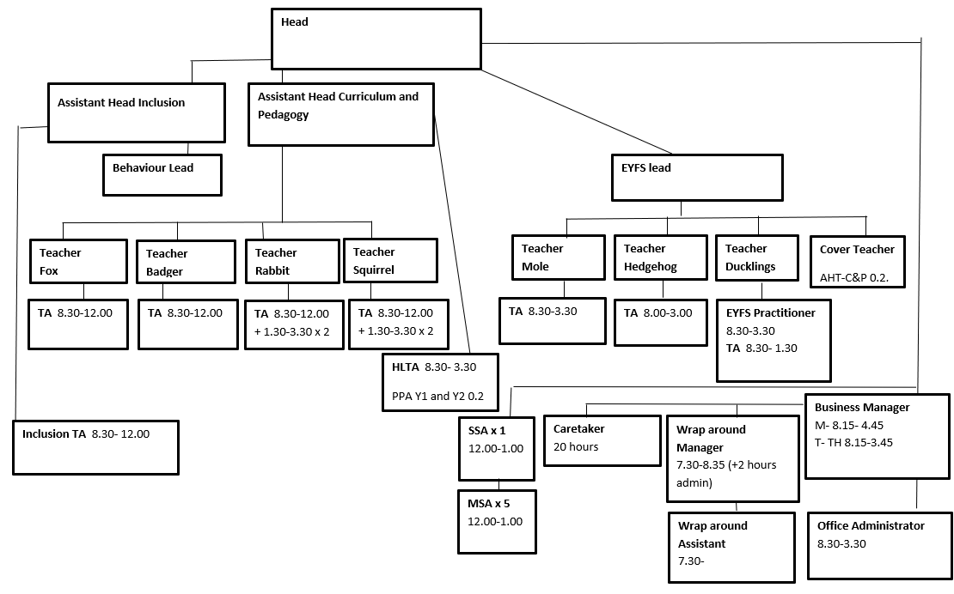

Please tick to confirm this questionnaire has been agreed by the department and any job holder(s)

