Weston Way Nursery School

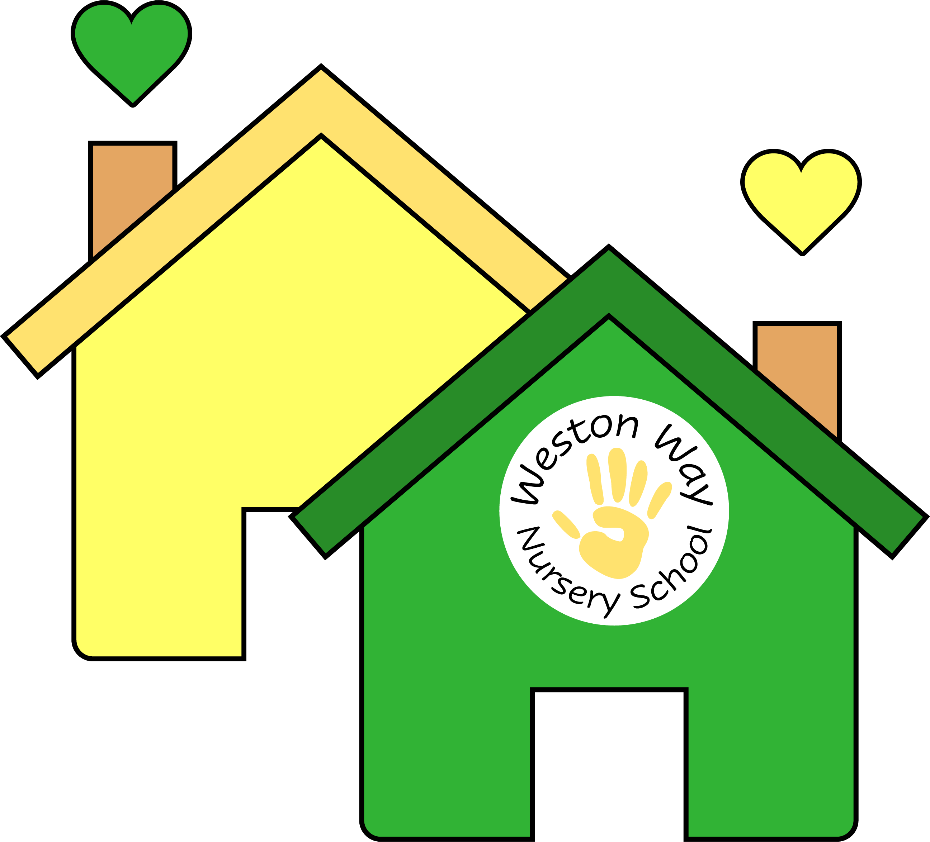

Person Specification: Forest School Practitioner

|  |  |  |
| --- | --- | --- |
|  | **Essential** | **Desirable** |
| **Experience** | * Experience of working with children in a preschool/nursery/school setting * Relevant qualifications (e.g. NVQ Level 3 in Early Years/HLTA Status/Teaching degree) * Level 3 Forest Schools Programme Certificate or willingness to work towards it. * Training or expertise in a relevant curriculum or other learning area (e.g. Early Years Foundation Stage Framework) | * Working with pupils with a range of special educational needs * Maths and Literacy GSCE [A-C] |
| **Skills and Attributes** | * Knowledge, understanding and practical experience of Forest School provision * Know how to use a range of teaching and learning strategies to support children’s progress * Plan effective activities for pupils * Use therapeutic approach to behaviour strategies in line with policy * Respond to young children’s needs * Understands the importance of the unique child within a holistic approach * Work independently * Able to work effectively as part of a team * Remain calm under pressure and be able to adapt to change quickly * Show genuine care and respect for young children and their families and a commitment to working with them * Have empathy with those facing barriers to their learning * Contribute to a purposeful learning environment * Encourage children to interact and learn cooperatively with others * Respond to guidance and proactively seek CPD opportunities * Be a positive role model * Ability to recognise the importance of confidentiality at all times | * Support children’s learning through play * Assist with escorting children on educational visits * Use ICT effectively * Contribute to children’s assessment data |
| **Knowledge** | * Understanding of relevant codes of practice/ and legislation * Understanding of child development and learning * Training in relevant learning strategies * Early Years Framework | * Working within a creative curriculum * Knowledge of health, safety and hygiene practices and requirements * Attends staff training sessions where appropriate |
| **Safeguarding** | * Has up-to-date knowledge of relevant legislation and guidance in relation to working with, and the protection of, children and young people * Displays commitment to the protection and safeguarding of children and young people. | * Possession of a current Basic First Aid or Paediatric certificate * Possession of Level 1 Safeguarding certificate * Willingness to undertake training for these qualifications |