TITLE OF JOB : Learning Support Assistant

LOCATION : Divine Saviour Catholic Primary School

GRADE

- JOB OUTLINE

1 a) REASON JOB EXISTS
To work under the direct instruction of teaching/senior staff, to ensure access to learning for pupils and to provide general support to the teacher in the management of pupils and the classroom.

1 b) DUTIES
- Supporting children in lessons, individually or in groups under the direction of the class or subject teacher
- Monitoring children’s educational and social needs
- Providing one-to-one follow up work directed from a class teacher/SENCO or outside agency for example an occupational or speech therapist
- Providing daily feedback to the teacher as to whether objectives are being met in lessons where they are supporting, so as to enable a clear picture of pupils’ achievements or learning needs.
- Attend to pupils' personal needs, including social, health, hygiene, first-aid and welfare matters
- Prepare classrooms and clear afterwards and assist with the display of pupils' work
- Provide clerical/admin support, e.g. photocopying, typing, filing, collecting money, record keeping
- Assist with the planning and delivery of learning activities
- Accompany teachers and pupils on out-of-school activities and take responsibility for a group, under the direction of a teacher
- Assist with the development of individual education health care plans (EHCPs) and personal care programmes
- Supervise, and provide individual support for, pupils with identified special educational needs

1 c) EQUALITIES
Be aware of and support difference and ensure that pupils have equality of access to opportunities to learn and develop

1 d) HEALTH AND SAFETY
Be aware of and comply with policies and procedures relating to child protection, health, safety and security, confidentiality and data protection; and report all concerns to an appropriate person.

1 e) CRIMINAL RECORDS BUREAU
This post is classed as having a high degree of contact with children or vulnerable adults and is exempt from the Rehabilitation of Offenders Act 1974. An enhanced disclosure will be sought through the DBS as part of ASCAT’s pre-employment checks.

1 f) ADDITIONAL INFORMATION
The jobholder is required to contribute to and support the overall aims and ethos of the school.
All staff are required to participate in training and other learning activities, and in performance management and development, as required by the school's policies and practice.

** The duties and responsibilities listed above describe the post as it is at present. The post holder is expected to accept any reasonable alterations that may from time to time be necessary.

2. ORGANISATION CHART
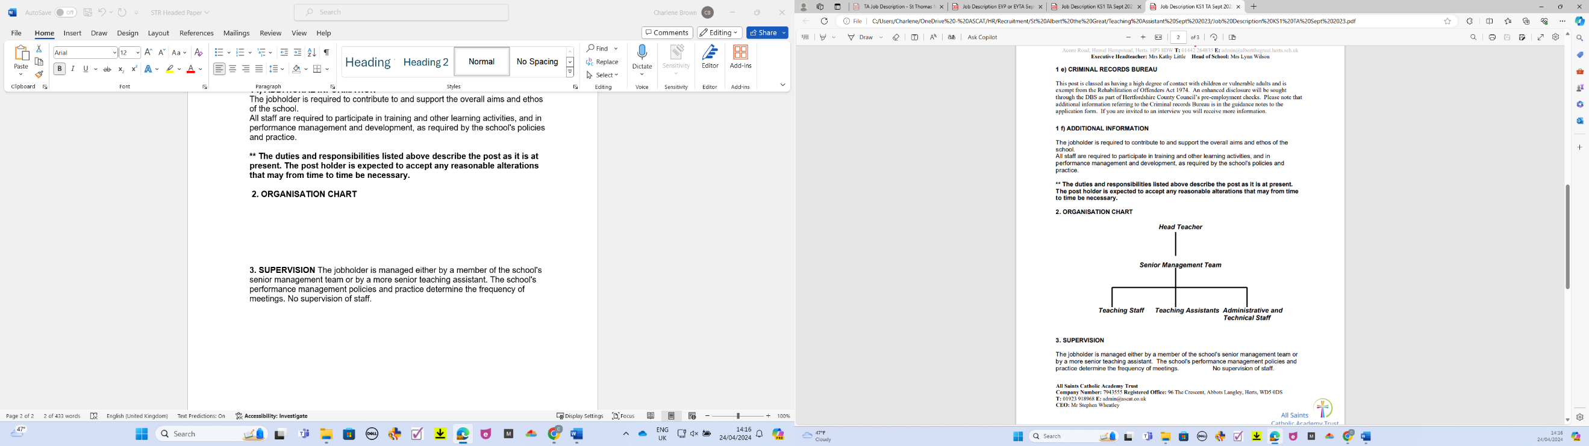

- SUPERVISION
The jobholder is managed either by a member of the school's senior management team or by a more senior teaching assistant. The school's performance management policies and practice determine the frequency of meetings. No supervision of staff.

- CONTACTS
The jobholder works with teachers and pupils and has occasional contact with parents and carers.

- KNOWLEDGE, EXPERIENCE AND TRAINING
♦Good standard of education –NVQ Level 2 or equivalent.
♦HLTA qualification (desirable).
♦ Experience of working with or caring for children of the relevant age
♦ Good numeracy and literacy skills
♦ Basic knowledge of first-aid
♦ Ability to use ICT to support learning
♦ Understanding of learning programmes and strategies or the ability to learn quickly
♦ Ability to work in a team

- PHYSICAL EFFORT
The job may involve lifting children after falls or accidents

- WORKING ENVIRONMENT
The job may include clearing up blood or other bodily fluids of children after accident or sudden illness.

