Holwell Learning Support Assistant Standards
Grade: Hertfordshire Support Staff Grade H2
Responsible to: SENDCo and Assistant SENDCo
Purpose of the role
To work in partnership with class teacher, Lead LSA and SENDCo to support learning of individual children who have a high level of Special Educational Needs (SEND) in line with the National Curriculum, Codes of Practice and School Policies and Procedures.

Section A: Learning Support Assistant Standards

The following are extrapolated from the National Teaching Standards (2019). All teaching assistants are expected to demonstrate the following practices consistently in their practice.
Part One: Teaching
Ethics and professional conduct | - serve in the best interests of the school’s pupils  - conduct themselves in a manner compatible with their position in the school by behaving ethically, fulfilling their professional responsibilities and modelling behaviour which reflects highly on the school.
Support the school’s high expectations which inspire, motivate and challenge pupils | - assist in establishing a safe and stimulating environment for pupils, rooted in mutual respect  - demonstrate consistently the positive attitudes, values and behaviour which are expected of pupils.  - support and work with an induvial child or children of varying ages and additional needs under the direction of teaching staff, SLT, SENDCo and assistant SENDCo  - liaise with other staff and provide information about the pupil as appropriate.
Promote good progress and outcomes by pupils | - support a given pupil within a class setting, small group setting or 1-1 setting  - participate in planning and evaluation of learning activities with the teacher, providing feedback to the teacher on pupil progress and behaviour.  - be aware of pupils’ capabilities and their prior knowledge, and support teaching to build on these  - guide pupils to reflect on the progress they have made and their emerging needs  - demonstrate knowledge and understanding of how pupils learn and how this impacts on learning  - encourage pupils to take a responsible and conscientious attitude to their own work and study.
Support with the planning and teaching of well structured lessons | - implement planned learning activities/teaching programmes as agreed with the teacher adjusting activities according to pupils’ responses as appropriate.  - support learning by arranging/providing resources for lessons/activities under the direction of the teacher  - have a good knowledge of the relevant subject(s) and curriculum areas, foster and maintain pupils’ interest in the subject, and assist in addressing misunderstandings  - demonstrate an understanding of and assist in the responsibility for promoting high standards of literacy, articulacy and the correct use of standard English  - if supporting the teaching of early reading, demonstrate a clear understanding of systematic synthetic phonics  - if supporting the teaching of early mathematics, demonstrate a clear understanding of appropriate teaching strategies.
Support with the adaptation of teaching to respond to the strengths and needs of all pupils | - have a clear understanding of the needs of pupil being supported and be able to support distinctive teaching approaches to engage and support them  - promote the inclusion and acceptance of children with special needs within the classroom ensuring access to lessons and their content through appropriate clarification, explanation and resources.  - support pupils to understand instructions support independent learning and inclusion of all pupils  - know when and how to differentiate appropriately, using approaches which enable pupils to learn effectively
Contribute to accurate and productive use of assessment | - monitor and record pupil activities as appropriate writing records and reports as required.  - provide feedback to the pupil in relation to attainment and progress under the guidance of the teacher.  - support the use of formative and summative assessment to secure pupils’ progress  - contribute in giving pupils regular feedback, both orally and through accurate marking, and encourage pupils to respond to the feedback
Support with Managing behaviour effectively to ensure a good and safe learning environment | - support the clear rules and routines for behaviour in classrooms, and take responsibility for promoting good and courteous behaviour both in classrooms and around the school, in accordance with the school’s behaviour policy  - have high expectations of behaviour, and establish a framework for discipline with a range of strategies, using praise, sanctions and rewards consistently and fairly  - support in the effective management of classes, using approaches which are appropriate to pupils’ needs in order to involve and motivate them  - maintain good relationships with pupils, exercise appropriate authority, and act decisively when necessary  - support pupils in social and emotional well-being, reporting problems to the teacher as appropriate.  - assist a pupil or pupils throughout the day, including break-time and lunch-time supervision if required.
Fulfil wider professional responsibilities | - engage with other LSAs working closely with SENDCO and Assistant SENDCo to create an effective team.  - make a positive contribution to the wider life and ethos of the school  - develop effective professional relationships with colleagues, knowing how and when to draw on advice and specialist support  - take responsibility for improving own practise through appropriate professional development and responding to advice and feedback from colleagues  - liaise with parents and carers, under the direction of a teacher and SENDCo  - assist with the development and implementation of pupil review meetings and EHCPlans.  - To provide support to student’s general welfare, including emergency First Aid, administering medication, feeding, toileting and changing pupil’s clothes as directed.

A Learning Support Assistant is expected to demonstrate consistently high standards of personal and professional conduct. The following statements define the behaviour and attitudes which set the required standard for conduct throughout a teaching assistant’s career.

Learning Support Assistant uphold public trust in the profession and maintain high standards of ethics and behaviour, within and outside school | - treat pupils with dignity, building relationships rooted in mutual respect, and at all times observing proper boundaries appropriate to a teaching assistant’s professional position  - having regard for the need to safeguard pupils’ well-being, in accordance with statutory provisions  - showing tolerance of and respect for the rights of others  - not undermining fundamental British values, including democracy, the rule of law, individual liberty and mutual respect, and tolerance of those with different faiths and beliefs  - ensuring that personal beliefs are not expressed in ways which exploit pupils’ vulnerability or might lead them to break the law
Learning Support Assistant must have proper and professional regard for the ethos, policies and practices of the school in which they teach, and maintain high standards in their own attendance and punctuality | - Uphold the ethos, policies and practices of the school  - Maintain the expected high standards in attendance and punctuality
Learning Support Assistant must have an understanding of, and always act within, the statutory frameworks which set out their professional duties and responsibilities | - Understand, and act within, the statutory framework that sets out the professional duties and responsibilities

This Job Description indicates only the main duties and responsibilities of the post. During the course of duties, you may be asked to carry out other tasks that may be reasonably assigned to you by the Head Teacher or Deputy Head in their absence.

Knowledge  NVQ level 1 (or equivalent)  Basic knowledge of ICT  Awareness of Health, wellbeing and safety  Awareness of keeping children safe  Awareness of Data protection and confidentiality  Basic knowledge of First Aid  Understanding of the Schools ethos and values | Competencies  Communication (written and verbal)  Problem Solving  Team working  Active Listening  Motivation

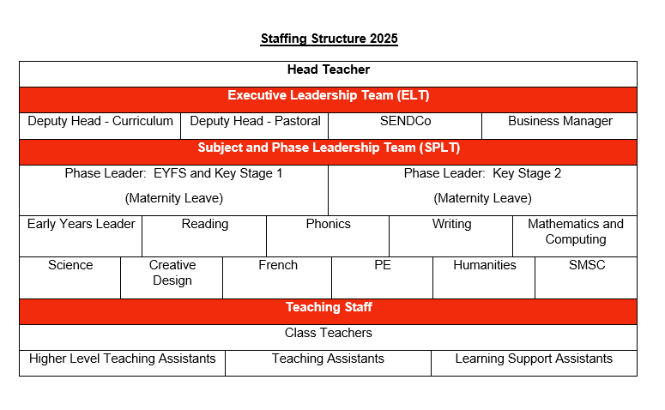
This post is classed as having a high degree of contact with children or vulnerable adults and is exempt from the Rehabilitation of Offenders Act 1974. An enhanced disclosure will be sought through the DBS as part of Hertfordshire County Council’s pre-employment checks. Please note that additional information referring to the Disclosure and barring Service is in the guidance notes to the application form. If you are invited to an interview you will receive more information. This role will be reviewed annually as part of the PMD process.
Line Management Responsibility
SENDCO
Assistant SENDCo
Learning Support Assistant

I agree to the job description above

Signed:
Name:
Date:

