BEHAVIOUR POLICY

Leverstock Green CofE (VC) Primary School

Policy Review

This policy was agreed by the governing body on 29th January 2025.

It is due for review in January 2026.

Signature …………………………………. Date ……………………

Head Teacher

Signature ………………….………………. Date ….…………………

Chair of Governors

Behaviour Policy

Our school vision is that we are all the children of God. Our school motto is ‘Striving for Excellence; Caring for the Individual.’ Our aim is that all children and adults will flourish, and we firmly believe that everyone has the right to learn, play and feel safe. Part of this is teaching the children to become aware of and regulate their feelings as well as managing their behaviour for learning, enabling themselves and others to succeed.

Our Christian ethos and core values of love, respect and forgiveness underpin our approach to relationships and behaviour management.

Aims of our policy
This policy has been written
- To uphold our school vision and values as a Church of England School
- To capture the ‘Therapeutic Thinking’ approach towards behaviour and wellbeing
- To explain what we mean by pro social behaviour and to promote a shared understanding
- To set out the roles and responsibilities of everyone in the school community
- To encourage, teach and recognise pro social behaviour
- To deal with anti-social behaviour with consequences that are consistent and fair, teaching our expectations
- To set out the support and help available for children who have additional needs and need help with regulating their behaviour
- To set out the adjustments and support available for children who have Special Educational Needs or Disabilities (SEND)

We believe that school must be a welcoming and caring place for all. We recognise that children, families, staff, governors and our local community all have a vital part to play in the success of our school.

Aspirations at our school
As a school we aim to inspire our children to:
- be enthusiastic and focussed about learning
- be kind, caring and considerate of others
- practise our Christian values of love, respect and forgiveness
- be polite, co-operative and able to work and play in groups
- aim high
- make pro social choices, tell the truth and do the right thing
- be able to safely regulate their behaviour and feelings
- recognise when things go wrong and take responsibility for their own actions

By creating a safe and secure learning environment, we believe that our children will discover their talents, develop their interests and have the self-confidence to become successful life-long learners.

What we expect from our school community
Our children to:
- be respectful to other children and all adults
- be kind, helpful and caring
- look after equipment and resources in our community
- have a positive attitude
- be aware of their own and other’s safety
- be active learners and encourage others to learn
- take on responsibilities around the school and in the community
- be responsible for their own actions
Our parents/carers to:
- be aware of, understand and support the policies and procedures that help our school work effectively
- model the pro social behaviour and actions expected of our children
- support the school in developing their child’s learning and their social and emotional wellbeing
- ensure that their children come to school ready to learn and on time

Staff and other adults in school to:
- be aware of, understand and support the policies and procedures that help our school work effectively
- model the pro social behaviour and actions expected of our children
- be appropriately organised for what they are here to do
- ensure that they are aware of specific needs and requirements of children in their care
- ensure that everyone is safe and secure within the school environment and on educational visits
- attend Therapeutic Thinking training and an annual refresher (Therapeutic Thinking is a therapeutic
programme of behaviour management and is approved by the local authority)

How the adults in our school teach pro social behaviour

We help children to be enthusiastic and focussed about learning by:
- recognising and acknowledging pro social behaviours and achievements
- providing high quality learning and varied experiences in a stimulating environment
- promoting a ‘can do’ attitude
- displaying children’s work in a variety of ways and celebrating their achievements

We help children to be kind, caring and considerate of others by:
- teaching children about their own and other people’s feelings including mindfulness
- modelling how we care for others
- modelling how we speak to others
- developing respectful relationships between everyone in our school
- modelling behaviour we would like to see in children
- noticing and praising consideration for others
- recognising kindness and support for others
- modelling pro social language to meet and greet each other

We help children to be co-operative and able to work and play in groups by:
- giving children jobs and responsibilities
- having organised classrooms and work areas so that it is easy for everybody to look after equipment
- establishing routines which are understood by the children so that they can organise their time effectively

We help children to aim high by:
- encouraging and praising all children’s efforts
- encouraging perseverance
- modelling how you can learn through mistakes
- rehearsing how you can do things in different ways
- setting realistic targets for behaviour and learning
- providing exciting learning opportunities which promote learning from each other
- providing challenge in our lessons for all groups of learners
- supporting children to take risks with their learning

We help children to make good choices and do the right thing by:
- having visual prompts about expectations relating to school life, which are agreed and referred to
- recognising effort as well as outcome
- talking to them using clear, specific, positive language
- modelling how you can learn through mistakes and do things in different ways
- teaching children the strategies to cope with minor setbacks through Circle Time and Personal Development
- reviewing situations to encourage reflective thinkers

Rewards & Consequences
As a school, we believe in teaching our children to develop intrinsic motivation. However, we acknowledge that recognition celebrates the success of individual pupils and builds pupils self-esteem, confidence and provide a role model for other children.

In accordance with the ‘Therapeutic Thinking’ approach, consequences are protective and educational. A protective consequence is immediate to keep a child(ren) safe and an educational consequence will always follow. The educational consequence is where the member of staff has a restorative conversation with the child aims to develop a link between the child’s behaviour and internal discipline.

 | REWARDS | CONSEQUENCES
In class | - praise  - comments in books  - work shown to other children or members of staff – Head Teacher’s award  - work shared in worship as appropriate  - pupil of the week certificate and ‘You can Toucan’ one per class per week which is also shared on the school newsletter  - 5R’s displayed in all classrooms. There will be a focus on 1 per half-term or term linking to pupil of the week.  - You Can Toucan certificate, one per class for Reception to Y6 which is also shared on the school newsletter  - Reader of the week? | - a class will not receive a consequence for the behaviour of one  - give the child a visual sign e.g. a raised eyebrow, a pointed finger or a move closer to the child to let them know that the teacher is aware  - praise a child nearby who is demonstrating pro social behaviour; praise the child who responds by making a positive change to their behaviour  - draw the child’s attention to their behaviour through a description of what is happening e.g. ‘You are talking when I am talking’ and encourage them to do the right thing  - Reflect, Repair and Restore slips (Appendix C) are used as part of the consequence and encourage the children to reflect on their behaviour the impact this had on the class. This is part of our restorative approach towards developing pupils’ pro-social behaviour.  - Third slip in 5 days triggers a notification to parents from a member of SLT and some play will be lost  - EYFS – time out age related. In class when needed, next step miss time outside.  - KS1 – 30 mins  - LKS2 – 45 mins  - UK2 – 1 hour  - For children with SEND, there may be a need for adaptions appropriate to their needs.  - Where there are ongoing concerns about a pupil’s behaviour, parents/carers will be invited in to work alongside the class teacher and a member of the leadership team to support a child’s individual needs. This will commonly involve using the Therapeutic Thinking resources such as roots and fruits, anxiety mapping and creating a plan of support.
  Autumn 1 | Responsibility
  Autumn 2 | Resilience
  Spring | Reflectiveness
  Summer 1 | Resourcefulness
  Summer 2 | Reciprocity
At playtimes | Given additional responsibilities  Positive feedback to class teacher | - The same high expectations apply to playground behaviour. The TAs, the Senior Midday Supervisor and her team have the right to expect the same respect from the children as the teaching staff. Anti-social behaviour will result in:  - removal from the playground or classroom during wet play for an orange consequence (defiance, rudeness, disturbing teaching, preventing learning) or a red consequence  (aggression/racism/homophobia) where two play times are lost and a phone call home by a member of SLT.

Foundation Stage Behaviour Policy Statement
At Leverstock Green School in the Foundation Stage we promote good behaviour; our emphasis is on praise. We understand that pupils in EYFS are at a different stage of development and therefore do not use the same consequences (Orange and Red behaviour slips) that are used in KS1 and KS2. However, the ‘Therapeutic Thinking’ approach and language around pro social behaviour and anti-social behaviour is used consistently. On rare occasions, a protective consequence (time away from peers) is required.

Public praise
Public acknowledgement of pro-social behaviour can be very powerful in a positive way. Talking about anti-social behaviour should be as private as possible; lowering a child’s self-esteem could increase misbehaviour, if not immediately, later. Praise can also be non-verbal: a smile or a thumbs-up.

Being consistent
Children have a need for the world to be as reliable as possible. When staff act consistently and reliably, they make the child feel safer and therefore less anxious. This in turn will make it less likely that events will trigger unwanted or inappropriate behaviour.

Model desired behaviour
It is important for adults within the school to model the kinds of behaviour that they expect from children in terms of respect, concern, fairness, how to apologise, how to resolve difficulties fairly and amicably.

Listen to children
Listen to children and make them feel significant. It is important to make children feel aware that you recognise their feelings … “You seem cross, did something happen?”
Follow up concerns raised, and complaints made, even if you need to say that you will deal with it later. Children need to feel able to share things with us and for issues to be dealt with.

Praising Pro-Social Behaviour
This can be hard with some children, but it is usually more important for them than for many others. Noticing and acknowledging anything that is praiseworthy will encourage the child to repeat and try good behaviour.

Offsite visits
It is expected that children will behave in the same way they do in school when they are offsite attending educational activities.

Teaching Self-Regulation
Our approach to developing relationships and positive behaviour in school is underpinned by the ‘Zones of Regulation’. Children are encouraged to recognise which ‘zone’ they are in and name the emotions they are experiences. This approach will help the children learn to self-regulate and de-escalate.

Each classroom has a visual display which identifies the four, key emotion zones. This is adapted by key stage to ensure it is accessible to each age range.

Zones of Regulation are part of daily practice. For example, having check-ins, using the language of self-regulation to support individuals or groups of pupils. Pupils are encouraged to develop their toolkit in order for them to be able to recognise what they need to do if they are feeling a certain emotion or feeling.

When faced with challenging Behaviour
Some behaviours exhibited can be more challenging. Adults’ responses to these behaviours will aim to de-escalate the behaviour through one of or a combination of the following as appropriate:
- Positive phrasing e.g. -“Stand next to me”, “Put the toy on the table”, “Walk beside me”
- Giving a limited choice e.g. -“Put the pen on the table or in the box”, “When we are inside, Lego or drawing”, "Talk to me here or in the library”
- Disempowering the behaviour e.g. -“You can listen from there”, “Come and find me when you come back”, "Come down in your own time”.
- Use of a De-Escalation Script (See Appendix D)

Where a pupil’s behaviour has been identified as causing concern, the school uses resources from ‘Therapeutic Thinking’ to respond to a child’s individual needs. This process will always take place in collaboration with the class teacher, at least one member of the leadership team and parents/carers. Pupils whose behaviour is causing concern may have a different de-escalation script and strategies to ensure their individual needs are met.
(Appendix E outlines the process towards supporting children with such behaviour.)

Risk assessments and unforeseeable behaviour
Pupils whose behaviour may place themselves and others at a risk of harm must have individual risk reduction plan. These are overseen by the Headteacher, who will ensure that they are reviewed and updated to reflect changes and progress. Learners who may need a risk reduction plan are those whose needs are exceptional, and the usual everyday strategies are insufficient. This will include learners who may require some specific intervention to maintain their own and others’ safety and to ensure learning takes place for all. A plan will:
•Take into consideration the times/ places/lessons that give the learner greater anxiety, triggers that could lead to difficult behaviours.
•Put in place risk reduction measures and differentiated measures that will lower the learners’ anxiety and enable the learner show positive behaviours at school.
•Give clear de-escalation strategies and scripts that all adults can follow when speaking to the learner to lessen difficult and dangerous behaviours.

Physical intervention
There are situations when physical intervention may be necessary. Staff are trained by Hertfordshire Therapeutic Thinking trainers in how to safely use physical intervention. Staff are instructed to be aware of the child’s age and individual circumstances when moving them as some children find this more upsetting than others. Situations may include:
•To comfort a student in distress, appropriate to their age and understanding.
•To support a child with their physical care (toileting, self-care, changing clothes).
•To gently direct/guide a person.
•For activity reasons (drama, physical games).
•To avert danger to the student, other persons or significant damage to property.

Suspension/Exclusion
Fixed term suspension or permanent exclusion may be used when all other strategies have failed or in extreme circumstances; for example, where false allegations are made against staff. Pupils’ needs, such as having SEND or being in a vulnerable group, will be carefully considered in the event of a possible exclusion.

Only the Headteacher, or in her absence the Assistant Headteacher following consultation, have the power to exclude.

We will use the following methods, as appropriate, to avoid excluding a child: time out of class as a consequence, protective consequences such as playtimes being carried out at a separate time, supported playtimes, loss of free play, meet and greet by a named adult, regular check-ins with a named adult, positive reward chart, reduced or adapted timetable, referral to external agencies or request for support from the Virtual School for CLA or PLA pupils.
Given the importance of the safety of the school community, the Governing Body supports the right of the school to exclude permanently for a single offence where it is considered that allowing the pupil to remain in school would seriously harm the education or welfare of the pupil or others in the school.

Following any fixed-term exclusion, the school will hold a reintegration meeting with the child and his/her parents. As outlined in Stage 4, strategies will be put in place to reduce the likelihood of the child needing to be suspended again; this may include a time-limited reduced timetable, referral to external agencies, risk reduction plans and other strategies.

Recording Behaviour Incidents
All anti-social behaviour including Orange and Red consequences are recorded on CPOMS in a timely manner. This is an online system that allows us to keep confidential records for each child.

When behaviour incidents are logged on CPOMS, this automatically alerts all members of the Senior Leadership team. This allows leaders to monitor that appropriate consequences and actions have been followed up.

A member of SLT reviews the Reflect, Repair and Restore form. When this is completed, it is filed in the class behaviour slip folder.

Monitoring and evaluation
The Senior Leadership Team monitor behaviour incidents and trends using the CPOMS reporting system. Each term, a report of behaviour slips is published to governors in the Headteacher report. This ensures that the governing body are aware of trends in behaviour over time and support the school further.

The Senior Leadership Team will evaluate this policy annually and report to Governors on its progress and effectiveness each term.

Links to other policies
Anti-bullying
Personal Development
Restrictive physical intervention policy

Appendix A
Strategies we use to secure pro social behaviour
- getting down to pupil’s level
- nonverbal thumbs up/thumbs side/thumbs down
- gentle touch of the arm
- lowering voice
- talking slowly & calmly
- telling the child what they need to do instead of emphasising the negative
- positive language ‘I like the way you’re just about to tidy away, well done’
- ‘I’ statements - I feel …………. when you …………… because …… I’d like you to ……………
- eye contact
- smiling

Appendix B
Considerations for behaviour display:
- We have a right to be safe and we will care for others
- We have a right to a good education, and we will work hard
- We have a right to contribute so we will listen to others and respect their views
- We have a right to rest and play and we will include others
- We have the right to be forgiven for our mistakes, we will learn from them, and we will forgive others
- We have a right to use good quality resources so we will care for them

KS2 Reflect, Repair and Restore form

I am responsible for: orange/red behaviour(s)

Name: ………………………………….  Class: ……………. | Date: …………………………………. Time: …………….  Member of staff issuing: ………………………………
Orange Behaviours | Red Behaviours
- Distracting learning  - Ignoring instructions  - Talking over staff or talking when silence is asked for  - Answering back/rudeness to staff  - Being unkind to others  - Unwanted touching of another person  - Making inappropriate facial expressions at others  - Not telling the truth  - Encouraging others to do any of the above | - Deliberate damage to or destruction of property  - Throwing objects/furniture  - Refusing to co-operate  - Leaving class or the building without permission  - Leaving school  - Spitting  - Deliberately hurting another person e.g. pinching, biting, punching  - Attacking another person  - Verbally abusive  - Shouting in an aggressive manner  - Inappropriate gestures or touch  - Swearing  - Homophobic, transphobic, sexist or racist language  - Radicalisation  - Encouraging others to do any of the above
Why I received a slip/what I did ………………………………………………………………………………………………………

……………………………………………………………………………………………………………………………………………………………

How did my behaviour choice affect other people and/or my learning? ………………………………………………

…………………………………………………………………………………………………………………………………………………………..

What will you do to repair what happened?

 I will go and help my teacher for five minutes
 I will help put resources away
 I will tidy up
 I will apologise
 I will write a sorry card/letter
 Other ………………………………………………………………………………………………………………………………………….

SLT Member Signature: ……………………………………… Date: …………………………………

Please note: All Orange and Red behaviours should be logged on CPOMs by the member of staff that dealt with the incident. Once complete, this form must be stored in the class behaviour file.

Name: ………………………………….  Class: ……………. | Date: …………………………. Time: …………….  Member of staff issuing: ………………………………
Orange Behaviours | Red Behaviours
KS1 Reflect, Repair and Restore form

What behaviour did you show?

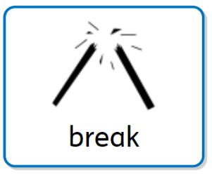
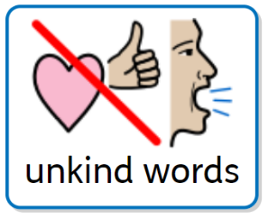
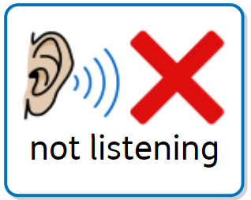
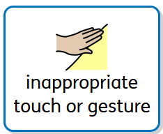

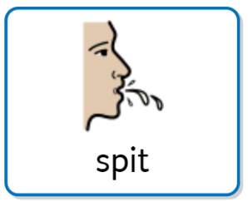
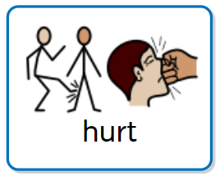
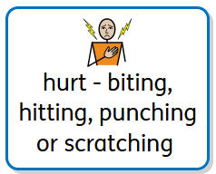

How did it make the other person feel?
blue | green | yellow | red

What will you do to put it right?

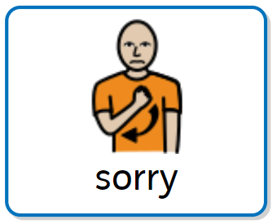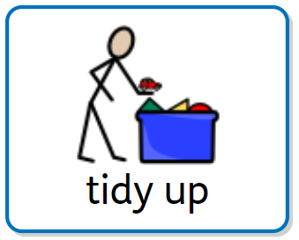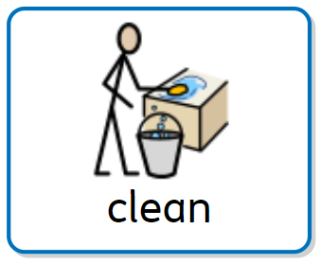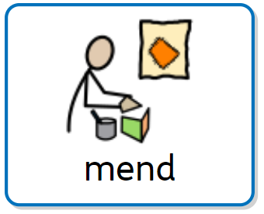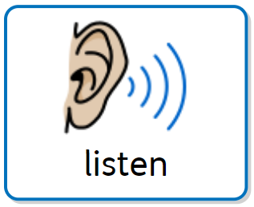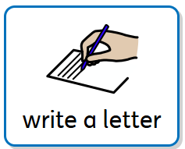

SLT Member Signature: ……………… Date: ……………………………………..

Please note: All Orange and Red behaviours should be logged on CPOMs by the member of staff that dealt with the incident. Once complete, this form must be stored in the class behaviour file.

Appendix D

De-escalation Script

- Learner’s name
- I can see something has happened
- I am here to help
- Talk and I will listen
- Come with me and……

Appendix E

Steps towards Responding to unsafe behaviour
(Using the Principles from Therapeutic Thinking Approach)
Step 1:
Reasonable adjustments made by the class teacher
Eg. Individual reward charts
Step 2:
Class Teacher to discuss concerns with parents/carers and behaviour to be monitored on CPOMS (School Monitoring, Tracking and Recording system)

Step 3:
If behaviour is still a concern, a member of the leadership team alongside the class teacher and parents/carers will arrange a meeting. The school will provide the following documentation: Roots and Fruits, Anxiety Mapping, Risk Reduction Plan and include a de-escalation script and planned responses.
Step 4:
Where previous intervention has not had the desired outcomes, with parental agreement, referrals will be made to external agencies and professionals for further support. For example: Woodfield, Therapeutic Thinking Team or other SEND Specialists.

Appendix F

Suspension/Exclusion
Serious incidents e.g. extreme/ deliberate/ unprovoked violence/ putting themselves or others at risk may result in a fixed term suspension or permanent exclusion. This is at the discretion of the Headteacher. These decisions are not made lightly and are informed by Local Authority and DfE guidance. Parents are informed of the decision and, in the case of suspension, work is sent home for the child to complete. A reintegration meeting is held with the parents and child on their return to school. Permanent exclusion is only a last resort when all other avenues have failed and the education, safety and well-being of the class and the school is at risk. Where poor behaviour persists at lunchtimes, lunchtime exclusions may be considered.

Pupils’ needs, such as having SEND or being in a vulnerable group, will be carefully considered in the event of a possible exclusion.

Examples of behaviour which may lead to fixed term exclusion | Examples of behaviour which may lead to permanent exclusion
- Persistent disruptive behaviour following in-school sanctions (see above)  - Bullying  - Deliberate racist, homophobic or sexist comments  - Stealing  - Deliberately using offensive language (to staff or pupils)  - Vandalism  - Serious injury with intent | - Serious actual or threatened violence against another pupil or a member of staff  - Sexual abuse or assault  - Supplying/using an illegal drug, solvent or alcohol  - Carrying an offensive weapon  - Malicious/false allegations against staff
These examples are not exhaustive, but are for illustrative purposes. | This list is not exhaustive but indicates the degree of severity of offence that might warrant a permanent exclusion for a first or “one-off” offence. The Headteacher will consider whether or not to inform the police where a criminal offence has taken place. The Headteacher will also consider making referrals to other agencies, e.g. in relation to child protection, as appropriate to the circumstances of the case.

Appendix G: Glossary of terms

Anti-social Behaviour: Behaviour that causes harm to an individual, a group, to the community or to the environment.

Behaviour: Everything a person says or does. The spectrum of behaviour goes from extreme prosocial to extreme anti-social behaviour.

Conscious behaviours: Those that are the result of thought and planning; a behaviour chosen by the child in order to secure a desired outcome or meet a specific need.

Consequences: a conclusion derived through logic. Something that logically or naturally follows from an action.

De-escalation: a technique to prevent conflict; communication is key to this technique.

Dangerous behaviour: That which is anti-social and will predictably result in imminent injury or harm. This includes harm to self or others, damage to property or behaviour that would be considered criminal if the person was the age of criminal responsibility, such as racist abuse.

Difficult behaviour: That which is anti-social, but not dangerous.

Educational consequences: the learning or teaching so the freedom can be returned.

External discipline: when staff impose rules and suppression may only achieve a short-term change.

Internal discipline: when staff work with a student’s experience and feelings and this results in long term change.

Protective consequences: removal of a freedom to manage harm.

Pro-social Behaviour: Relating to behaviour which is positive, helpful, and values social acceptance.

Reward: A desirable object or experience given to celebrate outcomes already achieved.

Subconscious behaviour: That which is present without any thought or planning; a behaviour a person is unable to contain.

