After School Club Assistant – Job Description

Pay grade: Hertfordshire Support Staff Hay Grade – H2
Responsible to: After School Club Manager

Main Duties and Responsibilities
- To create a safe, fun, welcoming, and inclusive environment for all children and their parents / carers
- To deliver the highest standards of care to all children who attend the After School Club
- Assist in the maintenance of a safe culture for all children in line with safeguarding, health and safety and equalities policies and procedures
- To be reliable and punctual, maintaining staffing ratios at all times
- Run activities for the children, taking into account their individual needs and abilities to provide a safe, caring and stimulating play environment.
- Ensure the club is well-resourced and creatively setup
- Encourage pupils to interact with others and engage in activities with the children
- To be professional and a good role model to the children and other staff members
- To work flexibly as part of the larger team, assisting and supporting colleagues wherever required, in order to ensure the smooth running of the club
- To safely prepare food and complete a Food Hygiene Level 1 qualification
- Keep completely confidential any information regarding the children, their families or other staff, which is acquired as part of the job.
- Administer first aid when necessary (you will be required to undertake a Paediatric first aid course)
- To undertake appropriate and relevant training as required.
- To undertake any other aspects of Club work according to need
This Job Description indicates only the main duties and responsibilities of the post. During the course of duties, you may be asked to carry out other tasks that may be reasonably assigned to you by the After School Club Manager or Business Manager in their absence.

This post is classed as having a high degree of contact with children or vulnerable adults and is exempt from the Rehabilitation of Offenders Act 1974. An enhanced disclosure will be sought through the DBS as part of Hertfordshire County Council’s pre-employment checks. If you are invited to an interview you will receive more information.
Leadership structure
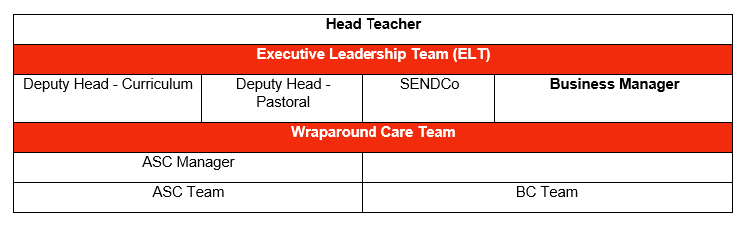
This role will be reviewed annually as part of the PMD process. I confirm my acceptance to the job description above.

Signed:
Name:
Date:

