Job Title | Best Start Inclusion Practitioner
Department | Family Support Services
Location | Based at Family Centre Hubs across Hertfordshire.
Reporting to
Responsibility for | No line management responsibility
Budgets | No direct budget holder responsibility unless delegated
Grade | G4
Vetting | An Enhanced Disclosure is required for this position
Travel | Some travel in and around Hertfordshire may be required at times along with working from Best Start Family Hubs and Family Centre Hubs.

Main Purpose of Role
The YMCA provides a wide range of services including children’s services, housing, health, wellbeing, youth and community provision for the benefit of local people across Hertfordshire, Buckinghamshire, Bedfordshire and beyond. YMCA is committed to making a difference through inclusive, high-quality services that respond to community need.
As the Inclusion Practitioner, you will support the effective delivery of inclusive family support services across Family Centres, ensuring that families with children with SEND, disabilities, or emerging needs can access, engage with and benefit from both universal and targeted provision.
You will play a key role in early identification and intervention, reducing inequalities, removing barriers to access (including digital exclusion), and embedding inclusive, strengths-based and relationship-centred practice, with a focus on parenting and the home learning environment, in line with Best Start Family Hubs and Healthy Babies (2026–2029) priorities.

Where your role fits in the team

Role-specific responsibilities
The key elements of the post are to:
The key elements of the post are to:
- Support the delivery of inclusive universal and targeted services for families with children under 5 (and siblings where appropriate), for those with SEND, disabilities or emerging needs.
- Work directly with families through home visiting, 1:1 support, group work, outreach and digital delivery to reduce practical, emotional, cultural and digital barriers to engagement.
- Promote early identification of developmental delay, disability and SEND, working collaboratively with health visitors, early years providers, SEND services and other professionals.
- Support families through key transitions, including starting early years provision and preparing for school, and to navigate and access appropriate services.
- Champion reasonable adjustments and inclusive practice across Best Start Family Hub and Family Centre activities, environments and communications, supporting colleagues to adapt delivery to meet diverse needs, including within the home learning environment and parenting
- Work collaboratively and discuss observations with families and multi-agency partners to maintain clear, joined-up pathways, ensuring families do not fall between services.
- Provide practical advice, modelling inclusive practice and short interventions, delivering activities such as sensory stay and play.
- Contribute to the development of inclusive resources, tools and information for families to support learning, development and engagement at home.
- Deliver inclusion-focused workshops, sessions and parenting support individually and in groups, face-to-face and digitally.
- Undertake lone working in family homes and community settings where required, following safeguarding and lone-working procedures at all times.
The responsibilities contained within this job description are indicative but not exhaustive and may be reviewed in discussion with the post holder.

General responsibilities
- Develop a good understanding of local demographics, inequalities and barriers to access affecting families.
- Put equality, diversity, inclusion and belonging at the heart of all interactions with colleagues, families and partners.
- Champion family voice and co-production, ensuring lived experience informs both individual support and wider service improvement.
- Contribute to service monitoring, evaluation and learning through case studies, data collection and reflective practice, helping identify gaps and inequalities.
- Safeguard children and vulnerable adults in line with YMCA policies and statutory guidance.
- Work flexible hours in line with service needs, including some early mornings, evenings and weekends.
- Undertake any other duties as YMCA may reasonably require that are commensurate with the grade of the post.

Person specification
Key skills and Attributes
- Strong interpersonal and communication skills with the ability to build trusted relationships with families facing complex challenges.
- Non-judgemental, compassionate and strengths-based approach to working with children and families.
- Ability to identify barriers (including digital exclusion) and develop practical, inclusive solutions.
- Strong organisational skills with the ability to manage a varied workload and caseload.
- Confidence working within integrated, multi-agency environments.
- Good IT skills and confidence supporting families to engage with digital services.
- Reflective practitioner committed to learning, improvement and inclusive practice.

Knowledge and Experience
- Experience supporting children with SEND, disabilities and/or emerging additional needs.
- Knowledge of early child development from birth to 5 and the importance of empowering parents and carers.
- Experience working with families least likely to engage with services.
- Experience of multi-agency working and understanding of safeguarding and early help frameworks.
Desirable
- Experience of home visiting and outreach work.
- Experience delivering inclusive sessions to families on a 1:1 and group basis, face-to-face and digitally.
- Knowledge of local SEND pathways and Family Hub services

Qualifications or training required (or appropriate demonstrable experience)
- NVQ Level 3 or equivalent in early years, health, social care, family support or a related field, or significant relevant experience.
- Additional training in SEND, inclusion or early intervention (desirable).

Other Requirements
- Ability to travel across locality (car driver)
- Willingness to work flexibly, including occasional evenings/weekends

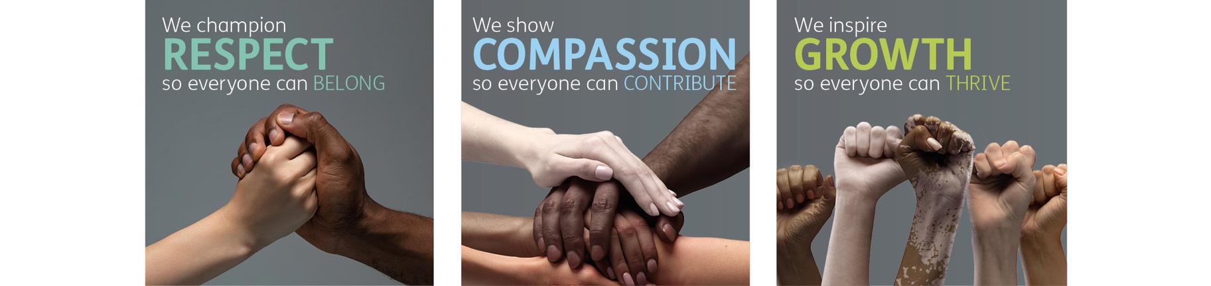
Role competencies, from One YMCA’s Competency Framework
RESPECT
- I treat everybody with dignity and respect.
- I follow the principles of EDIB in everything that I do.
- I do what is asked of me to the best of my ability.
- I work within my professional boundaries.
Compassion
- I support the needs of colleagues and service users.
- I approach challenging situations with empathy and care.
- I act with desire to make people’s lives better through my work.
- I know when to escalate difficult issues to my manager.
Growth:
- I make sure I understand the purpose of my role.
- I look for ways to improve my contribution and use my initiative.
- I solve problems when they occur or find solutions with my manager.
- I take responsibility for my development whilst listening to my manager’s advice.
- I keep up to date with new information and processes in my role.

Equality, Diversity, Inclusion & Belonging Statement
At One YMCA we are an inclusive organisation and actively promote equality of opportunity for all with the right mix of talent, skills, and potential. We do not discriminate on the basis of Age, Disability, Gender Reassignment, Marriage/Civil Partnership, Pregnancy/Maternity, Race, Religion/Belief, Sex and/or Sexual Orientation. We encourage applications from all backgrounds, communities, and industries, and are committed to having a team that is made up of diverse skills, experiences, and abilities.

