Job Title | Family Navigator
Department | Hertfordshire Family Support Service
Location | Watford or Stevenage Best Start Family Hub, with outreach across community venues
Reporting to | Community Engagement & Volunteering Lead
Responsibility for | N/A
Budgets | N/A
Grade | G5
Vetting | Enhanced DBS Disclosure required
Travel | Access to a vehicle for travel in the course of your work, along with suitable business insurance to cover work-related travel.

Main Purpose of Role
One YMCA delivers a wide range of services that support children, families and communities to thrive. Through Best Start Family Hubs, we work with families and partners to ensure support is accessible, joined-up and responsive to need.
As a Family Navigator, you will be a highly visible, trusted and accessible front-facing role within the Best Start Family Hub network, providing information, relationship-based navigation and coordination for families experiencing disadvantage, vulnerability or complexity. Acting as a single, consistent point of contact, you will support families to access the right help at the right time, build resilience, and remain engaged with services.
The role operates at a senior practitioner level, requiring strong professional autonomy, system knowledge and confidence in navigating health, safeguarding, early help and community systems. You will combine preventative, strengths-based engagement with the ability to work confidently with families whose needs span multiple services, in line with Best Start for Life and Healthy Babies 2026–2029 expectations.

Where your role fits in the team

Role-specific responsibilities
The key elements of the post are to:

Family Navigation and Relational Practice
- Act as a single, trusted and consistent point of contact for families, building non-judgemental, strengths-focused relationships.
- Work intensively with families experiencing multiple needs, supporting them to navigate complex systems.
- Use professional curiosity and judgement to identify need early, respond proportionately and prevent escalation wherever possible.
- Provide warm, supported handovers to services, including attending first appointments or introducing families directly to groups or professionals where appropriate.
- Follow up with families after handover to ensure support is accessed and remains effective.
- Promote parenting and home learning environment messages, effectively introducing families to appropriate programmes, in line with the Best Start in Life ambitions.

System Navigation and Safeguarding
- Support families to access services across:
- Health, maternity and Healthy Babies pathways
- Mental health and emotional wellbeing services
- Safeguarding, Early Help and family support
- Cost-of-living and wider community provision
- Act as a confident access and navigation point alongside statutory pathways, ensuring families are supported to engage appropriately.
- Identify, escalate and respond to safeguarding and risk concerns in line with organisational and statutory procedures.

Community Presence and Partnership Working
- Maintain a visible, approachable presence within Best Start Family Hubs and community settings including libraries, schools, early years settings and partner venues.
- Build and sustain strong relationships with early years settings, schools, health services, voluntary sector organisations, faith groups and community networks.
- Support families to connect into community provision that promotes resilience and reduces isolation.
- Work collaboratively with CE&V colleagues to ensure clear boundaries between individual navigation and community delivery.

Service Development and Learning
- Contribute to understanding local need by identifying gaps in provision, barriers to access and emerging trends, working closely with Locality Managers and CE&V Leads.
- Support co-production by valuing family voice and lived experience in shaping services.
- Maintain accurate, timely and reflective records, ensuring high-quality information sharing and data capture.
- Contribute to the achievement of internal and external key performance indicators, including engagement, access and equity measures.

General responsibilities
- This job description is not exhaustive and may evolve as services develop. The post holder is expected to work flexibly, including occasional early mornings, evenings or weekends, in response to family and service need. The role will be reviewed periodically with the post holder.

Person specification
The successful candidate will:

Key skills and Attributes
- Demonstrate strong commitment to relational, trauma-informed and strengths-based practice.
- Be confident working with families who may be mistrustful, disengaged or experiencing multiple pressures.
- Show high levels of professional autonomy, judgement and emotional intelligence.
- Communicate effectively with families and colleagues as well as external professionals, including managing complex and sensitive conversations.
- Work collaboratively across agencies, valuing different roles and perspectives.
- Be organised, adaptable and able to manage competing priorities.
- Use reflection, supervision and data to continuously improve practice.
- Be confident using IT systems, digital tools and Microsoft Office.

Knowledge and Experience
Applicants will have:
- Significant experience working directly with children and families in family support, early help, health, social care or community settings.
- Experience of navigating families across multiple services and systems.
- Sound knowledge of safeguarding legislation, procedures and multi-agency working.
- Experience of community engagement and partnership working.
- Understanding of Best Start Family Hubs and Best Start in Life principles (or commitment to develop this).

Qualifications or training required (or appropriate demonstrable experience)

- Level 4 or above recognised qualification in health, education, childcare, social care, youth or community work (or equivalent experience).
- Commitment to ongoing professional development.

- Access to a vehicle for travel in the course of your work, along with suitable business insurance to cover work-related travel. You must have a full Great Britain driving licence. If you have more than three points on your licence, please contact us to discuss before applying.

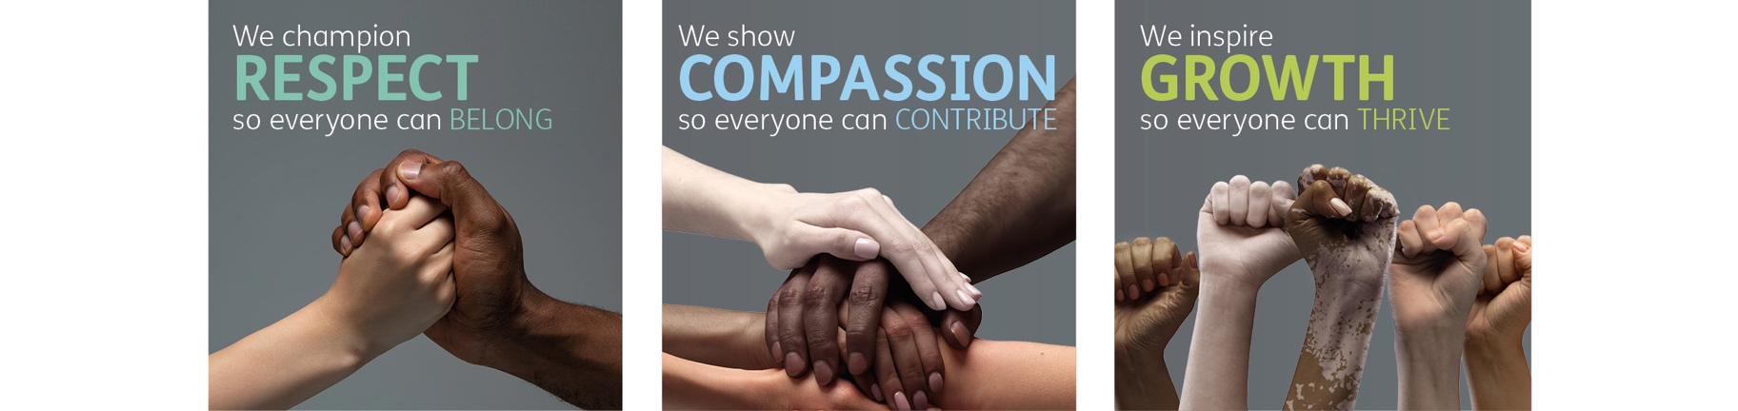
Role competencies, from One YMCA’s Competency Framework
RESPECT
- I treat everybody with dignity and respect.
- I follow the principles of EDIB in everything that I do.
- I do what is asked of me to the best of my ability.
- I work within my professional boundaries.
Compassion
- I support the needs of colleagues and service users.
- I approach challenging situations with empathy and care.
- I act with desire to make people’s lives better through my work.
- I know when to escalate difficult issues to my manager.
Growth:
- I make sure I understand the purpose of my role.
- I look for ways to improve my contribution and use my initiative.
- I solve problems when they occur or find solutions with my manager.
- I take responsibility for my development whilst listening to my manager’s advice.
- I keep up to date with new information and processes in my role.

Equality, Diversity, Inclusion & Belonging Statement
At One YMCA we are an inclusive organisation and actively promote equality of opportunity for all with the right mix of talent, skills, and potential. We do not discriminate on the basis of Age, Disability, Gender Reassignment, Marriage/Civil Partnership, Pregnancy/Maternity, Race, Religion/Belief, Sex and/or Sexual Orientation. We encourage applications from all backgrounds, communities, and industries, and are committed to having a team that is made up of diverse skills, experiences, and abilities.

