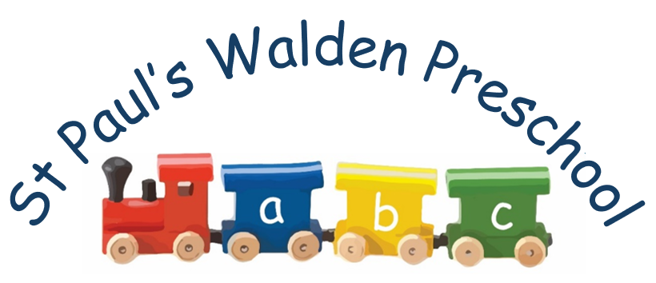

Preschool Apprentice
Job Description/ Roles and Responsibilities
Objective
To provide a high standard of physical, emotional, social and intellectual care for children within the setting and to work as part of a team in order to provide an enabling environment in which all individual children can play develop and learn, To provide support to the staff within the setting as well as ensuring that a strong partnership is built and maintained with parents to enable the children’s needs to be met.
Main Duties:
- To effectively deliver the EYFS ensuring that the individual needs and interest of children in the setting are
- To fulfil your Role as a key person (please refer to ‘the role as a key person’)
- To keep records of your key children’s development and learning journeys and share with parents, carers
- To complete work set outside preschool hours for apprenticeship. Being dedicated to completing your qualification whilst working.
- Support all staff and engage in a good staff team.
- To develop and maintain strong partnerships and communication with parents/carers to facilitate day-to-day caring and early learning needs.
- To ensure the provision of a high quality environment to meet the needs of individual children having an awareness of any disabilities, family cultures and medical histories.
- To advise manager/deputy of any concerns, e.g. over children, parents, the safety of the environment, preserving confidentiality as necessary.
- To be flexible within working practices of the setting, undertaking other responsible duties where needed, such as domestic tasks, preparation of snack meals, cleansing of equipment, etc.
- To read, understand and adhere to all policies and procedures relevant to your role and the safe running of the setting.
- To develop your role within the team, especially with regard to being a key person
- To keep completely confidential any information regarding the children, their families or other staff that is acquired as part of the job.
- To ensure good standards of safety, hygiene and cleanliness are maintained at all times.

