The Knights Templar School
Application Pack 2026

School Administrator

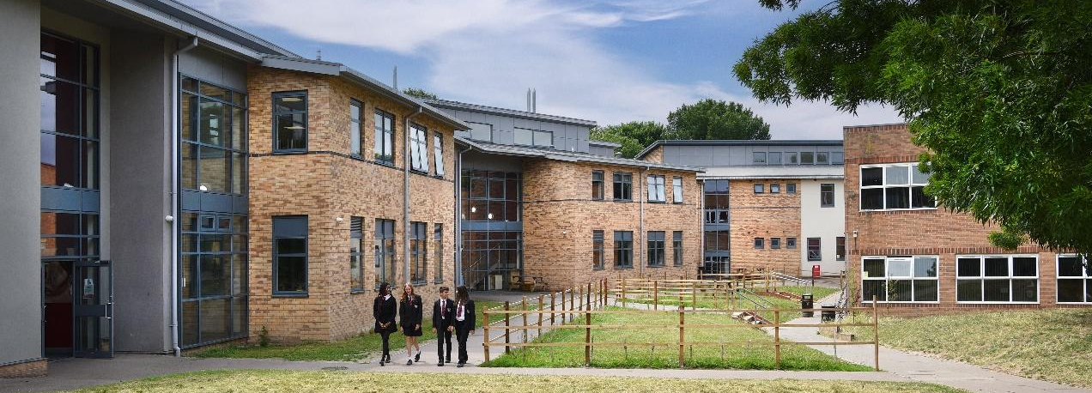
This is a vibrant and successful school at the heart of the community with high expectations and a reputation for academic excellence.
Central to everything we do is the school’s motto ‘Courage and Courtesy’. We recognise the importance of developing and providing all our students with the courage, confidence and communication skills they require to flourish and succeed, but also to promote traditional values of courtesy, respect and good discipline.



An Introduction to the School

‘Pupils are happy, feel safe and are safe. They are kind to one another. Pupils want to succeed, they work hard in lessons and enjoy their subjects, they learn and achieve well.’ (OFSTED 2023)

The Knights Templar School is both a successful and happy school. Students’ results are good and behaviour is excellent. The school is highly regarded locally, being regularly oversubscribed. We receive in the region of 600 applications for 210 Year 7 places each year.

Students of all abilities achieve well and make good progress. Young people have an excellent attitude to learning. They enjoy school and want to succeed. Outcomes at GCSE and A level are consistently good, results are above national and local averages, with over 70% of students achieve English and Maths at grade 4+, over 50% at 5+, with the school achieving consistently positive progress 8 scores.

The School has a large and strong sixth form, most progress on to university degree courses, including places at Russell group and Oxbridge.

‘Staff have good subject knowledge and are appropriately trained to deliver the curriculum effectively. ‘Staff have high expectations of pupils’ behaviour and manage behaviour well. As a result, the school is a calm and orderly environment. (OFSTED 2023)

The Knights Templar School offers a very broad range of opportunity beyond the classroom, with nearly 100 extra-curricular clubs running every week. There are a wide range of school sports teams in all years with traditional house matches and a sports day annually.

The House System is strong and senior students lead and run a number of house events every year. Some 250 students learn a musical instrument and there are many school concerts. Drama too is very strong with regular school productions.

‘Many pupils enjoy the activities available during the school day, at lunchtime and afterschool. Such opportunities are a strong feature of the school. (OFSTED 2023)’


The Duke of Edinburgh Award Scheme is particularly vibrant with 200 young people participating at Bronze, Silver or Gold level. We run a wide range of trips and visits both curriculum-based and of a wider educational nature. Staff are very generous with their time in supporting this wide range of activities.

Staff at Knights Templar “go the extra mile”. They give their time, effort and commitment to ensure high standards in the classroom and in the wider life of the school.

The school has high expectations of its staff as well as its pupils. We provide a disciplined, caring, fair and moral environment in which individuality is encouraged and equality of opportunity promoted, in order to allow students to develop personally and socially. There is a mutual respect and good relationships between students and also between staff and students, with the students being given responsibility and feeling valued whilst knowing that support and advice will always be available when needed. Pastoral care is a strength of the school; students learn to treat others with respect.

‘Pupils…say that the school values of ‘courage and courtesy’ are a part of their everyday school life.’ (OFSTED 2023)

The school’s name often provokes interest. The Knights Templar developed the town of Baldock in the Middle Ages. The school has been an all-ability mixed comprehensive school for over 40 years. In 2011, the school became an academy retaining its status as a community comprehensive school, serving the needs of Baldock and the surrounding villages that form our catchment area. Whilst some of the buildings are certainly showing their age, we have been proactive in the development of our school. We have an excellent modern Sports Centre with a floodlit all-weather pitch. A new purpose-built Sixth Form teaching block opened in 2016, this has been fully integrated together with our new Science and Arts and Design Centre.
We pride ourselves on giving our students a well-rounded education that prepares them for their future. We know students flourish if they lead rich and varied lives and are immensely proud of our exciting and wide-ranging curricular and extra-curricular provision. The school is open to children of all abilities and backgrounds and our outstanding pastoral care ensures that every student receives the nurturing, support and guidance they need. As a central part of our community, we are proud of our excellent relationships with primary schools, local residents, businesses and other organisations. These links provide students with a sense of cohesion within this community and enables them to be active citizens.
This is a great school, staffed with passionate, inspirational teachers, and is a special place for children to learn. If you would like to know more about the school or indeed if you would like to visit us during the day, please do not hesitate to contact us; we will be delighted to hear from you.



Sue Welch Edward Hutchings
Chair of Trustees Headteacher



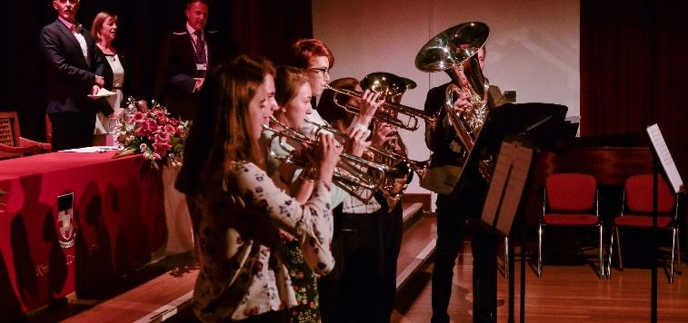
A ‘Great school’

A great school is;

- a school that knows its strengths and communicates these clearly, builds on them and holds fast to them.
- A school that questions its existing systems and constructively challenges what it does.
- A school that keeps it simple and that has clear coherent approaches that are consistently applied.

We are a reflective and self-confident school with teaching and learning at our core. We will continually strive for improvement and will always take opportunities to build the confidence of our students and to provide genuine leadership opportunities.

Induction and Teaching and Learning

Purposeful learning is at the heart of everything we do. Our dedicated and hardworking teaching staff ensure that students are engaged, challenged and able to succeed within a culture that values both tradition and innovation. We encourage a range of approaches to teaching that ensures that students have a rich and varied learning experience.

It is important that teachers have time to reflect, share ideas and develop their own practice. We have a structured programme of Continued Professional Development which provides opportunities for colleagues to work collaboratively and reflect upon the impact of research-based strategies on their own teaching. This is supplemented by external courses and trainers. We are committed to reflective, considered practice and to embed new innovative practice.

The school became an academy in April 2011. The trustees work to ensure that teachers’ pay and conditions are in line with national standards. Induction, training and continuing professional development have a very high priority in the school. All staff have an induction programme on joining the school.

Safeguarding

Safeguarding at The Knights Templar School takes precedence over any other activity. It’s vitally important to us that students feel safe in school so they can learn and thrive. As part of the recruitment process, we will ask about safeguarding students and obviously questions about candidates’ suitability to act as tutor. References will be sought and an enhanced criminal records check will be undertaken for this position.

Staff

The Knights Templar School currently employs 98 teaching staff and 72 support staff, many of whom have positively contributed to the school for a number of years. Many of the staff have children who are currently at the school or have passed through our school system. There are also members of staff who are past students.

Community

The Priority Area for the School consists of Baldock and surrounding villages. We are fortunate to have good relationships with the primary schools in the area with teachers and students from The Knights Templar School regularly running events for our primary partners. Our primary schools will often visit for a variety of activities in PE, music, drama, dance, maths and science to name but a few.

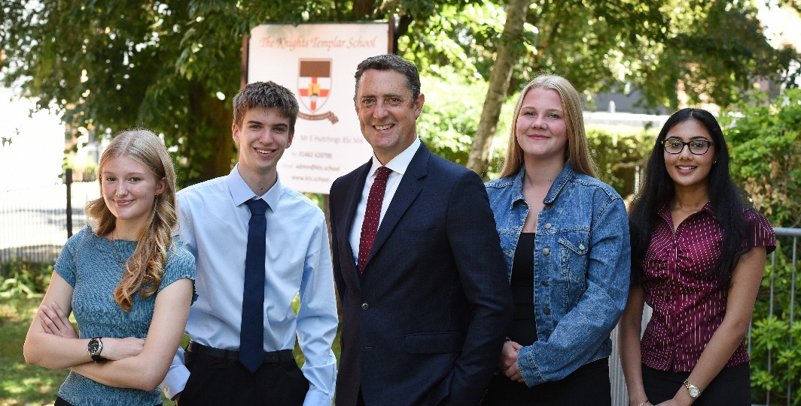

School Administrator - Job Description

TITLE OF JOB: SCHOOL ADMINISTRATOR
LOCATION: STUDENT SERVICES/SIXTH FORM
GRADE : H3
HOURS : up to 37 hours/week, term time only (flexible hours may be possible)

1. JOB OUTLINE

1 a) REASON JOB EXISTS

To provide attendance, admin and pastoral support to the sixth form.

1 b) MAIN AREAS OF WORK
- Working together with our whole school attendance team
- Management of Year 12 and 13 school and lesson attendance
- Contacting parents to check/query student absence
- Dealing with student attendance enquiries
- Dealing with telephone enquiries about attendance
- Responding to requests from parents about authorised and unauthorised time off school
- Accurate maintenance of student records on SIMS: Updating, interrogating and retrieving information as required.
- Supervision of sixth form private study room
- Supporting specific students in maintaining their attendance, through pastoral support and liaising with the sixth form team and form tutors
- Supporting students with organisation and pastoral matters with the support of the sixth form team and form tutors.
- Data input, including maintenance of student records relating to attendance
- Regular meeting with Head of Sixth Form and Year Leaders to discuss attendance
- Liaise with sixth form tutors
- Producing behaviour and achievement reports for both year groups for the week and sending to Head/Deputy Head of Sixth Form, and individual reports to Form Tutors for follow up action
- Producing behaviour and achievement reports for the year-to-date for Head/Deputy Head of Sixth Form
- Supporting in student services as required.

1 c) EQUALITIES

Be aware of and support difference and ensure that the school’s equalities and diversity policies are followed.

1 d) HEALTH AND SAFETY

Be aware of and comply with policies and procedures relating to child protection; health and safety; confidentiality; and data protection and report all concerns to an appropriate person.

1 e) CRIMINAL RECORDS BUREAU

This post is classified as having a high degree of contact with children or vulnerable adults and is exempt from the Rehabilitation of Offenders Act 1974. An enhanced disclosure will be sought through the Criminal Records Bureau as part of Hertfordshire County Council’s pre-employment checks. Please note that additional information referring to the Criminal Records Bureau is in the guidance notes to the application form. If you are invited to an interview you will receive more information.

1 f) ADDITIONAL INFORMATION

The postholder is required to contribute to and support the overall aims and ethos of the school. All staff are required to participate in training and other learning activities, and in performance management and development as required by the schools’ policies and practices.

** The duties and responsibilities listed above describe the post as it is at present. The post holder is expected to accept any reasonable alterations that may from time to time be necessary.

2. SUPERVISION

The job holder is managed by the Line Manager.

3. JOB CONTEXT

The job holder is one of a team of administrative staff who provide support services to the school. The work is varied and has daily, monthly and termly routines. The role would be based in an office in the sixth form area and the post-holder would work with the sixth form team.

4. CONTACTS

All members of staff, particularly teachers and students of sixth form.

5. KNOWLEDGE, EXPERIENCE AND TRAINING

- Experience in the use of ICT and specialist equipment, preferably in a learning environment.
- Evidence of accredited learning relevant to the post
- Ability to negotiate with professional staff to ensure that conflicting demands can be met.
- Understanding of the needs of teachers and students.

How to apply

Please apply via the TES advert.

Please note that an online search may be carried out as part of the due diligence on shortlisted candidates.
Further notes for applicants

Visits
If you wish to visit the school, you will be made welcome, though this is not a requirement at this stage. Please telephone to make an appointment; your chances of getting the post will not be affected by whether or not you make such a visit. Those invited for interview will, of course, be given plenty of chance to see the school.

Moving house
If you would need to move nearer, consider investigating property prices before deciding whether to apply: information is readily available via the web. The school may be able to support with advice and information regarding relocation. You might also be interested to look at the website of North Hertfordshire District Council (www.north-herts.gov.uk).

The Knights Templar
The school is named to commemorate the connection between Baldock and this ancient Order, which founded the town in the twelfth century. Readers of The DaVinci Code and similar works may be disappointed to find that we have no other connection with Templar organisations!




