Richard Hale School

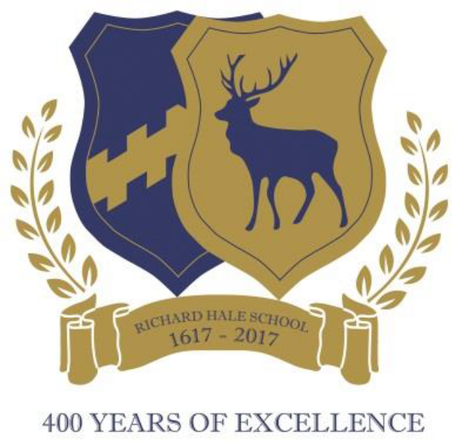

Application Pack

Teaching Assistant

June 2018

Richard Hale School
Teaching Assistant
Start date: 1st September 2018

Thank you for your interest in the post of Teaching Assistant. The application pack consists of an application form and the following information contained in this document:

- Copy of the advertisement
- Information about the School
- Job Description

Please note:

- Closing date: noon on Friday 22nd June 2018. Please note we reserve the right to close this vacancy early should sufficient applications be received so early application is essential.

- Electronic version of the application form
The application form is attached for completion and guidance notes are provided to assist you.

- References
Please ensure that you provide email addresses for all your referees as we may request references by email. A mobile number for them would also be useful. Referees are likely to be contacted after shortlisting, but before the interview stage.

- If you have any queries regarding this post
For general enquiries about the recruitment process, please contact Mrs Karen Dart, PA to the Headteacher, on 01992 583441 (karen.dart@richardhale.co.uk).

- How to apply and where to send your completed form
Please complete the application form and return it to the school as soon as possible, together with a letter of application, on no more than two sides of A4, which outlines the skills and abilities you could bring to the post. Please forward these by email to Karen Dart at karen.dart@richardhale.co.uk. Please accept our apologies as we may not be able to notify all candidates of the outcome of their application.

We look forward to reading your application, and thank you for your interest in our School.

Richard Hale School

Teaching Assistant
Required for September 2018

We are looking to appoint a motivated, enthusiastic and committed person to join our Student Support Centre. The successful candidate will have experience as a Teaching Assistant or experience of working with children with special educational needs and will support students in a full range of subjects. The position will be for 30 hours per week, 8.30am – 3.30pm Monday to Friday, term time plus one week. The salary will be dependent upon experience but will be paid between point H3 and H4 on the Hay Scale (hourly rate of pay in the range £9.16 - £10.27 excluding fringe allowance). The position will be for 12 months initially but may be extended according to SEND need. Hours may be negotiable for the right candidate.

Richard Hale is a very successful, oversubscribed, 11-18 boys’ school with an expanding co-educational Sixth Form located in the centre of the county town of Hertford. The School has an impressive reputation for achievement both academically and in a wide range of extra-curricular activities.

The school is committed to safeguarding children and young people. All postholders are subject to a satisfactory enhanced DBS (Disclosure & Barring Service).

The Application Pack together with the application form can be downloaded from the School’s website or you may contact Mrs Dart by email, karen.dart@richardhale.co.uk. The application form, together with a personal statement, on no more than two sides of A4, outlining the skills and abilities you could bring to the post, should be emailed to Karen Dart by noon on Friday 22nd June 2018. Please note we reserve the right to close this vacancy early should sufficient applications be received so early application is essential.

Richard Hale School
Information about the School

Richard Hale School, called after its original wealthy benefactor, has stood on its present site since 1930. It was founded as Hertford Grammar School in 1617 on a site behind All Saints’ Church nearer the town centre, and changed its name in 1974 when it became a comprehensive school. A door from the original school can be seen in the main foyer when you enter the school giving that sense of history that we are very proud of.

Richard Hale is an 11 - 18 year old boys’ comprehensive school with a six-form entry in Year 7. We are heavily oversubscribed and in the last two years have increased the number of students in Years 7 and 8 to 180.

Year 7 students are drawn from approximately 50 primary schools with admissions based on the post coding of traditional parishes. The intake comes from a large area of East Hertfordshire, particularly Hertford, Ware and the surrounding villages. The Sixth Form has continued to grow since becoming co-educational in 2005. It is now one of the largest in the area, with 285 students, and attracts boys and girls from further afield than the immediate locality.

As a comprehensive school we take students of all abilities, however the ability of the students on entry is higher than the national average. The number of students that we have from disadvantaged backgrounds or who have SEND are also significantly lower than the national average.

The school’s buildings have been improved extensively over the years. Recent additions include a Sixth Form Centre with tutorial rooms and a large common room, complete refurbishment of all Science laboratories, and a major programme of roof and window replacements. We have recently been given planning permission to build a sports hall. During 2017 a 3G all-weather football pitch was added to provide improved sport facilities for the students. We play our Rugby games at Hertford Rugby Club, this provides a real experience for the students playing in front of a good crowd and under floodlight during the winter evenings. We run a complete set of Saturday morning fixtures.

Underpinning all the work done within the school is a steadfast commitment to develop our students into thoughtful, disciplined, considerate and well behaved adults who are able to make a positive contribution to the community and wider world.

In the last Ofsted inspection report (2016), inspectors said: The school is a friendly and mutually supportive community where morale is high and pupils are well developed as all-round individuals. Your school is founded on strong and traditional values which underpin everything you do.

The School curriculum and extra-curricular activities

Our curriculum is traditional in principle, but also provides innovation where possible. Some key characteristics:

- We teach KS4 over three years so we can develop skills and enrich the students’ learning experience alongside the increased content the new qualifications require.
- All students take triple science and a large number take a modern foreign language at GCSE.
- Our Design and Technology provision includes engineering, we have a garage on site allowing the students to achieve an IMI motor engineering qualification, this is alongside the other D&T disciplines.
- We offer a broad and balanced curriculum which provides a range of opportunities for our students catering for all interests and aspirations.
- Students in the Sixth Form have access to two learning pathways, academic or vocational. The Advanced Level offer is extensive with 21 subjects taught on site, expanding to over 30 through the local Federation of secondary schools. BTEC Science and Sport provide students with a more focused vocational curriculum.

At KS5 we teach a linear syllabus with students sitting examinations at the end of the two year course. Our destination data is strong with all our students achieving offers for university, many of these from the Russell Group, or successful entry into apprenticeships or employment.

Our aim is to create a learning environment in which all students can develop their learning, intellectual and personal abilities, both inside and outside the classroom. To this end we provide an extensive extra-curricular programme, with the school excelling in sport, music, drama, science and engineering competitions. Our Duke of Edinburgh’s Award programme continues to expand with some 300 students taking bronze or gold awards. The School’s ethos is one of encouraging the participation of students in the wider school community through a diverse range of opportunities at all levels.

Much of the school activity is centred on the House system. Each pupil is allocated to one of the six houses (Cowper, Croft, Hale, Kinman, Page, Wallace) and throughout their school lives enjoy and compete in many activities, mainly organised by themselves and supported by the Heads of House. These range from sport, music and drama competitions to chess and other types of activity.

We work closely with a number of our primary schools. This ranges from some outreach work in music and other subjects as well as working with our primary schools to support transition arrangements for our Year 7 students.

Further information on the school and its history and achievements can be found on our website at www.richardhale.herts.sch.uk.

Richard Hale School
Student Support Centre

Richard Hale School is inclusive and aims to promote equality of opportunity, excellence and the development of individual potential. We believe that all our students are of equal value and share the same educational rights - irrespective of race, gender, sexuality or disability – and are given the same opportunities to progress and fulfil their potential. The School recognises the whole person and the gifts they may possess.

All students are entitled to, and should have the opportunity to, develop a wide range of learning and life skills. We believe that this entitlement should be delivered through a balanced and broad curriculum. We hope that all our students will develop the knowledge, skills and critical reasoning to function autonomously throughout life.

The Student Support Centre is led by Ms Hocking, Head of the Student Support Centre & SENDCo, and Jane Michelson, Family Support Worker. The school has a team of Teaching Assistants with training and experience of supporting students with a variety of needs such as Social, Emotional Mental Health, Autism, Speech, Language and Communication Difficulties and Literacy Difficulties.

Richard Hale School
Job Description: Teaching Assistant

Job Purpose
To support the inclusion and progress of students with Special Educational Needs and Disabilities.

Main purpose of the post:
To work under the guidance and direction of the Head of Inclusion and within an agreed system of supervision, to implement agreed work programmes/intervention strategies in the classroom and assist the class teacher in evaluating their impact. This will also involve assisting the teacher in planning, and the management/preparation of resources. The TA will work with and receive instructions from the Head of Inclusion, Teachers, and other professionals.

Main Duties:
In relation to the students:
- Establish positive and productive working relationships with students and actively promote the inclusion of all students.
- To develop an understanding of the special needs of the student/s concerned and where necessary refer any concerns to line manager.
- To encourage the inclusion of the student/s within the class taking into account the students special needs and ensure their access to the lesson and its content through appropriate clarification, explanations, equipment and materials.
- Assist students in their work according to need, keeping them on task, developing an understanding of self-esteem, independence, and other strategies for learning.
- To develop study and organisational skills.
- To support the behavioural and emotional needs of students, in line with classroom and school policies.
- To support primary transition and Year 7 forms for the first two terms of Year 7.
- To scribe and invigilate for external examinations, under the direction of the Examinations Officer through the Head of Inclusion.

In relation to outside agencies and other professionals, including Annual Reviews:
- To provide written reports for Annual Reviews and meetings, as required.
- To complete daily Record of Work sheets to support the tracking of students and identify areas for additional support.

In relation to the teachers:
- To support the teacher in the development and the presentation of the students individual programme.
- To have clear lines of communication with the students teacher.
- To have formal meetings with teachers to enable planning and preparation for lessons, where time permits.
- Where appropriate, to act as liaison between students and the teacher.
- Involvement in keeping records and evaluation of students programmes.
In relation to the school:
- Report to Student Support Centre each morning, as directed – in case of any changes to timetables or staffing.
- To work as part of the team in relation to individual students, liaising, advising and consulting where appropriate.
- To be aware of school policies and procedures, including those relating to confidentiality.
- To identify personal in-service needs and to attend appropriate internal and external in-service training.
- Any other tasks as directed by the Headmaster which fall within the purview of the post.

Supervision
- Direction from Head of Inclusion and within an agreed system of supervision. This will also involve
  - Assisting the teacher in planning, and the management/preparation of resources
  - Work with and receive instructions from the Head of Inclusion, Teachers, and other professionals.

Contacts
Maintain positive relationships with:
- Staff
- Pupils
- Visitors

Knowledge and Experience
- Sound knowledge of curriculum in order to benefit pupil grades
- Sound knowledge of ICT

Problems and Decisions
- Dealing with a number of queries simultaneously

We reserve the right to review and change the job description, in consultation with the postholder, dependent on the changing circumstances of the school.

Responsible To: | Head of Student Support Centre

This job description is not necessarily a comprehensive description of the duties required but outlines the main responsibilities of the post. It will be reviewed annually and can be added to at the discretion of the Headteacher.

An enhanced DBS check will be required for this post.

The job description is current at the date shown, but, in consultation with the post holder, may be changed by the Headteacher to reflect or anticipate changes in the job commensurate with the grade and job title. The successful candidate must have a commitment to safeguarding and promoting the welfare of children and young people.

