WOOLGROVE SCHOOL
Special Needs Academy
Pryor Way, Letchworth, Herts, SG6 2PT
Tel: 01462 622422 Fax: 01462 622022
email: admin@woolgrove.herts.sch.uk
Web:www.woolgrove.herts.sch.uk
Headteacher
Mrs Lisa Hall






March 2019

Dear Applicant,

Thank you for taking the time to review our advert on the Teach in Herts Website. If you have an interest in working with special needs children and feel after reading about our lovely school it is somewhere you would like to work, we very much hope that you will consider applying.

May we ask that you take the time to read the Job Description, Job Specification and attached policies.

As the advert states it is also very important that your application contains no gaps in your life history. Please can we ask that all dates follow on to enable us to ensure the safety of our pupils, gaps can cause delays and potentially result in applications not being taken further.

Thank you for your assistance and we look forward to receiving your application and potentially meeting you in the near future, should you decide to proceed.

Yours faithfully,

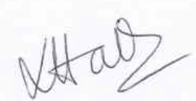

Lisa Hall
Headteacher

