At The Valley School, We Talk A Lot About “Different 4 Different”
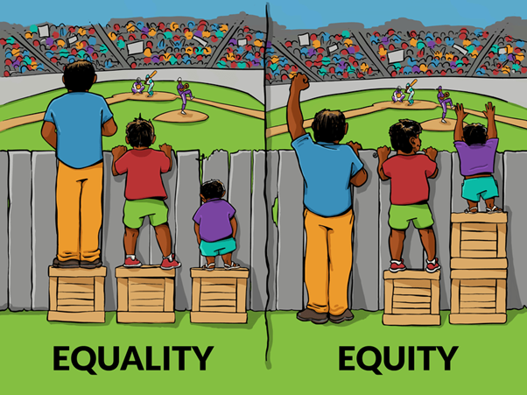

- It doesn’t mean we have different standards of what is acceptable.
- It doesn’t mean that we put up with things because our pupils have Special Needs.
- It doesn’t mean that we have different rules for all of our pupils.
It does mean that, in our commitment to ensure that our pupils leave us as effective learners, who manage their language and behaviour in a way that means that they can be influential members of the community, who can be part of positive relationships, who can hold down a job and be independent, we recognise that the route to success is different for each pupil and that the amount of support and creativity needed is unique.
If everything else is going well, we might well focus on the fact that a pupil is not wearing the right uniform. But for another, their uniform is possibly the smallest of the barriers we are trying to overcome and we may choose to ignore it whilst concentrating on a more urgently presenting barrier.
For one pupil, just “the look” may be all that is needed to change a behaviour, whilst for another we know that ignoring the behaviour at the time will be more effective.
Our B4L policy is built upon the principle that we do the least possible to bring about the desired outcome, but the least possible may have to be quite serious if other interventions have not achieved the desired outcome.
For many of our pupils, what we have in our general provision is inventive and creative enough to allow them to be making progress. However, for some, we may need the additional interventions offered in the Sensory Room or The Hub. Some may even need the very expensive route of alternative provision at a different setting.
As Senior Leaders and Learning Leaders, there will always be a small group of pupils who take a large proportion of our time.
No lack of progress or inappropriate language or behaviour should ever be left unchallenged, but the response needs to be in line with a commitment to make things better, so timing may need to be considered, as may time, place and audience.
None of us should be harmed in our role, either physically or emotionally, but in order to stop our pupils causing harm, the answer may take a long time and there may only be tiny steps of progress along the way.
“Different 4 Different” works because we have incredible knowledge of our pupils. In addition, the quality of our relationships with each other and with our pupils is second to none and is the root of all our successes.
You only have to look at our year 11 pupils and remember the journey they have been on to know that it works – but it does only work “over time” and, in some cases, “over a very long and bumpy time”.

