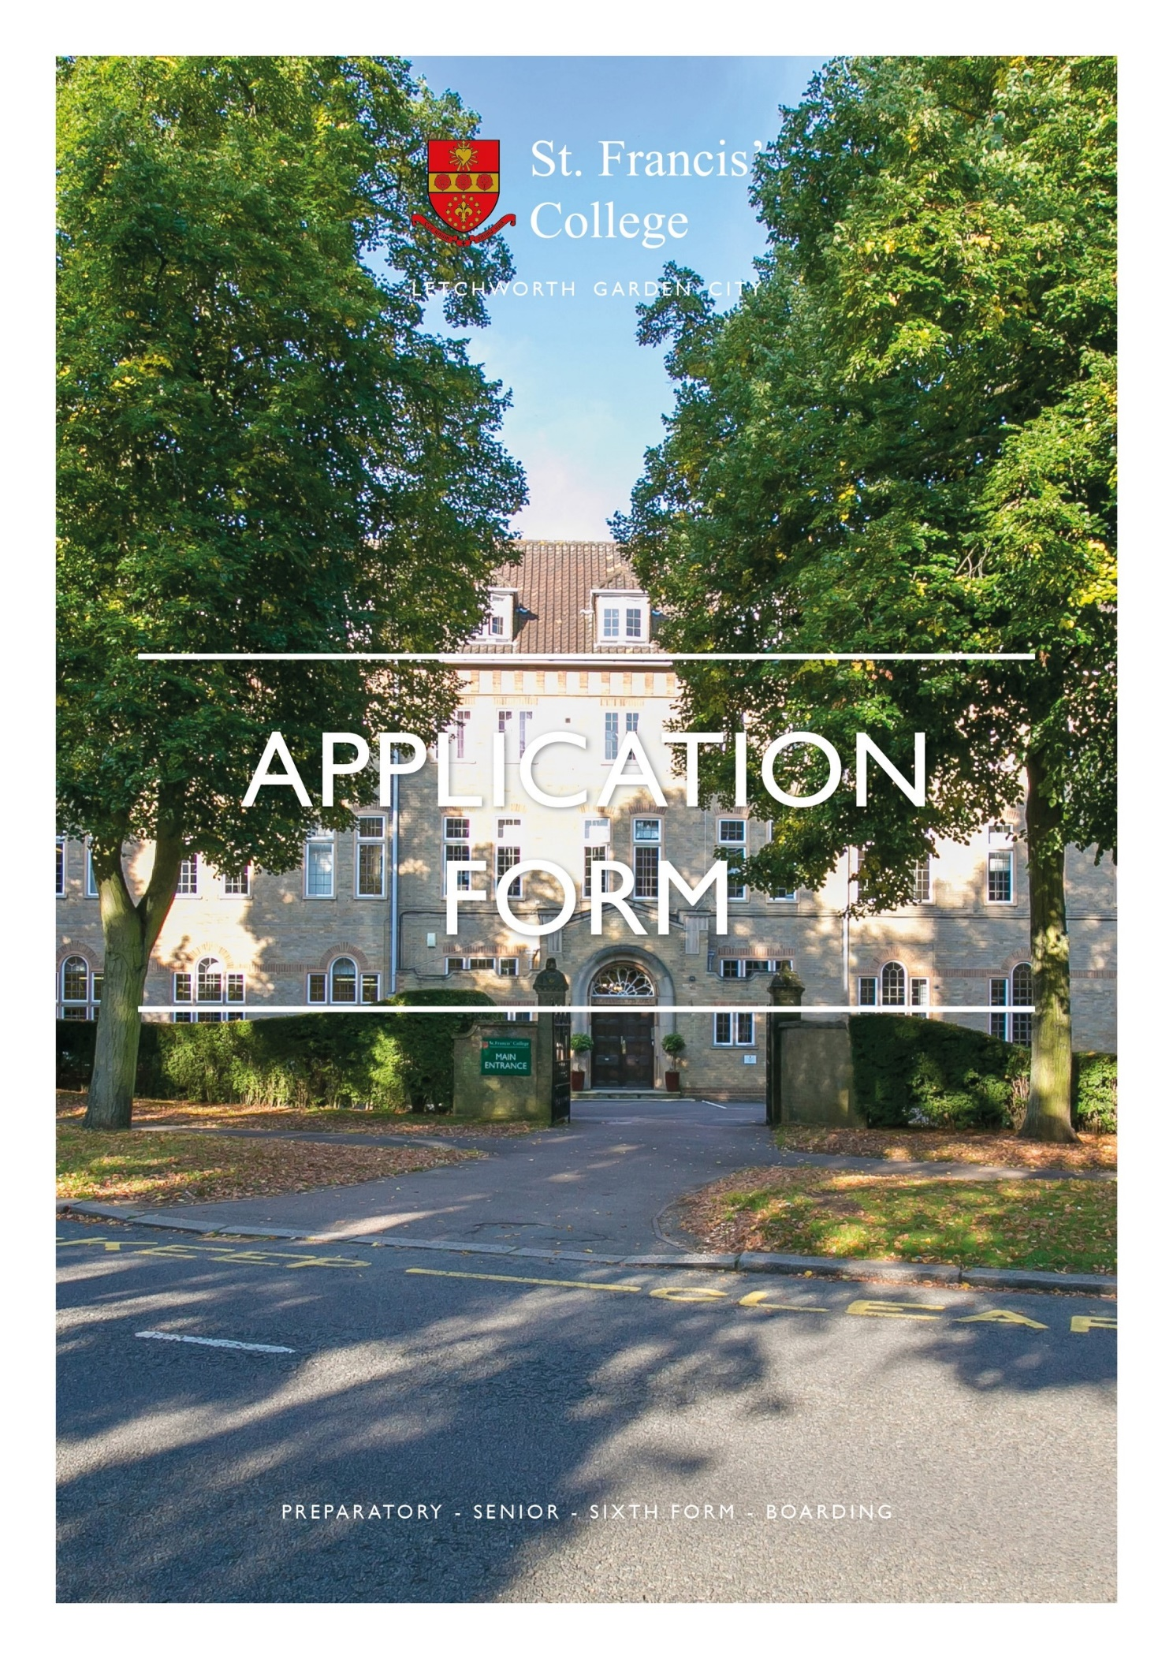

This application will be used to make an initial determination of your eligibility for this post. CVs are NOT accepted in place of this application form.

St. Francis’ College is committed to safeguarding and promoting the welfare of children and expects all staff and volunteers to share this commitment. Applicants must be willing to undergo Child Protection screening.

POST APPLIED FOR:

PERSONAL DETAILS
Surname: |  |  |  | Title:
Forename(s): |  |  |  | Previous Surname(s):
Home Address:  Post Code: |  |  |  | Telephone (Mobile):  Telephone (Home):  Email Address:
Do you have the right to take up employment in the UK and if necessary, a valid Work Permit? |  |  | Yes/No | Where did you see this vacancy advertised?
EDUCATION AND QUALIFICATIONS
Secondary education or study:
Dates Attended: |  | Establishment |  | Qualifications gained  (level/grade/date achieved)
From | To
Graduate/Postgraduate education, study or any other relevant professional qualification(s):
Dates Attended: |  | Establishment |  | Qualifications gained  (level/grade/date achieved)
From | To

CURRENT/MOST RECENT EMPLOYMENT
Job Title: |  |  |  |  |  | Name and Address of Employer
From  Month/Year |  | To  Month/Year |  | Final Salary | Reason for Leaving
Brief description of main duties and responsibilities
PREVIOUS EMPLOYMENT
Please give details of all previous employment since leaving full time education, with dates to the nearest month, beginning with your most recent. You should include all periods, including periods when not in paid employment.
All gaps in employment MUST be accounted for.
Job Title: |  |  |  |  |  | Name and Address of Employer
From  Month/Year |  | To  Month/Year |  | Final Salary | Reason for Leaving
Brief description of main duties and responsibilities
Job Title: |  |  |  |  |  | Name and Address of Employer
From  Month/Year |  | To  Month/Year |  | Final Salary | Reason for Leaving
Brief description of main duties and responsibilities
Job Title: |  |  |  |  |  | Name and Address of Employer
From  Month/Year |  | To  Month/Year |  | Final Salary | Reason for Leaving
Brief description of main duties and responsibilities

OTHER INFORMATION
If you have a disability, please give details of any special arrangements you would require to attend interview (this information will not be considered when short-listing):
What period of notice are you required to give to your current employer?
Do you hold a full driving licence (if relevant to the post you are applying for)?  If yes, do you have any current endorsements? Give further details: | YES/NO  YES/NO
Have you made a previous application to St Francis’ College?  If yes, give details of the post, date and outcome: | YES/NO
If offered this position do you intend working elsewhere in any other capacity?  If yes, give details: | YES/NO
Do you know any employee(s) or Governor(s) of the College?  If yes, give details: | YES/NO
DFES Teacher Reference Number (Teaching posts only):
Please use the space below to provide any other information that may assist your application. For example, give details of any other training, qualifications, interests, skills or experience relevant to the post you are applying for.

REFERENCES
Please note that if short-listed, references will be taken up prior to interview.
Please give details of three referees, one of whom should be your current or most recent employer.
References from relatives or friends are not accepted.

If you are known to the referees by a different name, please inform them of your present name and advise that they may be contacted.

Referee 1 (current or most recent employer):
Title | First Name: | Last Name:
Organisation Address:
Telephone Contact Number: Email:
In what capacity do you know this person?
Referee 2:
Title: | First Name: | Last Name:
Organisation Address:
Telephone Contact Number: Email:
In what capacity do you know this person?
Referee 3:
Title: | First Name: | Last Name:
Organisation Address:
Telephone Contact Number: Email:
In what capacity do you know this person?

Declaration
I declare that the information I have given on this form is, to the best of my knowledge, true and complete. I understand that if it is subsequently discovered that any statement is false or misleading, or that I have withheld relevant information, my application may be disqualified or, if I have already been appointed, I may be dismissed. I hereby give my consent to the College processing the data supplied on this application form for the purpose of recruitment and selection.

Signature:________________________________________ Date:______________________

If completing this form electronically, please enter your name. If your application is short-listed, you will be asked to sign your application when you attend for interview

EQUAL OPPORTUNITIES MONITORING FORM
This form is separate from the main application form and reflects the College policy to encourage inclusion and diversity in recruitment. Your answers will be treated in the strictest confidence and the information you provide will only be used for monitoring purposes. ONCE COMPLETED, PLEASE RETURN THIS FORM TO: recruitment@st-francis.herts.sch.uk
Post Applied For ………………………………………………….…  Surname: …………………………………….….  Forename(s): ……….…………………………..  Gender:  ☐ Female  ☐ Male  Which age group do you apply to:  ☐ Under 20  ☐ 21 - 29  ☐ 30 - 39  ☐ 40 - 49  ☐ 50 - 59  ☐ 60 and over  Sexual Orientation: ……………………………..  ☐ Prefer not to say | Do you consider yourself as having a disability? Yes No  If you have a disability what equipment, adaptations or adjustments to working conditions would assist you in carrying out your duties?  ……………………………………………………………  ……………………………………………………………  ……………………………………………………………  ……………………………………………………………  ……………………………………………………………  ……………………………………………………………  ……………………………………………………………  ……………………………………………………………
Which of the following best describes your Ethnic origin?  White:  ☐ British  Black or Black British:  ☐ Caribbean  ☐ African  Other Black background: ………………………  Chinese or other Ethnic group:  ☐ Chinese  ☐ Any other Ethnic group: ……………… | Mixed:  ☐ White & Black Caribbean  ☐ White and Black African  ☐ White & Asian  Other mixed group: ……………………………  Asian or Asian British  ☐ Indian  ☐ Pakistani  ☐ Bangladeshi  Other Asian: …………………….....………..….

