Dear prospective candidate,
Katherine Warington School is a comprehensive, co-educational and non-denominational academic secondary school. It opened in September 2019 and currently comprises over 900 students in oversubscribed year groups, with 210 in Year 8 and 180 in each of Years 7, 9, 10 and 11. We look forward to welcoming our first cohort of Year 12 students on opening our Sixth Form in September 2024 - and by 2025, we will have grown to our capacity of 1,180 students.
The school was established through the partnership of the Harpenden Secondary Schools Trust. This includes the three existing outstanding schools in Harpenden (Roundwood Park, St George's and Sir John Lawes) together with additional partners: the University of Hertfordshire and Rothamsted Research Centre (a world leading non-profit agricultural science research centre).
Further details about the school, including our prospectus and virtual tour, can be found on our website: www.kwschool.co.uk
We seek to employ the most able, dynamic and enthusiastic staff in our school. An ability to multi-task is essential and a positive, 'can do' attitude is equally important. In return, we can offer an excellent opportunity to develop your career as the school grows.
Our school is multi-ethnic and we understand the value of having a workforce that reflects and represents our student body from an equality, diversity and inclusivity perspective. We therefore welcome and embrace applications from all backgrounds.
I am very excited about the opportunities our school presents, for both our students and staff and look forward to hearing about what you can bring to our school.
Yours sincerely
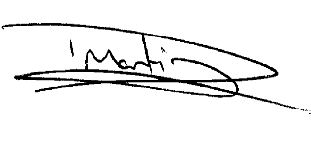
David Martin
Acting Headteacher

