Presdales School

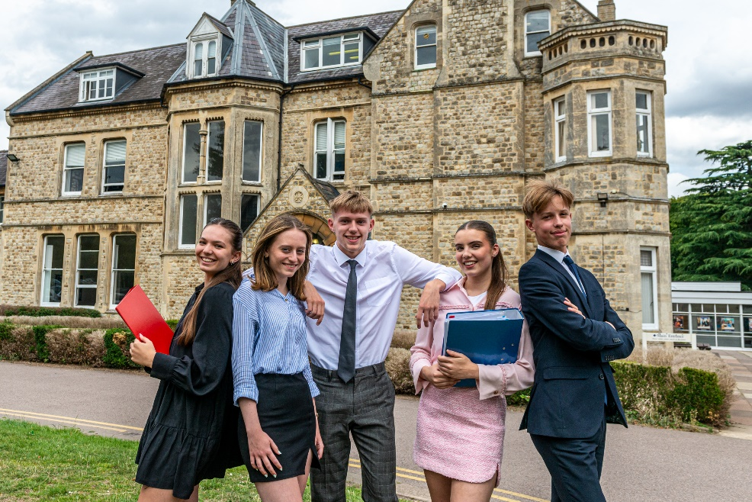

Candidate Information Pack

Teacher of Sociology

Part-time
Maternity Cover

Presdales School – Teacher of Sociology (part-time maternity cover)

‘Pupils thrive at Presdales’ Ofsted March 2024

Thank you for your interest in joining our team of outstanding staff. Please find enclosed in this pack general information about the school and specific information about the post.

Presdales School is a single sex comprehensive school in Ware for girls aged 11-18, with boys welcomed in the Sixth Form. We have a long tradition of providing an outstanding education for our students. Formerly Ware Grammar School for Girls, which opened in 1906, we became Presdales School in the mid-1960s, and a fully comprehensive school in the early 1970s. The mansion house, which fronts the school, and our stunning grounds provide a calm and relaxed atmosphere for our school community.

We are very proud of the high academic standards that our students achieve, regardless of their starting point. Our motto, ‘Achievement for All’, runs through all that we do. We understand that every student is an individual, with different interests, strengths and characteristics, and we celebrate the diversity that each one of them brings to our community. We believe that all students, with the appropriate balance of support and challenge, can be successful.

We aim to develop their creativity and independence inside and outside of classroom lessons. There is an extensive range of extra-curricular clubs and activities, including numerous trips throughout the school year, which provide students with the opportunity to develop their leadership skills, to be part of a team and to develop a ‘can-do’ attitude.

Our vision and values are instilled in our students throughout their time with us, whether this be through our House system, the excellent pastoral care they will receive or the culture of achievement for all that we foster in our community. We want our students to be happy and confident young women who are ready to make a meaningful contribution to our global society.

We are now in Year 3 of our BYOD rollout in school, with our current Year 7, 8 and 9 students using chrome books and our Sixth form using their own devices. Other year groups will be rolled out over the new few years.

We are committed to developing our staff from within. We jointly run, with Richard Hale School, an Aspiring Middle Leaders course, an Aspiring Pastoral Leaders Course and an Aspiring Senior Leaders course. CPD can be through external providers, in-school working groups or individual projects as identified by teachers. We are keen that all staff continue to develop their skills and knowledge, and that they have the opportunity to deepen their subject knowledge or progress their careers into middle and senior leadership.

We are seeking an enthusiastic teacher of Sociology to deliver both GCSE and A level in a very successful and growing department. Sociology is a popular subject at KS4 and has a high number of students at KS5, with many going on to study Sociology and related courses at university. We are looking for the successful candidate to have had previous experience of teaching Sociology and to have a passion and commitment to help promote and develop the subject within the school.

Over the past year we have been working with staff to ensure that all staff have an appropriate work/life balance. Initiatives include: Free Yoga after school on Friday, free flu jabs, continual programme of replacing staff laptops/chrome books, allowing personal deliveries to school, staff can leave at 2.30pm if they are not teaching or needed in a meeting, an extra occasional day off per year for all staff. We believe that staff work more effectively when they have a manageable workload.

I do understand and appreciate the time and effort it can take to complete an application for a job such as this; thank you for considering Presdales School.

Matthew Warren
Headteacher
Presdales School
Teacher of Sociology

Part-time / Maternity Cover
Start date: September 2024
MPS/UPS

We are looking to appoint an energetic and inspiring part-time Teacher of Sociology

Presdales School is a single sex comprehensive school in Ware for girls aged 11-18, with boys welcomed in to the Sixth Form. We are a school which values all students, irrespective of their age and ability and helps them to exceed expectations through high quality teaching and learning and the opportunity to take part in a wide variety of activities which will enrich their educational and personal development beyond the classroom.

We provide a caring environment where all students are supported, as well as challenged, to ensure that there is no limit to their potential. We prepare our students for a world that is constantly changing by encouraging them to be independent learners who are determined, confident and who never give up. Alongside academic excellence there is a strong focus on enjoyment, excellent behaviour and respect for all.

The school is committed to safeguarding and promoting the welfare of young people and expect staff to share this commitment. All posts are subject to a safer recruitment process which includes enhanced criminal records and barring checks, scrutiny of employment history, referencing and other vetting checks, including online searches.

Closing date for applications: 9.00am, Tuesday 7 May 2024
(we reserve the right to close applications before this date, so early applications are advisable)
We expect to interview: TBA

Please submit:

- A letter of application, no more than two sides of A4, outlining how you meet the person specification
- A completed application form (available on the school website)

Presdales School is committed to ensuring inclusion, diversity and equality of opportunity. We welcome applications from all suitable candidates and encourage those from underrepresented groups, and/or with protected characteristics, to apply.

You can post your application to the school, or send by email to recruitment@presdales.herts.sch.uk
Please note that CVs will not be accepted

Prospective applicants are welcome to visit the school prior to the application process. Please contact the Head’s PA at the above email address if you wish to arrange a visit

Person Specification

We are looking for a candidate who is able to demonstrate the following essential or desirable requirements

Qualifications
- A good honours degree
- Qualified teacher (QTS)/PGCE
- A commitment to on-going professional development with evidence of further study or professional training
Knowledge and Experience
- Enthusiasm and passion for teaching
- Excellent classroom practitioner
- Knowledge of current educational developments in subject and implications
- Good understanding of how students learn and how to engage all levels of learner
- Good understanding of how to use assessment to raise standards of achievement
- Good subject knowledge at GCSE and A Level
Skills and Abilities
- Able to communicate well, both in writing and orally
- Excellent organisational skills
- Good ICT skills and be able to use them in own teaching
- Able to manage time effectively and work to deadlines
- Ability to develop good personal relationships with students, staff and parents
Personal Qualities
- Committed to safeguarding and promoting the welfare of young people
- Excellent record of attendance and punctuality
- Ability to work well within a team
- Enthusiastic
- Ability to work under pressure and meet deadlines
- The ability to motivate others
- Positive attitude
- Self-motivated and hardworking
- Creative

Job Description

Vision and Purpose

- To teach across the age and ability range, as and when experience allows, and to provide a learning environment that enables all students to make progress regardless of their starting points

- To share the responsibility of all staff to ensure that our students are challenged, encouraged, nurtured and developed as all-round young people

Main Responsibilities

- Teach across the full range of age and abilities, as and when experience allows

- Committed to safeguarding and promoting the welfare of young people

- Monitor and evaluate the progress of students in your classes in line with school policies, and lead on actions within your classes to address underachievement

- Plan and deliver lessons that are in line with the department’s curriculum

- To maintain good order and discipline in line with the school’s behaviour policy

- Actively engage in the performance management process

- Communicate effectively both orally and in writing with students, staff, parents and governors

- Have a commitment to your own continued professional development

- Keep up to date with your subject knowledge

- Attend all relevant meetings as required in order to fulfil your role and responsibilities

- Lead and participate in extra-curricular activities

- Be a form tutor as required

- Take responsibility to complete all safety checks, e.g. online training, when directed

- Ensure that all students have equality of opportunity

- Promote the school’s ethos and culture within the department and wider community

- To comply with the school’s Health and Safety policy

Whilst this job description is current, and every effort has been made to explain the main duties and responsibilities of the post, each individual task may not have been identified. Employees will be expected to comply, following consultation, with any reasonable request from the Headteacher to carry out tasks and duties that are of a similar level, but not specified in the job description.

