Pixmore Junior School

Behaviour for Learning Policy 2023
Approved by: | Caroline Nicholson | Date: July 2023
Last reviewed on: | Revised July 2023
Next review due by: | August 2024

Table of Contents: | Page
Introduction to Behaviour for Learning Policy | 3
Key premise of our approach to behaviour management and zones of regulation | 4-5
Aims of the policy | 6
The Pixmore Way and behaviour for learning | 5-7
Positive behaviour management | 8
Restorative practice | 9
Bullying | 9
Racism | 9
Exceptional circumstances for serious incidents or frequent poor behaviour | 10
Permanent suspension | 10
Physical intervention | 11-12
Physical attacks on staff | 12-13
Behaviour outside of school | 13
Implementation of the Policy:  - The role of parents  - The role of teachers  - The role of the head teacher  - The role of the behaviour support team (including the SENCo)  - The role of governors | 14  14-15  15  15-16  16
Monitoring | 16-17
Review details | 18
- Appendix 1 – The Pixmore Way | 19
- Appendix 2 – Behaviour ladder | 20
- Appendix 3 – Behaviour consequences ladder | 21
- Appendix 4 – Behaviour Rainbow | 22
- Appendix 6 – Scripts for staff | 23
- Appendix 6 – Roots and fruits and anxiety mapping guidance | 24

Include, Achieve, Inspire
Introduction:

At Pixmore Junior School, we recognise that understanding our emotions is a key aspect of understanding and managing behaviour. Through Emotion Coaching and being attachment aware, both children and adults are able to both manage their behaviour and to create an environment that is conducive to learning. We understand that part of our role, in partnership with home, is to help pupils to understand rules and values; to be able to make informed choices about what is right and wrong.

Underpinning the behaviour for learning policy is the belief that everyone can learn to self-manage/self –regulate their own emotions and behaviour. Through this we encourage reflective thinking and do not accept prejudice in any form. Ultimately, we wish to give our children confidence about their capacity to think for themselves and to make sense of their own lives and experiences, beyond school and into the world they will live in after they finish school.

Pixmore Junior School is committed to creating an environment where positive behaviour is at the heart of productive learning. Everyone is expected to maintain the highest standards of personal conduct, to accept responsibility for their behaviour and encourage others to do the same. As members of our community, we adhere to the behaviour for learning values of being: ‘Ready, Respectful, Safe.’ We use the ‘Pixmore Way’ to teach these values, which are communicated by all adults in school in their daily interactions with the children, both inside and outside the classroom - and through assemblies and Learning for Life opportunities in all subject areas, in order to provide children with real life experiences that provide discussion points to enable them to voice their views and make reasoned decisions about their behaviour, and how it impacts on themselves and those around them.

We use the Therapeutic Herts approach to support staff in providing a consistent model of behaviour management as we know that consistency is key to the success of any behaviour for learning strategies. Consistency helps children to feel safe in their school environment. We use a range of strategies to support children to understand their emotions, using ‘Zones of Regulation’ to contextualize the range of emotions they may feel, how to recognize them, and how to manage strong feelings in a positive way. We use a restorative justice approach as a way of allowing children to talk about what has happened with an adult safely and in a non-judgemental manner, in order to help them to develop emotional literacy.

Key premise of our approach:

- Being ‘fair’ is not about everyone getting the same (equality) but about everyone getting what they need (equity).
- Behaviour is a form of communication: The change in terminology in the 2015 Code of Practice of Special Educational Needs (SEN) - which replaces the Behaviour and Social Difficulties (BESD) with Social, Emotional, and Mental Health (SEMH) difficulties – this helps to promote a shift towards viewing behaviour as a communication of an emotional need (whether conscious or unconscious), and responding accordingly.
- Taking a non-judgmental, curious and empathic attitude towards behaviour. We encourage all adults in schools to respond in a way that focuses on the feelings and emotions that might drive certain behaviour, rather than the behaviour itself. Children with behavioural difficulties need to be regarded as vulnerable rather than troublesome, and we all have a duty to explore this vulnerability and provide appropriate support.

Thinking of a child as behaving badly disposes you to think of punishment.
Thinking of a child as struggling to handle something difficult encourages you to help them through their distress.

- We have adopted an ethos that promotes strong relationships between staff, children and their parents/carers that fosters connection, inclusion, respect and value for all members of the school community.
- Maintaining clear boundaries and expectations around behaviour. Changing how we respond to behaviour does not mean having no expectations, routines or structure. In order to help children feel safe, we aim to provide an educational environment that is high in both nurture and structure. Children need predictable routines, expectations and responses to behaviour. These are modelled appropriately by all staff, within the context of a safe and caring school environment. Our use of Herts Steps ensures that all staff adopt a common approach to supporting children in the development of self-regulation
- We are attachment aware and recognise that children’s life experiences can significantly affect their ability to relate to others and need support from sensitive adults who are aware of the difficulties children can experience as a result of their life experiences
- Not all behaviours are a matter of ‘choice’ and not all factors linked to the behaviour of children are within their control. Therefore the language of choice (e.g. ‘good choice/bad choice’) is not always helpful.
- We encourage parent/carer engagement as their involvement is absolutely crucial when addressing and planning support for children’s SEMH needs.

“The parent-child connection is the most powerful mental health intervention known to mankind”
(Bessel van der Kolk)

Our approach to behaviour management is to achieve authentic inclusion and wholehearted learning.

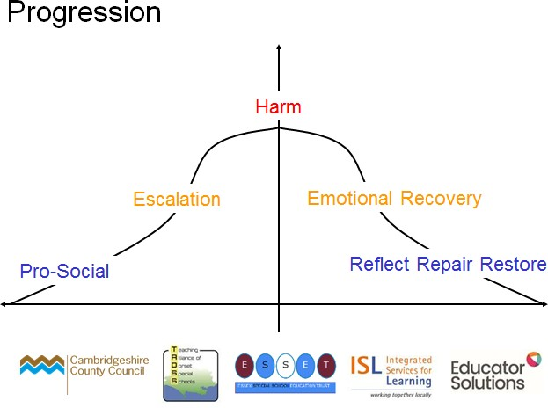
Underpinning our approach through Therapeutic Herts:

- Negative experiences create negative feelings. Negative feelings create negative behaviour.
- Positive experiences create positive feelings. Positive feelings create positive behaviour.
- We need to plan for 5 phases of behaviour:

- Pro-Social (Stable)
- Escalation
- Harm
- Emotional Recover (Cool Down)
- Reflect, Repair & Restore

When pupils are well engaged and learning, we need to ‘catch them getting it right’. This can be by recognising and rewarding their efforts through praise, merits, charts, certificates, or anything, which has meaning for the individual pupil. Pupils should also be made aware that their pro-social behaviour can be rewarding in itself and also brings about positive experiences and feelings in others.

Zones of Regulation

We teach all children about the Zones of Regulation. The Zones is a behavioural approach used to teach self- regulation by categorising all the different ways we feel and states of alertness we experience into four coloured zones. The Zones framework provides a toolkit for students to become more aware of, and independent with, controlling their emotions and impulses, manage their sensory needs, and improve their ability to problem solve conflicts. This is known as ‘emotional literacy’ and forms part of our Learning for Life curriculum.

THE FOUR ZONES: Our feelings and states determine which zone we are in:

- The Red Zone is used to describe extremely heightened states of alertness and intense emotions. A person may be elated or experiencing anger, rage, devastation, or terror when in the Red Zone.

- The Yellow Zone is also used to describe a heightened state of alertness and elevated emotions; however, one has more control when they are in the Yellow Zone. A person may be experiencing stress, frustration, anxiety, excitement, silliness, the wiggles, or nervousness when in the Yellow Zone.

- The Green Zone is used to describe a calm state of alertness. A person may be described as happy, focused, content, or ready to learn when in the Green Zone. This is the zone where optimal learning occurs.

- The Blue Zone is used to describe low states of alertness and down feelings such as when one feels sad, tired, sick, or bored.
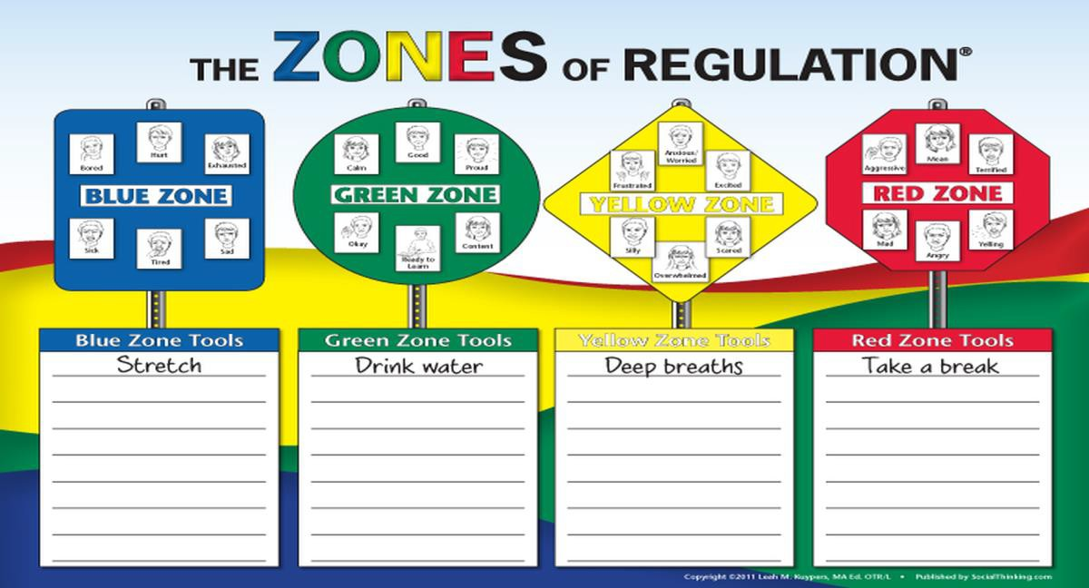

Our aims:

At Pixmore we aim to:

- Provide a safe, comfortable and caring environment where optimum learning takes place
- Provide clear guidance for children, staff and parents of expected levels of behavior
- Teach children how to recognize and acknowledge their emotions, and how to manage any strong feelings safely and calmly, and in a safe environment where adults are on hand to support if necessary.
- Use a consistent and calm approach
- Ensure all adults take responsibility for managing behaviour and follow-up incidents personally
- Ensure all adults use consistent language to promote positive behaviour and
- Use restorative approaches instead of punishments

Purpose of the behaviour policy

To provide simple, practical procedures for staff and children that:
- Foster the belief that there are no ‘bad’ children, just ‘bad choices’
- Encourage children to recognise that they can and should make ‘good’ choices
- Recognise individual behavioural norms and respond appropriately
- Promote self-esteem and self-discipline
- Teach appropriate behaviour through positive intervention

All staff must:
- Take time to welcome children at the start of the day
- Be at the door of their rooms at the start of each session
- Always pick up on children who are failing to meet expectations
- Always redirect children by referring to ‘Be Ready, Be Respectful and Be Safe’

The Head teacher and The Senior Leadership Team must:
- Be a visible presence around the school
- Regularly celebrate staff and children whose efforts go above and beyond expectations
- Encourage use of positive praise, phone calls/MarvellousMe/notes home and certificates/stickers
- Ensure staff training needs are identified and met
- Use behaviour records to target and assess interventions
- Support teachers in managing children with more complex or challenging behaviours

Members of staff who manage behaviour well:
- Deliberately and persistently catch children doing the right thing and praise them in front of others
- Know their classes well and develop positive relationships with all children
- Relentlessly work to build mutual respect
- Remain calm and keep their emotion for when it is most appreciated by children
- Demonstrate unconditional care and compassion

Children want teachers to:
- Give them a ‘fresh start’ every lesson
- Help them learn and feel confident
- Be just and fair
- Have a sense of humour
Pixmore Junior School behaviour for learning principles: ‘Be Ready, Be Respectful and Be Safe’

We recognise that clear structure of predictable outcomes have the best impact on behaviour. Our principle sets out the rules, relentless routines and visible consistencies that all children and staff follow. It is based on the work of Paul Dix and his book ‘When the adults change, everything changes’. Good behaviour is recognised sincerely rather than just rewarded. Children are praised publicly and reminded in private.

‘’When people talk about behaviour, they obsessively search for the instant solution. Some peddle magic dust or ‘behaviour systems’ that glisten yet quickly fade. Others relentlessly scream for a bigger stick to beat children down with. Both extremes harbour an irresistible idea that there is a short cut to changing behaviour. They sell the lie that you can provoke sustained behavioural change in others without doing much hard work yourself. The truth is that there is no alternative to the hard work: building relationships with those who would rather not, resetting expectations with those who trample them, being relentlessly positive and sustaining a poker face when confronted with challenging behaviour.’’

Paul Dix, Pivotal Education

The school has 3 simple rules ‘Be Ready, Be Respectful and Be Safe’ which can be applied to a variety of situations and are taught and modelled explicitly through the Pixmore Way and using our behaviour ladders as discussion points with the children to provide consistency of approach.

We also understand that for some children following our behaviour expectations are beyond their developmental level. In this case, these children will have bespoke positive behaviour plans which may include rewards to reinforce positive behaviour.

The Pixmore Way and Behaviour for Learning:

- Learning cannot take place without positive behaviour and relationships. We encourage our pupils to make pro social behaviour choices and to learn to be responsible for their own actions.

- The Pixmore Way (see Appendix 2) provides guidance on how to identify pro social behaviour in school. The Pixmore Way has been discussed with the pupils and their views considered. It forms the basis of how we manage behaviour for learning, setting clear expectations of the behaviour which supports a nurturing and safe learning environment with a clear message that an individual’s behaviour can affect the learning of more than just the person displaying it and can also be imitated by younger members of the school community.
- We use a behaviour ladder (Appendix 3), and behaviour consequences ladder (Appendix 4) to guide the children in identifying pro social and anti social behaviour choices in the classroom. The colour-coded ladder and consequences are displayed in every class room and shared area as a reference point for children and staff when talking about behaviour. This is simplied into a behaviour rainbow (Appendix 5) for daily use and to provide a positive emphasis to behaviour management and self-regulation.
- Conversely, when anti social behaviour is noted, staff will support a child in recognizing where their behaviour fits on the ladder and how this affects their learning and the learning of others, the consequences of the behaviour, as well as what needs to change.
- Poor behaviour choices on the playground are dealt with by discussion, restorative justice conversations and use of time out on benches on the playground to allow children to calm themselves and reflect on their behaviour.
- Staff at Pixmore School understand that many factors can affect behaviour. They attach a great deal of importance to helping children to understand their behaviour by trying to identify the reasons for any anti- social behaviour and providing additional support to reduce the impact of external factors.
- We help the children to understand why positive behaviour for learning is important using the language of Pixmore Learning Power (PLP) which is based on the Guy Claxton’s Behaviour for Learning principles. Class teachers regularly use the language of PLP to motivate the children and to encourage them to become independent and motivated learners who do not give up and who understand that their behaviour can directly affect their learning and may influence others in a positive or negative way. Our Learning for Life curriculum also provides opportunities to discuss behaviour at school, home and the wider community to support the development of self-regulation.

Positive Behaviour Management:

We believe that pro social behaviour is best achieved through positive practices and strategies, including:

- Using Zones of Regulation to help children to understand their emotions and know how to manage them when they are strong, and before they become overwhelming.
- Noticing and praising good behaviour (“Catch them being good‟) in order for children to develop the ability to accept praise over rewards
- feedback during and after lessons
- Golden tickets and Blue tickets awarded for positive learning behaviour – children are told specifically what they have done well
- whole-school recognition in Friday Achievement Assembly through special mentions
- positive feedback to classes through the School Council
- Head Teacher award to mark momentous learning or behaviour choice
- Silver Leaves to acknowledge a child’s effort or achievement in any one area
- attendance certificates
- house points with awards at intervals for achieving specific targets.
- strategic ignoring and positive re-direction, highlighting the good example of others
- showing work to other teachers or the head teacher
- “Circle Time‟ activities where appropriate behaviour is explored and discussed
- individual target setting (e.g. Pastoral Support Plan, Risk Reduction Management Plans, class targets);
- partnership work with the North Herts. Primary Support Service (NHPSS), eg, within a class, group or individually
- dealing with incidents individually and providing children with opportunities to have a fresh start
- pupils working on a 1:1, group or classroom basis with our school-based Learning Mentors
- Using anxiety mapping, including roots and fruits analysis, to identify problem areas and anxiety triggers for individuals who are not responding to whole class systems, or where there is a change in behaviour (see Appendix 5 and 6).

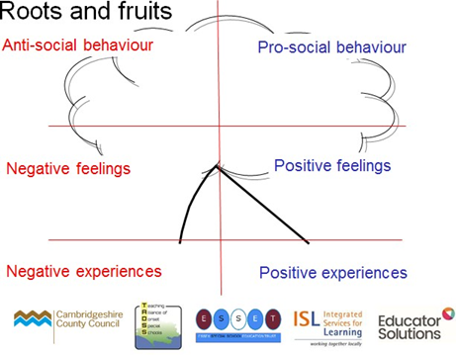
Planned responses to escalating behaviour can include:

- Positive phrasing
- Limited choice
- Disempowering the behaviour
- Consequences related to the incident

Restorative Practice:

All members of the school community will endeavour to use restorative strategies to repair relationships. Individuals are given the opportunity to rehearse conversations before being brought together for a meeting. A “script‟ is available for staff and children to use to structure the supported restorative conversations. The children are given the opportunity to explain how the incident has affected them, and how it can be put right, including any consequences. This empowers children, and is a strong motivator to encourage children to take responsibility for their actions, so that the antisocial behaviours are reduced.

Where children are displaying antisocial behaviour, staff use de-escalation techniques to support them, which include de-escalation scripts known to all staff. The scripts are worded so as to minimize inflammatory language and reduce the anxiety felt by children when they are struggling with their behaviour. Once calm, children are encouraged to talk about what has happened and strategies to help them manage their own behaviour.

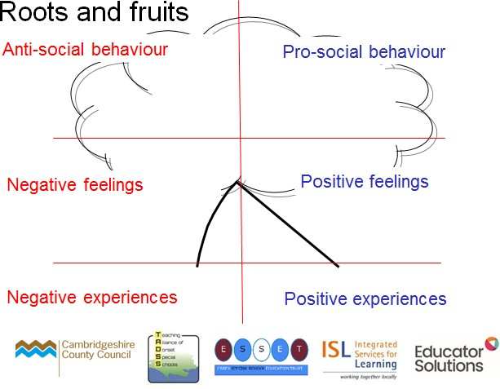
Bullying:

Bullying is considered to be extremely serious and is treated with zero tolerance.
Staff and children are taught about the different types of bullying, including physical, verbal, cyber, emotional, prejudicial and sexual bullying, how to recognize when someone is being bullied, and what to do about it. Sometimes bullying can be indirect and staff are alert to this behaviour so that the children involved can be supported in understanding the impact their indirect bullying can have on others.
All staff who become aware of an allegation of bullying must refer to the school’s Anti-Bullying Policy (2023). Incidents of serious bullying are reported to the Governors as part of the Head teacher’s report.

Racism:

In addition to the sanctions contained within this policy, all incidents of racism must be reported to the Head teacher who will inform the appropriate authority as stipulated by the Hertfordshire County guidance documents. All incidents of racism are taken very seriously and are dealt with immediately.

Exceptional Circumstances for Serious Incidents or Frequent Poor Behaviour:
In the event of extreme behaviour where:

- the child puts others’ safety at risk,
- the child puts his or her own safety at risk,
- school property is seriously or repeatedly damaged,
- there is persistent breach of the Behaviour for Learning Policy,

It may sometimes be necessary to impose a Fixed Term or Permanent Suspension. Suspension is only applied as a last resort. Staff will work with the SENCo and parents to create a Risk Reduction Management Plan. The plan will be written with all adults working with the child and the details explained and discussed with the child and his/her parent. The plan will be shared with all staff in order to provide a consistent way of working with the child. We will aim to reduce the number of fixed term and permanent suspension where they are disproportionally high through early intervention and targeted support.

This may include the implementation of a temporary part-time timetable aimed at further reducing the risk of permanent suspension in order to allow time for a child to ‘get back on track’. It may also include time spent in respite placement in another local school supported by a member of school staff and a member of staff from the North Herts Primary Support Service, the role of which is to work intensively with a child to enable their re-integration back into school as well as to support the school in providing strategies targeted to the individual child’s needs.

At Pixmore we follow the Hertfordshire County Council regulations for Fixed Term and Permanent Suspension from The Education and Inspections Act 2006. Only the Head teacher has the power to suspend a pupil from school. The Head teacher may suspend a pupil for one or more fixed periods, for up to 45 days in any one school year. The Head teacher may also suspend a pupil permanently. It is also possible for the Head teacher to convert a fixed-term suspension into a permanent suspension, if the circumstances warrant this.

Parents will be contacted by telephone first and a letter giving details of the incident will follow immediately. A copy of the letter will be sent to the Chair of Governors and the Local Authority.

Parents have the right of appeal against a suspension and should write to the Chair of Governors requesting a meeting within 15 school days to consider whether the suspension was justified in terms of the school’s Behaviour for Learning Policy.

Permanent suspension from school:

All avenues of support should be explored before permanent suspension.

Physical Intervention:

There are occasions when staff will have cause to have physical contact with individuals for a variety of reasons, for example:
- To comfort or reward a student
- To direct or steer a student
- For activity reasons (for example in drama, physical games)

At Pixmore School, we provide clear guidance for staff regarding appropriate touch that can be used to comfort a child. This includes:
- The ‘Pixmore hug’, where an adult stands side on to a child and places a cupped hand on each of the child’s shoulders and uses reassuring words to comfort them. Contact should be kept to a minimum.
- Offer the child a hand – if the child accepts this, the adult can walk with the child to comfort them e.g. into the classroom at drop-off.
- Offer an arm – the adult places a hand on their hip for a child to hook their arm through – e.g. this may be used for children where there may be a medical difficulty and adults are maintaining the child’s safety.
In all cases, the adult needs to consider if the contact is in the child’s best interests and is for minimum time necessary in the given situation.

In addition, there may be times when adults may need to intervene physically when, for example, a child is putting themselves or others at risk of harm.

Section 93 of the Education and Inspections Act 2006 affirms the lawful right for a member of staff to use reasonable force. It says:

School staff may use “such force as is reasonable in the circumstances to prevent a pupil from doing, or continuing to do, any of the following:

- committing any offence (or, for a pupil under the age of criminal responsibility, what would be an offence for an older pupil);
- causing personal injury to, or damage to the property of, any person (including the pupil him / herself);
- engaging in any behaviour prejudicial to the maintenance of good order and discipline at the school, or among any pupils receiving education at the school, whether during a teaching session or otherwise”.

All members of staff are aware of the regulations regarding the use of force by teachers, as set out in Section 93 of the Education and Inspections Act 2008 (DFES Guidance 2008 – Use of force to control and restrain pupils) Our commitment to positive behaviour management means that physical intervention is used only as a last resort when all other preventative methods have proved ineffective. Physical intervention is never used in a threatening way or as a punishment. Staff will take steps in advance to avoid the need for restrictive physical intervention through dialogue and diversion. Only the minimum force necessary will be used. Staff will be able to show that the intervention used was a reasonable response to the incident
All staff are trained in the Therapeutic Herts approach to support positive behaviour management, which includes advice on managing difficult or dangerous behaviour with a focus on pre-emptive strategies and de-escalation techniques. We follow guidance set out in the Hertfordshire Model Policy for Restrictive Physical Intervention in Schools (May 2017 – still current for 2023) to ensure that all staff use a consistent and validated approach at all times.

- Restrictive Physical Interventions will be used when all other strategies been considered and therefore only as a last resort
- There are situations when restrictive physical intervention may be necessary, for example in a situation of clear danger and extreme urgency

A “Time out” room is available for children who need to take adult directed or self-directed timeout away from the classroom. A child may be allowed to sit alone in the room, but a member of staff will always be present to support the child when they are ready to talk about what has happened, and will remain during the time it takes for them to become calm and feel ready to go back to their learning. Procedures are in place for supporting and debriefing the student after every incident of restrictive physical intervention, as it is essential to safeguard the emotional well-being of all involved at these times.

Physical Attacks on Adults

At Pixmore Junior School, we take incidents of violence toward staff very seriously. We also understand that staff are the adults in the situation and can use a ‘common sense’ approach to keep themselves and the child safe to manage the situation effectively. Staff can use ‘reasonable measures’ to protect themselves in accordance with our Policy for Restrictive Physical Intervention in Schools (2023) and should call for support if needed. Only staff who have been trained in physical intervention should move a child.

All staff should report incidents directly to the Headteacher or SENCo and they should be recorded on CPOMS. We appreciate these incidents can cause distress for the adults involved, therefore all staff are entitled to take some time away from the classroom to recover their composure. In extreme cases, the member of staff may be allowed to go home by a member of SLT.

Whilst incidences of violence towards staff are wholly unacceptable, we must remember that we are a nurturing school that values each child under our care. It is important for us as adults to reflect on the situation and learn from our actions. Children who attack adults may do this for several reasons but as adults we need to still show compassion and care for the child. Suspension will only happen once we have explored several options and have created a plan around a child.

Beyond the School Gate

Whilst this behaviour policy refers mainly to the behaviour of pupils within school premises, the school reserve the right to discipline beyond the school gate.

Our policy covers any inappropriate behaviour when children are:

- taking part in any school organised or school related activity
- travelling to or from school
- wearing school uniform
- in some way identifiable as a pupil from our school
- poses a threat to another pupil or member of the public
- could adversely affect the reputation of the school

In the incidences above, the headteacher may notify the police of any actions taken against a pupil. If the behaviour is criminal or causes threat to a member of the public, the police will always be informed.

Out of School Behaviour

The school is committed to ensuring our pupils act as positive ambassadors for us. Taking the above into account, we expect the following:

- Good behaviour to and from school, on educational visits or during learning opportunities in other schools
- Positive behaviour which does not threaten the health, safety or welfare of our pupils, staff, volunteers or members of the public.
- Reassurance to members of the public about school care and control over pupils in order to protect the reputation of the school.
- Protection for individual staff and pupils from harmful conduct by pupils of the school when not on the school site.
- The same behaviour expectations for pupils on the school premises apply to off-site behaviour.

Sanctions and Disciplinary Action – Off-Site Behaviour

Sanctions may be given for poor behaviour off the school premises which undermines any of the above expectations and regardless of whether or not it is an activity supervised directly by school staff. Sanctions may be in the form of withdrawal of privileges, fixed term suspension or in very serious cases, permanent suspension. In issuing sanctions, the following will be taken into account:

- The severity of the misbehaviour
- The extent to which the reputation of the school has been affected
- Whether pupils were directly identifiable as being a member of our school
- The extent to which the behaviour in question could have repercussions for the orderly running of the school and/or might pose a threat to another pupil or member of staff (e.g. bullying another pupil or insulting a member of staff).
- Whether the misbehaviour was whilst the pupil was taking part in learning opportunities in another school, participating in a sports event (and in any situation where the pupil is acting as an ambassador for the school) which might affect the chances or opportunities of being chosen to represent the school again.

Implementation of the Policy:

- All new families to receive a leaflet, and directed to the policy on the Pixmore School website, and requested to sign a Home – School Agreement
- All new staff and trainees to receive training in the policy implementation, including the Therapeutic Herts approach to managing positive behaviour
- Staff, pupils, parents and governors to be regularly consulted and informed of changes
- Behaviour for learning is discussed by the School Council and opportunity provided for comment
- The Pixmore Way and behaviour ladder are displayed prominently around the school and in classrooms
- The Pixmore Way and behaviour ladder are discussed and reinforced in classrooms, and in assemblies
- Serious Incident Forms are completed to record, track and monitor issues following individual school procedures.
- Physical Intervention Forms are completed to record, track and monitor issues following individual school procedures.
- Annual Therapeutic Herts training refresher to enable staff to support children in developing good behaviour for learning, especially those with additional needs for whom adjustments need to be made in order to enable them to participate more fully in school life. The refresher is delivered by two members of senior leadership, who attend an annual trainer refresher course and local cluster groups to share good practice. Our current Therapeutic Herts tutor is Sue Willans, who is also the SENCo.

The role of parents:

- Pixmore School works collaboratively with parents, so children receive consistent messages about how to manage their behaviour at home and at school. We believe it is important to maintain a dialogue with parents.

- We explain the school rules in the school prospectus, and we expect parents to read these and support them. We know that consistency at home and school support children in their understanding of our way of working to support their learning.

- We expect parents to support their child’s learning, and to co-operate with the school, as set out in the home–school agreement. We try to build a supportive dialogue between the home and the school, and we inform parents immediately if we have concerns about their child’s welfare or behaviour.

- If the school has to use reasonable consequences in relation to a child’s behaviour, parents should support the actions of the school. If parents have any concern about the way that their child has been treated, they should initially contact the class teacher, then the Head teacher in order to follow the school’s complaints procedure.

The role of the class teacher:

- It is the responsibility of the class teacher to ensure they support their class in developing an understanding of their behaviour and how this can affect their learning

- The class teachers in our school have high expectations of the children in terms of behaviour, and they strive to ensure that all children work to the best of their ability.

- The class teacher treats each child fairly and applies the advice School Behaviour for Learning policy consistently. The teacher treats all children in their class with respect and understanding.

- The class teacher keeps a record of behaviour incidents through the pupils’ reflection sheets and CPOMS (Level 3 behaviours on the Behaviour ladder).

- The class teacher, with the SENCo, liaises with external agencies, as necessary, to support and guide the progress of each child. They may, for example, discuss the needs of a child with the North Herts Primary Support Service or the Educational Psychologist.

- The class teacher reports to parents about the progress of each child in their class, in line with the whole–school policy. The class teacher may also contact a parent if there are concerns about the behaviour or welfare of a child.

For those children who are identified as needing extra support in managing their behaviour, the class teacher works with the SENCo to formulate a Pastoral Support Programme, or Risk Reduction Management Plan, with the focus on strategies to support the development of appropriate behaviour choices. The teacher also liaises with, and works alongside, any key workers who have been assigned to a specific child.

The role of the Head teacher is:

- Under the School Standards and Framework Act 1998, to implement the Pixmore Behaviour for Learning Policy consistently throughout the school, and to report to governors, when requested, on the effectiveness of the policy

- To ensure the health, safety and welfare of all children and staff in the school.

- Support the staff by implementing the policy, by setting the standards of behaviour, and by supporting staff in the implementation of the policy.

- To keeps records of all reported serious incidents of misbehaviour.

- To issue fixed-term suspensions to individual children for serious acts of misbehaviour. For repeated or very serious acts of anti-social behaviour, the head teacher may permanently suspend a child. Both these actions are taken following HCC’s and the school’s suspension guidance.

- To send out the Home School Agreement to parents on an annual basis. The school, parents and pupils are all expected to sign this agreement.

- The Head teacher is also the designated teacher for Child Protection and if any staff has a concern that behaviour is linked to or is a result of a child protection incident then staff should then follow the child protection procedures of the school and LEA in line with the CP policy.

The role of the Behaviour Support Team at Pixmore School (which includes SENCo)

- The behaviour team are key workers to support identified children within the school who consistently struggle to make good behaviour choices, and for whom a more personalised approach is required in order to minimise the impact of their behaviour on their learning and that of their peers. These children frequently display Level 3 and 4 behaviours on the Pixmore Behaviour Ladder and are therefore at risk of suspension.

- Serious incidents or a rising number of incident forms for a particular child could trigger them receiving key worker support, which may be on a 1:1 basis in order to support the development of positive behaviour choices, and to develop emotional literacy. Key workers are available to support their assigned children when required. They will also give their children support/mentoring sessions.

- The key worker will work with the class teacher, SENCo, parents and the child to complete a pen portrait that identifies their strengths, triggers for inappropriate behaviours and strategies to use to support the development of more appropriate behaviour choices and support their learning.

- A RRMP (Risk Reduction Management) is completed for children with more complex emotional regulation needs. This will detail strengths, areas of difficulty, strategies to support the development of emotional literacy and reduce the incidence of challenging behaviour, and details of our response to more difficult or dangerous behaviour . It is sometimes necessary for a child to be put onto a short-term part-time timetable in order to enable them to be successful in working towards the development of emotional literacy and to help them to learn. Parents will be consulted and supported throughout this process. Additional funding (Local High Needs Funding) may be applied for in some cases. In some situations, we may discuss alternative provision where we feel that, in spite of the support given, we are unable to meet the needs of a child in our setting. The RRMP will be reviewed at least every term, or as a child’s needs change.

- Children with key workers may have their own personalised behaviour ladder which supports them in identifying their behaviour and how to manage it themselves. Key workers support the child in developing a greater understanding of their own behaviour, the triggers to the behaviour and how to manage it before it becomes distressing for them and results in them making inappropriate choices.

- We have implemented the use of Zones of Regulation this year to support the children to develop emotional literacy in a child-friendly and developmentally appropriate way.

The role of governors:

- The governing body has the responsibility of setting down these general guidelines on standards of discipline and behaviour, and of reviewing their effectiveness. The governors support the Head teacher in following these guidelines.

- The Head teacher has the day-to-day authority to implement the school Behaviour for Learning Policy, but governors may give advice to the Head teacher about particular disciplinary issues. The Head teacher must take this into account when making decisions about matters of behaviour.

Monitoring:

- The Head teacher monitors the effectiveness of this policy termly through monitoring the number of incidents of inappropriate behaviour and how children respond to intervention. She also reports to the governing body on the effectiveness of the policy and, if necessary, makes recommendations in consultation with the staff for further improvements.

- The Head teacher has the responsibility of carrying out a School Behaviour Audit on a termly basis. The criteria for the success of this policy is that over 80% of pupils are on the ‘usually OK’ and above on the Pixmore Way Behaviour Ladder. Any pupils who display behaviour outside of this criteria have been identified by the Behaviour Support team and are being appropriately supported by the school.

- Pupil voice interviews as part of our safeguarding monitoring allow SLT and governors to monitor the effectiveness of our provision with supporting our children to develop emotional literacy, and to help them to feel that they can contribute towards decision-making at our school.

- The school keeps records of incidents of misbehaviour. We also keep a record of any incidents that occur at break or lunchtimes via word of mouth from key workers daily. The SENCo monitors these incidents and records them in SLT/ key worker/teachers, and sometimes other support staff. Racist, homophobic and bullying incidents are recorded in the Head teacher’s behaviour file and logged using the HCC pro forma, and on CPOMS.

- The Head teacher keeps a record of any pupil who is suspended for a fixed-term, or who is permanently suspended.

- It is the responsibility of the governing body to monitor the rate of suspensions, and to ensure that the school policy is administered fairly and consistently.

- The Behaviour Support team monitors behaviour incidents throughout the school on a weekly basis and decides on actions to be taken to provide additional support for children who are struggling to manage their behaviour independently.

Review

The governing body reviews this policy every year. The governors may, however, review the policy earlier than this if the government introduces new regulations, or if the governing body receives recommendations on how the policy might be improved.

This policy should be read in conjunction with other school policies, including the Policy for Special Educational Needs and Disability (2023), Anti-Bullying Policy (2023), and the Policy for Restrictive Physical Intervention (2023)

Author: Sue Willans (SENCo)
Review date: Autumn Term 2024

Appendix 1:The Pixmore Way Be Ready, Be Respectful, Be Safe

When you are following the Pixmore Way, you are ready to learn and using Pixmore Learning Powers. You….  - always work hard and show good learning behaviour  - are keen to learn and try your best at all times  - respond appropriately to everyone  - are respectful to everyone  - tell your teacher if you have a problem  - avoid disputes  - walk around school in the Pixmore Way  - work well in a team  - do homework well or do extra homework  - stop and line up when the whistle goes  - look after property responsibly  - are helpful and offer to do jobs for your teacher  - have good manners  - always wear the correct uniform and take pride in your appearance | The consequence may be:  - praise from your teachers  - move to showing pride, role model or superstar  - Marvellous Me messages  - stickers  - Golden Tickets  - Blue Tickets  - house points  - silver leaves  - certificates
Have you challenged yourself?  - Extra effort in your learning noticed by your teacher | This has been noticed by your teacher…  You are a role model to others and are using Pixmore Learning Powers to help you learn
- Great improvement in the amount of effort you are putting into your learning | You are showing pride and using Pixmore Learning Power well
- Great effort always | You are a superstar, using Pixmore Learning Powers to support your learning

Appendix 2: Classroom Behaviour and Consequences Ladder
The behaviour described and consequences are not intended to be a comprehensive list. Discretion should be used when determining the level of any presenting behaviour not described below.
When the behaviour occured | Playground | Classroom
Super Star | Immediately or as soon as possible
Showing Pride
Role model
Following the Pixmore Way
Warning 1 (Level 1) | - Immediately apologise.  - Discuss what has happened with a key worker to see what you could have done differently.  - You will lose 5/10 minutes of playtime sitting on the time-out benches.  - If incident occurs at the end of break/lunch, they must apologise immediately but miss time off of the next playtime (who ever is on the next duty will need to be made aware of this) * | - Immediately apologise.  - Stay in at the next break/lunch if more time is needed to complete work because their behaviour caused them to not have enough time or because the teacher needs to speak about the incident without it disrupting learning for the rest of the class.
Warning 2 (Level 2) | - Immediately apologise and talk about what has happened with a key worker and any other children involved.  - Discuss what other choices you had and how can make better choices next time.  - You will lose 10/15 minutes of playtime sitting on the time-out bench.  - If incident occurs at the end of break/lunch, they must apologise immediately but miss time off of the next playtime (who ever is on the next duty will need to be made aware of this) *  - Log incident | - Stay in at the next/break lunch to write their apology and consider their behaviour (it is the responsibility of who ever gave the warning to ensure this happens).  - Any work not completed due to their behaviour affected their learning should be completed during this time.  - Log incident
Red Warning (Level 3) | - Removed by a key worker or member of SLT from the situation until it is safe for them to return  - This means they may miss some of break/lessons to  -use strategies to help them to calm down  -do some pastoral work or restorative justice  -discuss the consequence  - The incident and appropriate consequence must be discussed with key worker/SLT and logged  - Support and/or exclusion put in place

Behaviour |  | Consequence
Level 1 – think about it
If you choose to do any of the following:  - Interrupt lessons e.g. calling out, off-task talk, making noises  - Not following instructions specific to you  - Wearing incorrect uniform  - Not getting on with your work  - Swing on your chair  - Run in the school  - Wear jewellery at school  - Talk in assembly  - Not line up appropriately  - Bring sweets to school or eat in class  - Carry on playing when the whistle goes  - Come into the cloakroom or classroom before school or at break-times without permission  - Run on the bank  - Go in out of bounds areas around school grounds without permission |  | Verbal warning – think about it – get it right now  - Unacceptable behaviour highlighted by teacher - warning  After one verbal warning:  - Repeat of Level 1 behaviour after one warning will result in your teacher talking to you about your behavior briefly to remind you of the expectations.  - You may need to stay in to complete work if your behavior has prevented you from doing this  - Any level 1 behavior during break or lunchtime will result in loss of 5/10 minutes break or lunch time on the time-out bench and talking with an adult about your behaviour
Level 2 – Consequence

If you choose to do any of the following:  Carry on with level 1 behaviour after you have been asked to stop  - Walk around the classroom when you should be working  - Continuing to not follow adult instructions  - Deliberately spoil your work  - Open letters addressed to your parents  - Call people names or say unkind things to them  - Deliberately stop other children from working  - Answer back or speak rudely to an adult  - Deliberately lie about what has happened  - Leave your classroom without permission  - Spoil someone else’s work on purpose  - Get into fights on the playground without intending to hurt anyone  - Use bad language on the playground |  | - Teacher choice - Face-to-face meeting with teacher or key worker to talk about what has happened  - Restorative justice conversation to help you understand what you need to do next time  - Not representing the school at a planned event  - Loss of break/lunchtime minutes  - Loss of the whole of break or lunchtime  - For level 2 behaviour on the playground, loss of 10/15 minutes of your break or lunch time spent on the time out bench, and a conversation about your behavior with a member of staff
Level 3

If you choose to do any of the following:  Carry on with level 2 behaviour after you have been asked to stop  - Deliberate physical violence e.g. hit or punch someone  - Verbally threaten, swear at, or intimidate someone so they are made to feel unsafe in school.  - Leaving class without asking and presenting a danger to yourself or others  - Run out of school  - Hide on the school site  - Repeated use of bad language  - Insult someone else e.g. call them a racist name  - Damage school equipment on purpose  - Steal something from school or another child | Then the consequence will be: Mrs. Evans will be told what you have done and your parents will be contacted to discuss what has happened  Your behaviour may then result in:  - Exclusion from class for lessons and/or break times for a period of time.  - Fixed term exclusion from school  - Permanent exclusion from school  - Additional outside support and/or separate behavior system  - Pastoral Support Programme in liaison with parents and external professionals  - Level 3 behaviour on the playground carries the same consequences as in the playground

Appendix 4 – Pixmore Behaviour Rainbow

Appendix 6:

