
St John the Baptist C.E. V.A. Primary School
Child Protection Policy

C O N T E N T S
- Introduction
- Statutory Framework
- The Designated Senior Peron
- The Governing Body
- When to be concerned
- Dealing with Disclosures
- Record Kepping
- Confidentiality
- School Procedures
- Communicating with parents
- Allegations involving School Staff/Volunteers
Appendix 1: Link to Keeping Children Safe in Education (DfE, 2016)
Part One: Information for all school and college staff
Annex A: Further information
Appendix 2 - Declaration for staff:
Child Protection Policy and Keeping Children Safe in Education (DfE, 2016)
Appendix 3: What to do if you’re worried a child is being abused: advice for practitioners flowchart (DfE 2015)
Appendix 4: Indicators of abuse and neglect

1. INTRODUCTION

Safeguarding is defined as protecting children from maltreatment, preventing impairment of children’s health and/or development, ensuring that children are growing up in circumstances consistent with the provision of safe and effective care and taking action to enable all children to have the best life chances (Working Together to Safeguard Children, DfE, 2015, pg.92)

This Child Protection Policy forms part of a suite of documents and policies which relate to the safeguarding responsibilities of the school.

In particular this policy should be read in conjunction with the Safer Recruitment Policy, Behaviour Policy, Physical Intervention Policy, Anti-Bullying Policy, Code of Conduct and ICT Acceptable Usage Policy.

Purpose of a Child Protection Policy
To inform staff, parents, volunteers and governors about the school's responsibilities for safeguarding children.
To enable everyone to have a clear understanding of how these responsibilities should be carried out.

Hertfordshire Safeguarding Children Board Inter-agency Child Protection and Safeguarding Children Procedures
The school follows the procedures established by the Hertfordshire Safeguarding Children Board; a guide to procedure and practice for all agencies in Hertfordshire working with children and their families. www.hertssafeguarding.org.uk

School Staff & Volunteers
All school and college staff have a responsibility to provide a safe environment in which children can learn.
School staff and volunteers are particularly well placed to observe outward signs of abuse, changes in behaviour and failure to develop because they have daily contact with children.
All school staff and volunteers will receive safeguarding children training, (which is updated every 3 years in line with Hertfordshire Safeguarding Children Board advice), so that they are knowledgeable and aware of their role in the early recognition of the indicators of abuse or neglect and of the appropriate procedures to follow. In addition all staff members receive safeguarding and child protection updates (for example, via email, staff notice sheets and staff meetings), as required, but at least annually, to provide them with relevant skills and knowledge to safeguard children effectively.

Temporary staff and volunteers will be made aware of the safeguarding policies and procedures by the Designated Senior Person-including Child Protection Policy and staff behaviour policy (code of conduct)

Mission Statement
Establish and maintain an ethos and culture where children feel secure, are encouraged to talk, and are listened and responded to when they have a worry or concern.

Establish and maintain an ethos and culture where school staff and volunteers feel safe, are encouraged to talk and are listened and responded to when they have concerns about the safety and well being of a child.

Ensure children know that there are adults in the school whom they can approach if they are worried.

Ensure that children, who have additional/unmet needs are supported appropriately. This could include referral to early help services or specialist services if they are a child in need or have been / are at risk of being abused and neglected.

Consider how children may be taught about safeguarding, including online, through teaching and learning opportunities, as part of providing a broad and balanced curriculum.

Staff members working with children are advised to maintain an attitude of ‘it could happen here’ and ‘it could be happening to this child’ where safeguarding is concerned. When concerned about the welfare of a child, staff members should always act in the interests of the child.

Implementation, Monitoring and Review of the Child Protection Policy
The policy will be reviewed at least annually by the governing body. It will be implemented through the school’s induction and training programme, and as part of day to day practice. Compliance with the policy will be monitored by the Designated Senior Person and through staff performance measures.

2. STATUTORY FRAMEWORK
In order to safeguard and promote the welfare of children, the school will act in accordance with the following legislation and guidance:
- The Children Act 1989
- The Children Act 2004
- Education Act 2002 (section 175)
- Hertfordshire Safeguarding Children Board Inter-agency Child Protection and Safeguarding Children Procedures (Electronic)
- Keeping Children Safe in Education (DFE 2016)
- Keeping Children Safe in Education: Part One- information for all school and college staff (DfE, September 2016) – APPENDIX 1
- Working Together to Safeguard Children (DfE 2015)
- Sexual Offences Act (2003)
- The Education (Pupil Information) (England) Regulations 2005
- Section 26, The Counter Terrorism and Security Act 2015 (PREVENT duty)
- Female Genital Mutilation Act 2003 (Section 74 ,Serious Crime Act 2015)

Working Together to Safeguard Children (DfE 2015) requires each school to follow the procedures for protecting children from abuse and neglect which are established by the Hertfordshire Safeguarding Children Board.

Schools are also expected to ensure that they have appropriate procedures in place for responding to situations in which:
- a child may have been abused or neglected or is at risk of abuse or neglect
- a member of staff has behaved in a way that has, or may have harmed a child or that indicates they would pose a risk of harm.

3. THE DESIGNATED SENIOR PERSON
( Keeping Children Safe in Education, DfE 2016 refers to this role as Designated Safeguarding Lead - DSL)

Governing bodies and proprietors should ensure that the school designates an appropriate senior member of staff to take lead responsibility for child protection. This person should have the status and authority within the school to carry out the duties of the post including committing resources and, where appropriate, supporting and directing other staff.

During term time the designated safeguarding lead and or a deputy will always be available (during school or college hours) for staff in the school or college to discuss any safeguarding concerns and individual arrangement for out of hours/out of term activities will be: (individual school needs to outline these below):

The Designated Senior Person (DSP) for Child Protection in this school is:

NAME: Miss Lydia Hunt

A Deputy DSP is appointed to act in the absence/unavailability of the Lead DSP.

The Deputy Designated Senior Person (DDSP) for Child Protection in this school is:

NAME: Caroline Volschenk

The broad areas of responsibility for the designated safeguarding lead are:

Managing referrals

- Refer all cases of suspected abuse or neglect to the Local Authority Children’s Services (Safeguarding and Specialist Services) , Police (cases where a crime may have been committed) and to the Channel programme where there is a radicalisation concern
- Liaise with the head teacher to inform her of issues, especially ongoing enquiries under section 47 of the Children Act 1989 and police investigations
- Act as a source of support, advice and expertise to staff on matters of safety and safeguarding and when deciding whether to make a referral by liaising with relevant agencies
- Support staff who make referrals

- Share information with appropriate staff in relation to a child’s looked after (CLA) legal status (whether they are looked after under voluntary arrangements with consent of parents or on an Interim Care Order or Care Order) and contact arrangements with birth parents or those with parental responsibility.

- Ensure they have details of the CLA’s social worker and the name of the virtual school Head Teacher in the authority that looks after the child.

Training

The Designated Senior Person should undergo formal training every two years . The DSP should also undertake Prevent awareness training In addition to this training, their knowledge and skills should be refreshed(for example via e-bulletins, meeting other DSPs, or taking time to read and digest safeguarding developments) at least annually to:

- Understand the assessment process for providing early help and intervention, for example through locally agreed common and shared assessment processes such as early help assessments
- Have a working knowledge of how local authorities conduct a child protection case conference and a child protection review conference and be able to attend and contribute to these effectively when required to do so
- Ensure each member of staff has access to and understands the school’s or college’s child protection policy and procedures, especially new and part time staff

- Be alert to the specific needs of children in need, those with special educational needs and young carers

- Understand and support the school or college with regards to the requirements of the Prevent duty and are able to provide advice and support to staff on protecting children from the risk of radicalisation
- Be able to keep detailed, accurate, secure written records of concerns and referrals
- Obtain access to resources and attend any relevant or refresher training courses
- Encourage a culture of listening and responding to children and taking account of their wishes and feelings, among all staff, in any measures the school or college may put in place to protect them

Raising Awareness

The designated safeguarding lead should:

- Ensure the school’s policies are known, understood and used appropriately:

- Ensure the school’s child protection policy is reviewed annually and the procedures and implementation are updated and reviewed regularly, and work with governing bodies or proprietors regarding this
- Ensure the child protection policy is available publicly and parents are aware of the fact that referrals about suspected abuse or neglect may be made and the role of the school or college in this
- Link with the Local Safeguarding Children’s Board (LSCB) to make sure staff are aware of training opportunities and the latest local policies on safeguarding
- Where children leave the school or college ensure their child protection file is copied for any new school or college as soon as possible but transferred separately from the main pupil file
- Schools should obtain proof that the new school/education setting has received the safeguarding file for any child transferring and then destroy any information held on the child in line with data protection guidelines (see Record keeping Guidance on Hertfordshire Grid for Learning for further information. )

4. THE GOVERNING BODY

Governing bodies and proprietors must ensure that they comply with their duties under legislation. They must also have regard to this guidance to ensure that the policies, procedures and training in their schools or colleges are effective and comply with the law at all times.

The nominated governor for child protection is:
Mr Stuart Elsom

The responsibilities placed on governing bodies and proprietors include:
- their contribution to inter-agency working, which includes providing a coordinated offer of early help when additional needs of children are identified
- ensuring that an effective child protection policy is in place, together with a staff behaviour policy
- ensuring staff are provided with Part One of Keeping Children Safe in Education (DfE 2016) – Appendix 1 and are aware of specific safeguarding issues
- ensuring that staff induction is in place with regards to child protection and safeguarding
- appointing an appropriate senior member of staff to act as the Lead Designated Senior Person.
- ensuring that all of the Designated Senior Persons (including deputies) should undergo formal child protection training every two years (in line with LCSB guidance) and receive regular (annual) safeguarding refreshers (for example via e-bulletins, meeting other DSPs, or taking time to read and digest safeguarding developments)
- prioritising the welfare of children and young people and creating a culture where staff are confident to challenge senior leaders over any safeguarding concerns
- ensuring that children are taught about safeguarding in an age appropriate way
- ensuring appropriate filters and appropriate monitoring systems are in place to safeguard children from potentially harmful and inappropriate online material. Additional information to support governing bodies is provided in Annex C of Keeping Children Safe in Education(DFE 2016)- available at http://www.thegrid.org.uk/info/welfare/child_protection/policy/national.shtml
- Having a senior board level lead to take leadership responsibility for the organisation’s safeguarding arrangements
- WHEN TO BE CONCERNED

If staff members have any concerns about a child they will need to decide what action to take. Where possible, there should be a conversation with the Designated Senior Person to agree a course of action, although any staff member can make a referral to Children’s Services by ringing 0300 123 4043.

If a child is in immediate danger or is at risk of harm, a referral should be made to Children’s Services and/or the police immediately. Anyone can make a referral. Where referrals are not made by the designated senior person, the designated senior person should be informed as soon as possible that a referral has been made.

A child centred and coordinated approach to safeguarding:

Safeguarding and promoting the welfare of children is everyone’s responsibility. In order to fulfil this responsibility effectively, each professionals should make sure their approach is child centred. This means that they should consider, at all times, what is in the best interests of the child.
Schools and colleges and their staff form part of the wider safeguarding system for children. This system is based on the principle of providing help for families to stay together where it is safe for the children to do so, and looking at alternatives where it is not, whilst acting in the best interests of the child at all times.

Children who may require early help ( known as Families First in Hertfordshire)

Families First is Hertfordshire's programme of early help services for families.
A directory of early help services is available at www.hertfordshire.gov.uk/familiesfirst and will help practitioners and families find information and support to prevent escalation of needs and crisis.

All staff should be aware of the early help process, and understand their role in identifying emerging problems, sharing information with other professionals to support early identification and assessment of a child’s needs. It is important for children to receive the right help at the right time to address risks and prevent issues escalating. This also includes staff monitoring the situation and feeding back to the Designated Senior Person any ongoing/escalating concerns so that consideration can be given to a referral to Children’s Services (Safeguarding and Specialist Services) if the child’s situation doesn’t appear to be improving.

Staff and volunteers working within the School should be alert to the potential need for early help for children also who are more vulnerable. For example:
- Children with a disability and/or specific additional needs.
- Children with special educational needs.
- Children who are acting as a young carer.
- Children who are showing signs of engaging in anti-social or criminal behaviour.
- Children whose family circumstances present challenges, such as substance abuse, adult mental health or learning disability, domestic violence
- Children who are showing early signs of abuse and/or neglect.
School and college staff members should be aware of the main categories of maltreatment: physical abuse, emotional abuse, sexual abuse and neglect. They should also be aware of the indicators of maltreatment and specific safeguarding issues so that they are able to identify cases of children who may be in need of help or protection.

See Appendix 4 for information on indicators of abuse and Appendix 1 for specific safeguarding issues.
Children with special educational needs and disabilities:

Additional barriers can exist when recognising abuse and neglect in this group of children.
This can include:
- Assumptions that indicators of possible abuse such as behaviour, mood and injury relate to the child’s impairment without further exploration;
- Assumptions that children with SEN and disabilities can be disproportionally impacted by things like bullying- without outwardly showing any signs;
- Communication barriers and difficulties

- Reluctance to challenge carers , (professionals may over empathise with carers because of the perceived stress of caring for a disabled child)

- Disabled children often rely on a wide network of carers to meet their basic needs and therefore the potential risk of exposure to abusive behaviour can be increased.

- A disabled child’s understanding of abuse.

- Lack of choice/participation

- Isolation

Peer on peer abuse

Education settings are an important part of the inter-agency framework not only in terms of identifying, evaluating and referring concerns to Children’s Services and the Police, but also in the assessment and management of risk that the child or young person may pose to themselves and others in the education setting.

If one child or young person causes harm to another, this should not necessarily be dealt with as abuse. When considering whether behaviour is abusive, it is important to consider:

- Whether there is a large difference in power (for example age, size, ability, development) between the young people concerned; or
- whether the perpetrator has repeatedly tried to harm one or more other children; or
- Whether there are concerns about the intention of the alleged perpetrator.

Peer on peer abuse can manifest itself in many ways and different gender issues can be prevalent. Severe harm may be caused to children by abusive and bullying behaviour of other children, which may be physical, sexual or emotional and can include gender based violence/ sexual assaults, sexting, teenage relationship abuse, peer-on-peer exploitation, serious youth violence, sexual bullying or harmful sexual behaviour.

Hertfordshire County Council recommends that education settings use The Sexual Behaviours Traffic Light Tool by the Brook Advisory Service to help professionals assess and respond appropriately to sexualised behaviour. The traffic light tool can be found at www.brook.org.uk/our-work/the-sexual-behaviours-traffic-light-tool.

Guidance on responding to and managing sexting incidents can be found at http://www.thegrid.org.uk/info/welfare/child_protection/reference/index.shtml#sex
Staff should recognise that children are capable of abusing their peers and should not be tolerated or passed off as “banter” or “part of growing up”.

In order to minimise the risk of peer on peer abuse the school:

- Provides a developmentally appropriate PSHE curriculum which develops students understanding of acceptable behaviour and keeping themselves safe.
- Have systems in place for any student to raise concerns with staff, knowing that they will be listened to, believed and valued.
- Develop robust risk assessments where appropriate (e.g. Using the Risk Assessment Management Plan and Safety and Support Plan tools).
- Have relevant policies in place (e.g. behaviour policy).

Where there is an allegation or concern that a child has abused others Section 4.4 of the Hertfordshire Safeguarding Children Board Inter Agency Child Protection Procedures manual, ‘Children Who Abuse Others’:

http://hertsscb.proceduresonline.com/chapters/p_chil_abuse.html

6. DEALING WITH A DISCLOSURE

If a child discloses that he or she has been abused in some way, the member of staff / volunteer should:

- Listen to what is being said without displaying shock or disbelief

- Accept what is being said

- Allow the child to talk freely

- Reassure the child, but not make promises which it might not be possible to keep

- Never promise a child that they will not tell anyone - as this may ultimately not be in the best interests of the child.
- Reassure him or her that what has happened is not his or her fault

- Stress that it was the right thing to tell

- Listen, only asking questions when necessary to clarify

- Not criticise the alleged perpetrator

- Explain what has to be done next and who has to be told

- Make a written record (see Record Keeping)

- Pass the information to the Designated Senior Person without delay

Support
Dealing with a disclosure from a child, and safeguarding issues can be stressful. The member of staff/volunteer should, therefore, consider seeking support for him/herself and discuss this with the Designated Senior Person.
If a school staff member receives a disclosure about potential harm caused by another staff member, they should see section 11 of this policy– Allegations involving school staff/volunteers.

7. Record Keeping

All concerns, discussions and decisions made and the reasons for those decisions should be recorded in writing. If in doubt about recording requirements staff should discuss with the designated safeguarding lead.

When a child has made a disclosure, the member of staff/volunteer should:

- Record as soon as possible after the conversation. Use the school record of concern sheet wherever possible. (pro-forma available in the staff room or from DSP)

- Record the date, time, place and any noticeable non-verbal behaviour and the words used by the child

- Draw a diagram to indicate the position of any injuries

- Record statements and observations rather than interpretations or assumptions

- Do not destroy the original notes in case they are needed by a court

All records need to be given to the Designated Senior Person promptly. No copies should be retained by the member of staff or volunteer.

The Designated Senior Person will ensure that all safeguarding records are managed in accordance with the Education (Pupil Information) (England) Regulations 2005.

If a pupil who is/or has been the subject of a child protection plan changes school, the Designated Senior Person will inform the social worker responsible for the case and transfer the appropriate records to the Designated Senior Person at the receiving school, in a secure manner, and separate from the child’s academic file.

8. CONFIDENTIALITY

Safeguarding children raises issues of confidentiality that must be clearly understood by all staff/volunteers in schools.

- All staff in schools, both teaching and non-teaching staff, have a responsibility to share relevant information about the protection of children with other professionals, particularly the investigative agencies (Children’s Services: Safeguarding and Specialist Services and the Police).

- If a child confides in a member of staff/volunteer and requests that the information is kept secret, it is important that the member of staff/volunteer tell the child in a manner appropriate to the child’s age/stage of development that they cannot promise complete confidentiality – instead they must explain that they may need to pass information to other professionals to help keep the child or other children safe. This will ultimately be in the best interests of the child.

- Staff/volunteers who receive information about children and their families in the course of their work should share that information only within appropriate professional contexts.

9. School Procedures
Please see Appendix 3: What to do if you are worried a child is being abused : flowchart.

If any member of staff is concerned about a child he or she must inform the Designated Senior Person. The Designated Senior Person will decide whether the concerns should be referred to Children’s Services: Safeguarding and Specialist Services. If it is decided to make a referral to Children’s Services: Safeguarding and Specialist Services this will be discussed with the parents, unless to do so would place the child at further risk of harm.

While it is the DSPs role to make referrals, any staff member can make a referral to Children’s Services . If a child is in immediate danger or is at risk of harm (e.g. concern that a family might have plans to carry out FGM), a referral should be made to Children’s Services and/or the Police immediately. Where referrals are not made by the DSP, the DSP should be informed as soon as possible.

If a teacher ( persons employed or engaged to carry out teaching work at schools and other institutions in England) , in the course of their work in the profession, discovers that an act of Female Genital Mutilation (FGM) appears to have been carried out on a girl under the age of 18 the teacher must report this to the police. This is a mandatory reporting duty. See Appendix 1- Keeping Children Safe in Education (DfE 2016): Annex A for further details.

If the allegations raised are against other children, the school should follow section 4.3 of the Hertfordshire Safeguarding Children Board Procedures Manual – Children Who Abuse Others. Please see the school’s anti-bullying policy for more details on procedures to minimise the risk of peer on peer abuse.

The member of staff must record information regarding the concerns on the same day. The recording must be a clear, precise, factual account of the observations. (record of concern pro-forma is available on the Hertfordshire Grid for Learning).

Particular attention will be paid to the attendance and development of any child about whom the school has concerns, or who has been identified as being the subject of a child protection plan and a written record will be kept.

If a pupil who is/or has been the subject of a child protection plan changes school, the Designated Senior Person will inform the social worker responsible for the case and transfer the appropriate records to the Designated Senior Person at the receiving school, in a secure manner, and separate from the child’s academic file.

The Designated Senior Person is responsible for making the senior leadership team aware of trends in behaviour that may affect pupil welfare. If necessary, training will be arranged.

10. Communication with Parents

St John the Baptist C. of E. Primary School will ensure the Child Protection Policy is available publicly via the school website and through the school office.
Parents should be informed prior to referral, unless it is considered to do so might place the child at increased risk of significant harm by:
- The behavioural response it prompts e.g. a child being subjected to abuse, maltreatment or threats / forced to remain silent if alleged abuser informed;
- Leading to an unreasonable delay;
- Leading to the risk of loss of evidential material;
(The school may also consider not informing parent(s) where this would place a member of staff at risk).
Ensure that parents have an understanding of the responsibilities placed on the school and staff for safeguarding children.
.

11. ALLEGATIONS INVOLVING SCHOOL STAFF/VOLUNTEERS

An allegation is any information which indicates that a member of staff/volunteer may have:

- Behaved in a way that has, or may have harmed a child
- Possibly committed a criminal offence against/related to a child
- Behaved towards a child or children in a way which indicates s/he would pose a risk of harm if they work regularly or closely with children

This applies to any child the member of staff/volunteer has contact within their personal, professional or community life.

What school staff should do if they have concerns about safeguarding practices within the school:

All staff and volunteers should feel able to raise concerns about poor or unsafe practice and potential failures in the school or education setting’s safeguarding arrangements.
Appropriate whistleblowing procedures, which are suitably reflected in staff training and staff behaviour policies, should be in place for such concerns to be raised with the school or college’s senior leadership team.

If staff members have concerns about another staff member then this should be referred to the Head Teacher. Where there are concerns about the Head Teacher, this should be referred to the Chair of Governors. Staff may consider discussing any concerns with the school’s designated safeguarding lead and make any referral via them.

The Chair of Governors in this school is:

NAME: Mr. Nick Cummins CONTACT NUMBER:01920 870135

In the absence of the Chair of Governors, the Vice Chair should be contacted. The Vice Chair in this school is:

NAME: Mr. Stuart Elsom CONTACT NUMBER: 01920 870135
In the event of allegations of abuse being made against the Head Teacher, where a staff member feels unable to raise an issue with the Gvernor or feels that their genuine concerns are not being addressed, allegations should be reported directly to the Local Authority Designated Officer (LADO). Staff may consider discussing any concerns with the Designated Senior Person if appropriate make any referral via them. (See Keeping Children Safe in Education: Part Four, DfE 2016, for further information).

The person to whom an allegation is first reported should take the matter seriously and keep an open mind. S/he should not investigate or ask leading questions if seeking clarification; it is important not to make assumptions. Confidentiality should not be promised and the person should be advised that the concern will be shared on a ‘need to know’ basis only.

Actions to be taken include making an immediate written record of the allegation using the informant’s words – including time, date and place where the alleged incident took place, brief details of what happened, what was said and who was present. This record should be signed, dated and immediately passed on to the Head Teacher.

The recipient of an allegation must not unilaterally determine its validity, and failure to report it in accordance with procedures is a potential disciplinary matter.

The Head Teacher/Chair of Governors will not investigate the allegation itself, or take written or detailed statements, but will assess whether it is necessary to refer the concern to the Local Authority Designated Officer:

Children’s Services – 03001234043
SOOHS (Out of Hours Service-Children’s Services) – 03001234043

If the allegation meets any of the three criteria set out at the start of this section, contact should always be made with the Local Authority Designated Officer without delay.

If it is decided that the allegation meets the threshold for safeguarding, this will take place in accordance with section 4.1 of the Hertfordshire Safeguarding Children Board Inter-agency Child Protection and Safeguarding Children Procedures.

If it is decided that the allegation does not meet the threshold for safeguarding, it will be handed back to the employer for consideration via the school’s internal procedures.

The Head Teacher should, as soon as possible, following briefing from the Local Authority Designated Officer inform the subject of the allegation.

For further information see:
HSCB Inter-agency Child Protection and Safeguarding Children Procedures (Electronic)
Section 4.1 Managing Allegations Against Adults who work with Children and Young People

Where a staff member feels unable to raise an issue with their employer/through the whistleblowing procedure or feels that their genuine concerns are not being addressed, other whistleblowing channels may be open to them:

- Children’s Services 0300 123 4043
- NSPCC whistleblowing helpline is available for staff who do not feel able to raise concerns regarding child protection failures internally. Staff can call: 0800 028 0285 – line is available from 8:00 AM to 8:00 PM, Monday to Friday and Email: help@nspcc.org.uk

Safer working practice

To reduce the risk of allegations, all staff should be aware of safer working practice and should be familiar with the guidance contained in the staff handbook/ school code of conduct / staff behaviour policy and Safer Recruitment Consortium document Guidance for safer working practice for those working with children and young people in education settings (September 2015) available at http://www.thegrid.org.uk/info/welfare/child_protection/allegations/safe.shtml

The document seeks to ensure that the responsibilities of school leaders towards children
and staff are discharged by raising awareness of illegal, unsafe, unprofessional and unwise
behaviour. This includes guidelines for staff on positive behaviour management in line with the ban on corporal punishment (School Standards and Framework Act 1998). Please see the school/college’s behaviour management policy for more information.

This policy will be reviewed annually

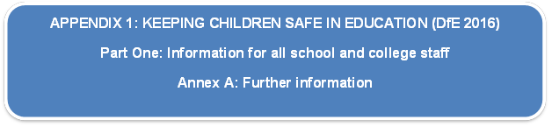

Staff must make sure they read this document and sign the declaration to say they have done so (see appendix 2)

https://www.gov.uk/government/publications/keeping-children-safe-in-education--2

Paper copies are available on request.

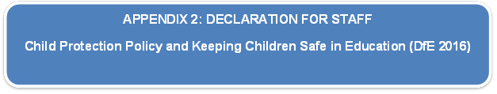
St John the Baptist C. of E. V.A. Primary School Academic Year: …2017-18
Please sign and return to Lydia Hunt (DSP) by …18th September 2017

I, ___________________________________________ have read and am familiar with the contents of the following documents and understand my role and responsibilities as set out in these document(s).:

(1) The Schools Child Protection Policy
(2) Part 1 and Annex A of 'Keeping Children Safe in Education' DfE Guidance , 2016
Staff Code of conduct

I am aware that the DSPs are:
……………………………………………………………………… ……………………… …………………..
……………… ……………………… ……………………………… ……………… …………………………

……………………………………………………………………………………………………………………
……………… ……………………… ……………………………… ……………… ………………………..

and I able to discuss any concerns that I may have with them.

I know that further guidance, together with copies of the policies mentioned above, are available in the policies folder on the staff network and in the Headteacher’s office

Signed_____________________________________________ Date____________________

APPENDIX 3: WHAT TO DO IF YOU ARE WORRIED A CHILD IS BEING ABUSED: ADVICE FOR PRACTITIONERS (DfE 2015)
Flowchart

APPENDIX 3: WHAT TO DO IF YOU ARE WORRIED A CHIL

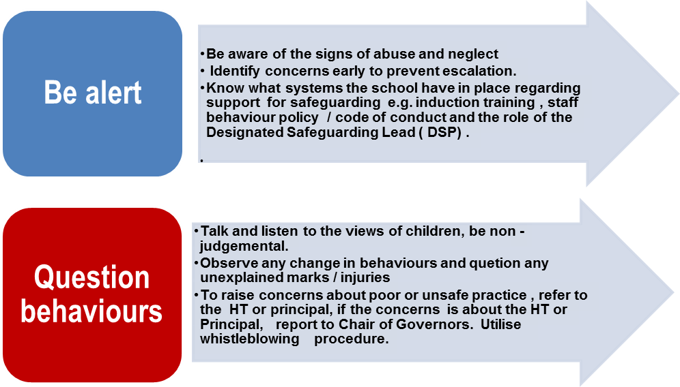

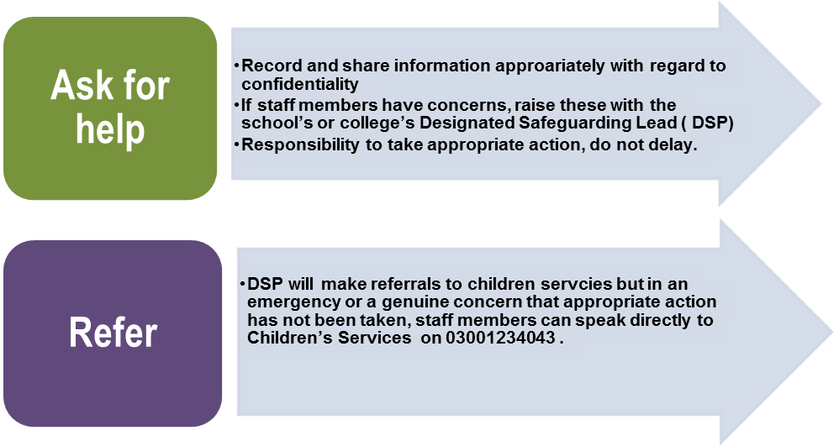

APPENDIX 4: INDICATORS OF ABUSE AND NEGLECT

The framework for understanding children’s needs:
Working Together to Safeguard Children (DFE, 2015)

Physical abuse
A form of abuse which may involve hitting, shaking, throwing, poisoning, burning or scalding, drowning, suffocating or otherwise causing physical harm to a child. Physical harm may also be caused when a parent or carer fabricates the symptoms of, or deliberately induces, illness in a child.
Child
Bruises – shape, grouping, site, repeat or multiple | Withdrawal from physical contact
Bite-marks – site and size  Burns and Scalds – shape, definition, size, depth, scars | Aggression towards others, emotional and behaviour problems
Improbable, conflicting explanations for injuries or unexplained injuries | Frequently absent from school
Untreated injuries | Admission of punishment which appears excessive
Injuries on parts of body where accidental injury is unlikely | Fractures
Repeated or multiple injurie | Fabricated or induced illness -
Parent | Family/environment
Parent with injuries | History of mental health, alcohol or drug misuse or domestic violence.
Evasive or aggressive towards child or others | Past history in the family of childhood abuse, self-harm, somatising disorder or false allegations of physical or sexual assault
Explanation inconsistent with injury | Marginalised or isolated by the community.
Fear of medical help / parents not seeking medical help | Physical or sexual assault or a culture of physical chastisement.
Over chastisement of child

Emotional abuse
The persistent emotional maltreatment of a child such as to cause severe and persistent adverse effects on the child’s emotional development. It may involve conveying to a child that they are worthless or unloved, inadequate, or valued only insofar as they meet the needs of another person. It may include not giving the child opportunities to express their views, deliberately silencing them or ‘making fun’ of what they say or how they communicate. It may feature age or developmentally inappropriate expectations being imposed on children. These may include interactions that are beyond a child’s developmental capability, as well as
over protection and limitation of exploration and learning, or preventing the child participating in normal social interaction. It may involve seeing or hearing the ill-treatment of another. It may involve serious bullying (including cyber bullying), causing children frequently to feel frightened or in danger, or the exploitation or corruption of children. Some level of emotional abuse is involved in all types of maltreatment of a child, though it may occur alone.
Child
Self-harm | Over-reaction to mistakes / Inappropriate emotional responses
Chronic running away | Abnormal or indiscriminate attachment
Drug/solvent abuse | Low self-esteem
Compulsive stealing | Extremes of passivity or aggression
Makes a disclosure | Social isolation – withdrawn, a ‘loner’ Frozen watchfulness particularly pre school
Developmental delay | Depression
Neurotic behaviour (e.g. rocking, hair twisting, thumb sucking) | Desperate attention-seeking behaviour
Parent | Family/environment
Observed to be aggressive towards child or others | Marginalised or isolated by the community.
Intensely involved with their children, never allowing anyone else to undertake their child's care. | History of mental health, alcohol or drug misuse or domestic violence.
Previous domestic violence | History of unexplained death, illness or multiple surgery in parents and/or siblings of the family
History of abuse or mental health problems | Past history in the care of childhood abuse, self harm, somatising disorder or false allegations of physical or sexual assault
Mental health, drug or alcohol difficulties | Wider parenting difficulties
Cold and unresponsive to the child’s emotional needs | Physical or sexual assault or a culture of physical chastisement.
Overly critical of the child | Lack of support from family or social network.

Neglect
The persistent failure to meet a child’s basic physical and/or psychological needs, likely to result in the serious impairment of the child’s health or development. Neglect may occur during pregnancy as a result of maternal substance abuse. Once a child is born, neglect may involve a parent or carer failing to:
• provide adequate food, clothing and shelter (including exclusion from home or abandonment);
• protect a child from physical and emotional harm or danger;
• ensure adequate supervision (including the use of inadequate care-givers); or
• ensure access to appropriate medical care or treatment.

It may also include neglect of, or unresponsiveness to, a child’s basic emotional needs.
Child
Failure to thrive - underweight, small stature | Low self-esteem
Dirty and unkempt condition | Inadequate social skills and poor socialisation
Inadequately clothed | Frequent lateness or non-attendance at school
Dry sparse hair | Abnormal voracious appetite at school or nursery
Untreated medical problems | Self-harming behaviour
Red/purple mottled skin, particularly on the hands and feet, seen in the winter due to cold | Constant tiredness
Swollen limbs with sores that are slow to heal, usually associated with cold injury | Disturbed peer relationships
Parent | Family/environment
Failure to meet the child’s basic essential needs including health needs | Marginalised or isolated by the community.
Leaving a child alone | History of mental health, alcohol or drug misuse or domestic violence.
Failure to provide adequate caretakers | History of unexplained death, illness or multiple surgery in parents and/or siblings of the family
Keeping an unhygienic dangerous or hazardous home environment | Past history in the family of childhood abuse, self harm, somatising disorder or false allegations of physical or sexual assault
Unkempt presentation | Lack of opportunities for child to play and learn
Unable to meet child’s emotional needs | Dangerous or hazardous home environment including failure to use home safety equipment; risk from animals
Mental health, alcohol or drug difficulties

Sexual abuse
Involves forcing or enticing a child or young person to take part in sexual activities, not necessarily involving a high level of violence, whether or not the child is aware of what is happening. The activities may involve physical contact, including assault by penetration (for example, rape or oral sex) or non-penetrative acts such as masturbation, kissing, rubbing and touching outside of clothing. They may also include non-contact activities, such as involving children in looking at, or in the production of, sexual images, watching sexual activities, encouraging children to behave in sexually inappropriate ways, or grooming a child in preparation for abuse (including via the internet). Sexual abuse is not solely perpetrated by adult males. Women can also commit acts of sexual abuse, as can other children.
Child
Self-harm - eating disorders, self-mutilation and suicide attempts | Poor self-image, self-harm, self-hatred
Running away from home | Inappropriate sexualised conduct
Reluctant to undress for PE | Withdrawal, isolation or excessive worrying
Pregnancy | Sexual knowledge or behaviour inappropriate to age/stage of development, or that is unusually explicit
Inexplicable changes in behaviour, such as becoming aggressive or withdrawn | Poor attention / concentration (world of their own)
Pain, bleeding, bruising or itching in genital and /or anal area | Sudden changes in school work habits, become truant
Sexually exploited or indiscriminate choice of sexual partners
Parent | Family/environment
History of sexual abuse | Marginalised or isolated by the community.
Excessively interested in the child. | History of mental health, alcohol or drug misuse or domestic violence.
Parent displays inappropriate behaviour towards the child or other children | History of unexplained death, illness or multiple surgery in parents and/or siblings of the family
Conviction for sexual offences | Past history in the care of childhood abuse, self harm, somatising disorder or false allegations of physical or sexual assault
Comments made by the parent/carer about the child. | Grooming behaviour
Lack of sexual boundaries | Physical or sexual assault or a culture of physical chastisement.

