[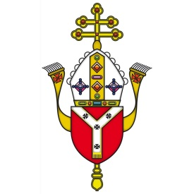](http://www.google.co.uk/url?sa=i&rct=j&q=&esrc=s&frm=1&source=images&cd=&cad=rja&uact=8&ved=&url=http://rcdow.org.uk/diocese/jobs-archive/&psig=AFQjCNFE_aKr2qt2yfV3TxMGUgOTc_BW6g&ust=1461405392081593)

**St. Philip Ho Diocese of Westminster**

**St Philip Howard Catholic School**

Woods Avenue, Hatfield AL10 8NN

🕿: 01707 263969

Email: [bursar@sphoward.herts.sch](mailto:bursar@sphoward.herts.sch)

[www.sphoward.herts.sch.uk](http://www.sphoward.herts.sch.uk)

Headteacher: Mairéad Waugh

[Hertfordshire County Council](http://www.thegrid.org.uk/)

**Foundation Stage Teacher required for September 2016**

Due to a retirement, the Governors are seeking to appoint a dedicated and enthusiastic teacher to join our successful and popular school.

We are looking for a teacher who is:

* A practising Catholic or has a firm commitment to the Catholic ethos of the

school and is able to actively contribute to that ethos

* able to inspire, nurture and motivate learners
* lively and forward thinking
* an outstanding classroom practitioner

Applications are welcome from experienced and newly qualified teachers.

Our Diocese Inspection (October 2015) said:

*“Pupils benefit from the excellent Catholic education they receive… The school is a very welcoming community and promotes respect in relationships at all levels… Pupils spoke warmly about the school and are proud to belong to the community… The friendly and warm approach of staff is a real strength of the school.”*

Ofsted (November 2014) said:

* *Pupils are extremely polite and well-mannered and their behaviour is excellent. They listen very well to their teachers and to each other and show a high level of acceptance and care towards others.*
* *Relationships throughout the school are excellent and a real strength.*
* *A delightful atmosphere pervades the school that contributes to pupils’ good learning.*

**Visits are warmly welcomed and encouraged. Please contact Mairéad Waugh, Headteacher, for a tour of the school and more information.**

Closing date: Tuesday 10th May 2016

Interviews: Week beginning Monday 16th May 2016

The school is committed to safeguarding and promoting the welfare of children and all appointments are subject to the necessary checks being carried out.

