Teaching and Learning Policy

Aims and Purposes
In order to raise standards our focus must be securely on teaching and learning. Continued and sustained improvement is dependent upon improving and sustaining the quality of teaching and learning that is taking place on a daily basis. Across our two schools the expectation is that all pupils are provided with high quality learning experiences that lead to consistently high levels of pupil achievement.
We expect every teacher to be at least good, preferably outstanding, no child deserves less.
By adopting a whole school approach to teaching and learning across both schools, we aim:

- To provide consistency of teaching and learning across our schools
- To enable teachers to teach as effectively as possible
To enable children to learn as efficiently as possible
- To give children the skills they require to become effective lifelong learners
- To provide an inclusive education for all learners
- To learn from each other through the adoption of a collaborative, enquiry-based approach to teaching and learning where good practice is shared

There is no single recipe for improving teaching and learning in our schools. However, this policy outlines some of the key elements which are key to raising standards in teaching and learning. It also sets out a broad structure for lessons, based on best practice and research linked to how we best learn.

When reading this policy it is important to remember that adopting a broad template for structuring lessons does not preclude: Spontaneity, Creativity, Imagination and Individuality … unless you let it!

Key elements and principles of teaching and learning across our schools – a practical summary guide.

All lessons should include the following key elements to ensure high quality teaching and learning. New teachers to our schools will receive training to ensure they fully understand these elements and to enable them to embed these strategies in their everyday practice.
1. Clear learning objectives
- Learning objectives are shared orally, displayed and copied (or pasted) into children’s books
- All learning objectives begin with “At the end of this lesson I will know / be able to / understand” …
- All learning objectives are written up and explained in child friendly language.
- Learning objectives are not muddled up with the context of the lesson.
- When marking children’s work, the main focus is on meeting the learning objective.

2. Well planned success criteria

- All pupils are clear about how they will achieve the learning objective.
- Success criteria are displayed for the pupils to follow during the lesson or are drawn up with the pupils.
- Weekly planning includes success criteria for each learning objective.
- Pupils use the success criteria to self-assess their own or their partner’s work.
- Pupils are reminded of the success criteria during the lesson – often pupil’s work is used to illustrate the success criteria.

3. Clear differentiation to enable all pupils to access learning.

- All learners are challenged appropriately
- Planning shows clear differentiation
- Learning objectives are the same for all children.

4. All pupils are actively engaged in learning.

- Pupils are actively engaged during all parts of the lesson.
- Opportunities for think / pair / share and discussion with a talk partner are regular features in our lessons.
- Pupils are trained to use appropriate body language when engaged in discussion with a talk partner.
- Mini whiteboards are used for short bursts of activity, to develop understanding and to ensure children are active and engaged during the lesson.
- Visuals, artefacts, auditory input are all used creatively as a way to enhance learning.

5. All pupils receive regular and clear feedback which enhances learning.

- AfL and effective marking is embedded in everyday practice and is used to inform teaching and learning.
- All pupils are clear about how they need to improve.
- Marking is linked to the learning objective and identifies next step prompts.
- Pupils are given regular time to address issues raised in marking using a XXX pen / pencil.

All pupils should be able to list these standards and explain what they look like / sound like / feel like in action. Co-operative learning will be embedded in both of our schools.

Standards must be:
- Specifically taught
- Used consistently throughout the day
- Reinterpreted when new learning is introduced
- Positively reinforced
- Continually reviewed

A. Learning is enhanced through the use of ICT.
- ICT is used to enhance learning where ever possible.
- Although ICT is frequently used at the start of lessons to engage children and in the plenary to consolidate learning, it is also used during the lesson as an aid to learning.
- The use of ICT is highly visible and effective in all teaching and learning contexts across our schools and teachers are continually searching for ways to use technology as a learning tool.

B. Learning is enhanced through co-operative learning.
- Co-operative learning refers to a set of instructional methods in which children work in small, mixed-ability learning teams. The children in each teach are responsible not only for the learning material themselves, but also for helping their team learn.
- Although co-operative learning features primarily in topic lessons, it can and should be used across the curriculum.
- Before co-operative learning can be implements, positive teamwork behaviours need to be explicitly taught and reinforced.

C. Learning is enhanced through the use of consistent classroom management signals
Clear management signals are designed to minimise the time spent on behaviour management and maximise the time spent on learning.
All our staff must consistently follow the same signals:
- 1,2,3 when moving from the carpet to tables, teachers use 1 (still and quiet), 2 (get ready) and 3 (move).
- Zero noise: to stop the class and get everyone’s attention, the zero noise signal is used. This is non-verbal. The expectation for pupils is that once they see the signal they finish the sentence they are writing or saying, remain quiet and look at the speaker (with magnet eyes!).
- Active listening: To ensure active listening, particularly on the carpet (perhaps after a discussion or activity) the active listening signal is used. Again this is non-verbal – the children “show” the adult they are ready.
D. Learning is enhanced through the effective use of additional adults
- Additional adults are clearly directed to support learning.
- Learning Support Practitioners (LSPs) are fully engaged with pupils on the carpet and at tables during lesson times. They are not photocopying work, sharpening pencils or sticking work in books during learning time! LSPs are clear about who they are supporting and why.
- Planning is shared in advance with LSPs.
- LSPs sit next to the pupil / pupils they are working with quietly engaging the pupils, explaining the task or using the resources e.g. number line, to facilitate learning.
- They are involved in assessing pupils’ understanding, recording observations and feeding assessments to the teacher.

Our Co-operative Learning Standards are:
- Practice active listening
- Help and encourage each other
- Everyone participates
- Explain your ideas / tell why
- Complete tasks

A detailed guide to our lesson structure
All lessons in our schools should follow a basic structure made up of four parts.
Phase One: Set the scene, place learning in a wider context, link to prior learning; review previous lesson; provide the ‘big picture’; share learning objectives

Phase Two: Pupils receive new information; instruction / exposition

Phase Three: Pupils make sense of information; processing; understanding

Phase Four: Review information and plan next steps
Precise interpretation of the four phase structure will inevitably be very different in different situations. Age, ability, timing of the lesson, subject area and the particular focus for the lesson will all have a significant impact.
Teachers may well scroll through the phases more than once during the lesson. For example, after a short period of exposition, pupils may be engaged in an activity designed to help them make sense of new material. This may be followed by another period of exposition and an appropriate exercise. (mini plenaries)
The phases are not always sequential. Review, for example, is not confined to the end of the lessons. Good teachers weave review through the entire lesson and know that success criteria are only successful when repeated and referred to throughout the lesson.

Teaching and learning are not the same thing. Encountering information is not the same as understanding it. While stages are inextricably linked, they are separate processes. This must be reflected in the lesson.

Diagram from Tweak to Transform: Improving Teaching: A Practical Handbook for School Leaders, Mike Hughes (2002)
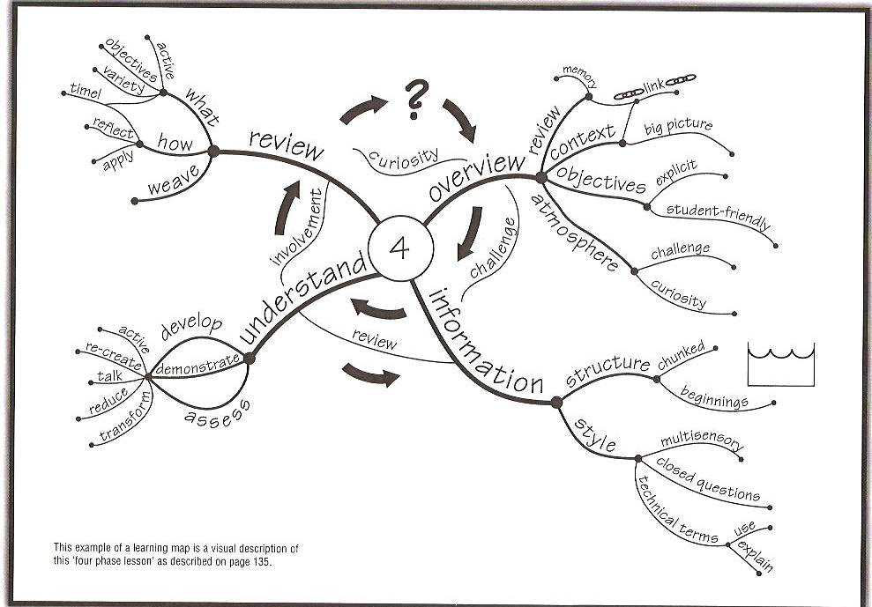

Phase One – Overview

Although this is relatively short in duration it includes a number of key features. The emphasis on this phase is on:

Creating an appropriate working atmosphere
Pupils will not learn if they are in an appropriate state to learn. We use a range of metacognition strategies to establish a climate conducive to learning including:
- Creating a classroom environment that is stimulating, reassuring and organised;
- Being fully prepared for lessons. Ensuring resources are prepared and on tables in advance of lessons;
- Other adults to sensitively engage with a pupil who is not ‘ready to learn’;
- Greeting pupils with a smile!

Linking the lesson to prior learning
Linking the lesson to prior knowledge e.g. reviewing previous lesson;
- Think about the three most important things you learnt in the last lesson – now tell your partner.
- In two minutes I am going to ask you what you learnt last lesson. You may talk to your partner if you wish.
- Today’s lesson is about the water cycle. Jot down on your whiteboards what you already know. Work in pairs.

Providing an overview
The brain is more likely to absorb detail when it can place them within a wider context. This is often referred to as providing the ‘big picture first’. Curriculum learning walls in all classes include a topic map to enable pupils to see the ‘bigger picture’. Pupils add their own questions and answers to the learning map and are encouraged to carry out their own independent research at home.

Sharing learning objectives with pupils
Pupils must know exactly what they are going to learn and what is expected of them by the end of the lesson. For learning objectives to be shared effectively, teachers must:
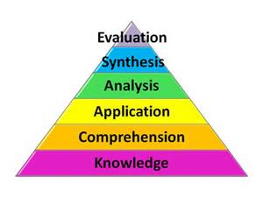
- Move away from saying “today we are doing …” and instead say “By the end of today’s lesson you will all know / be able to understand …”
- Make learning objectives specific e.g. use Bloom’s taxonomy (see picture).
- Use child-friendly language – there is little point in sharing a learning objective if pupils don’t understand what you mean.
- Refer to them at the start of the lesson and during the lesson

Triggering the brain
The brain will tend to notice things if it has been primed to look for them. Beginning a lesson by saying: “Today when I am reading I want you to listen out for some really powerful adjectives that you can use in your own writing later on.” Or “For homework tonight, I am going to be asking you to write down the functions of the different parts of a plant – you will find out what they are in today’s lesson”.

Phase Two – Receiving New Information

The emphasis in this phase is on providing pupils with new information or skills. This is the teaching phase. Although we want all pupils to understand the information as they encounter it, the emphasis during phase two is on providing the new information. New information is delivered in many ways:
- Exposition
- Audio-visual aids e.g. video clips
- Diagrams, pictures etc.
- ICT
- Demonstration
- Modelling
- Books

The quality of the input during this phase will have a big bearing upon the extent to which pupils understand information. While high-quality exposition does not guarantee understanding, it does make it significantly more likely. We use a number of techniques across our schools to ensure that the quality of input in phase two is kept high.
Periods of exposition are short
Pupils have limited concentration spans. A widely used and useful rule of thumb is that concentration spans will be about two minutes in excess of a chronological age. Periods of exposition are therefore kept short and punctuated by regular breaks or activities. In general terms, significantly more learning will take place when new information is transferred and explained in three bursts of ten minutes rather than in one long session of thirty minutes.

More than one ‘beginning’ is created
Pupils tend to remember more t=from the beginning of an experience. When exposition is chunked into 10-15 minutes slots, a number of ‘beginnings’ are created in the lesson. Make the new start obvious. Use phrases such as “Now we are moving on to …” or “The next activity we are going to be doing is …” or “I want you to move back to the carpet for the next part of our lesson”.

The input phase needs to be punctuated with questions
Although phase two is principally about exposition and delivering new information, it should be punctuated by regular questioning. Ask regular closed questions during the input. This will keep pupils alert and provide instant feedback as to whether they have heard correctly and have understood – although at a shallow level. Asking too many open question during an explanation can easily take a lesson off on inappropriate tangents. It also allows an individual to take the lesson off in a direction that causes other pupils to lose their train of thought.
Ask open questions before and / or after an input. Posing an open question at the start of an explanation will prime the brain to notice detail and begin to form an answer, even at a subconscious level, during the input. Asking an open question at the end of an input takes the learning into phase three and is designed to develop and assess deeper understanding. The input phase is punctuated with activity (model whatever you want the children to do).

Punctuate the input of new information with activities designed to help pupils make sense of it (phase three)
This kind of integrated ‘phase two, phase three’ can often be more effective than an extended period of explanation. For example, a teacher might be modelling how to write complex sentences. She might ask the children to work with a partner to write one together on a mini whiteboard before continuing further instruction.

New information is presented in several different ways (VAK)
The fact that people prefer to receive information in different ways demands that information is transmitted in more than one way during phase two. A verbal explanation may well be clear and concise and of high quality. However, two-thirds of the class may be working outside of their preferred style or have English as an additional language and struggle to grasp what is being said.

We aim to make learning multi-sensory so that all pupils have opportunities to learn from seeing, hearing and doing.
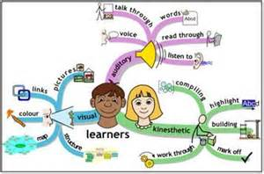

Phase Three – processing the information

The emphasis in phase three is on:

- Developing understanding
- Demonstrating understanding
- Assessing understanding

This is the key phase.

The extent to which pupils will understand information depends on these factors:
Quality of Interactions
It is adults who help pupils make sense of information. The frequency and nature of interaction between teacher and pupils is highly significant. We develop understanding by:

- Using open-ended questions
- Providing wait-time, pupils need time to think through their answers before replying
- Providing thinking time by giving an advance warning, such as “In two minutes I am going to ask you…”
- Allowing pupils to explore and articulate their thinking by giving them time ot discuss their responses in pairs or groups. Pupils then respond with “We think that …”
- Ensuring pupils fully understand the question by asking them to say it back or rephrase it.
- Extending and deepening understanding by asking follow-up questions such as “What made you think that?”

- Asking pupils to identify three possible answers and then select the best on (so they don’t always give you the first answer that pops into their head).
- Scaffolding thinking and answering for example: “In two minutes I am going to ask you X, but before I do I’d like you to think about (or talk about) A. Now I’d like you to think about B. Now can you respond to my original question?”

Talking and Interaction

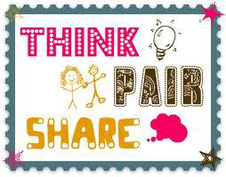
Across our two schools we believe that talking and interaction are central to learning. All lessons include planned and unplanned opportunities to discuss questions and extend thinking. We us the co-operative learning standards in all that we do as well as a range of Assessment for Learning (AfL) strategies.
We learn:
10% of what we read
20% of what we hear
30% of what we see
50% of what we see and hear
70% of what we discuss with others
80% of what we experience
95% of what we teach to others
William Glaser (1960s)

Our Co-operative Learning Standards are:
- Practise active listening
- Help and encourage each other
- Everyone participates
- Explain your ideas / tell why
- Complete tasks

Phase Four – Review

The emphasis in this phase is on:

- Reviewing what has been learned
- Reflecting on how and why it has been learned
Review is a key to memory and certainly not confined to the end of the lesson. Good teachers weave review throughout the entire lesson and are constantly referring pupils back to the success criteria of the lesson, and reinforcing prior learning. Reviewing material is a highly significant part of the learning process, not least because large amounts of information can be forgotten very quickly.

Pupils are actively involved
When teachers summarise what has been learned, the effect on the pupils’ memories is relatively insignificant. However, when the pupils themselves identify what they have learned as the lesson draws to a close, their memories will be given a significant boost.

Always refer back to the learning objectives and success criteria
Encourage pupils to reflect on what they have learned and what has helped them to learn. Use prompts like:
- What did you do today that you found most helpful when you were learning?
- What did you do today that you found less helpful?
- If you had to do the task again, how would you do it?
- If you have to give one piece of advice to someone tackling the same task tomorrow, what would it be?

Teaching and Learning Activities are designed to provide pupils with opportunities to meet the Learning Objective
Feedback is based on the Learning Objective and the Success Criteria
Teacher Questioning always keep the Learning Objective in focus
Success Criteria are directly related to the Learning Objective
Pupils Self-assess in the light of the Learning Objective and the Success Criteria
The Assessment Task / Activity matches the Learning Objective

Learning Objective

Classroom Environments

The surrounding in which pupils learn can greatly influence their academic performance and well-being in our schools. The better our school looks, the more it inspires the people inside it. A well cared-for classroom and school can make pupils feel that what they achieve and how they themselves are perceived is important.

We aim to ensure that all classrooms, group learning areas and whole school areas are spaces that everyone can use to learn and be proud of.

Details of what is expected in all classrooms can be found in our Staff Handbook.
In our school we believe that classrooms should be bright, well organised learning spaces. Pupils need to know how to access resources and respect the classroom environment. Each teacher differs about how they will organise their classrooms. However, to ensure a sense of security and consistency across the schools, the points below need to be adhered to in all classes:

- Class rules / code of conduct is on display in all classes
- Learning walls that have a theme are displayed in/out of each class for English, mathematics, science and topic.
- Classrooms are tidy, labelled and organised.
- Pupils take responsibility for ensuring their classroom is a pleasant and safe place to learn.
- Pupils are taught to respect equipment and resources.
- Basic equipment (pens, pencils, rulers …) is out on tables at all times – pupils do not have to waste time getting these items from trays etc.
- In KS2 reading and spelling books should be on the table at all times.
- All trays are clearly labelled – word processed, not hand-written.
- Grouping, e.g. Maths, writing etc. are on display in the class.
- Displays are a learning resource – they are not just a reflection of previous learning. All displays are labelled and changed regularly.

Marking and Feedback

Marking has the potential to be the most powerful, a manageable and useful diagnostic record of achievement, Shirley Clarke (2001)

We think of marking in terms of feedback about a pupils’ work. This feedback may take a number of forms: oral; written; formal and informal; and may be given on a group basis as well as an individual one. The nature of marking influences and encourage the learner and gives her / him the confidence to take another learning step.

Full details are found in our Marking and Feedback Policy.

Pupils’ Self and Peer Assessment
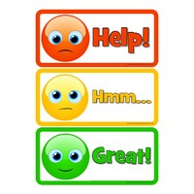
All assessment should be used to inform future groupings, planning and activities. Pupils should be taught how to self and peer assess before being given opportunities to undertake these assessments in lessons.

Agreed by Outcomes Committee
Agreed by Full Governors
Next update due

