Our aim is to inspire children to ask questions of the world around them, based on the principle of ‘learning through play’.
Our emphasis is on fun and children are encouraged to participate in a variety of structured activities designed to lay down a solid foundation of skills, both physical and social, that will promote the learning habit which can be built upon at primary school.
Our preschool is run by fully qualified staﬀ who are constantly updating their knowledge and skills to ensure the school reaches its full potential in working towards the ‘Early Learning Goals’ of the Early Years Foundation Stage of the National Curriculum, as laid down by Ofsted.


Starting PreSchool

Knebworth Recreation Ground

Children start with us at Stepping Stone at two although parents do have the option to defer for one term. If after one term, you feel that your child is still not ready for school, you can remain on our waiting list until a space becomes available.
Before you start, we invite you and your child to join us for a ‘Stay & Play’ session at school. At this time, we discuss with you how best to introduce your child to school and how we can settle him or her into preschool life. We operate a key person

system; the key person is a member staﬀ who takes an extra special interest in your child’s development and they will be present at the Stay and Play session. To further build on the bond between key person and child, we like to come and visit you at home. This home visit lasts about half an hour and gives you a chance to liaise closely with staﬀ and discuss with them information on the likes and dislikes of your child by highlighting the little idiosyncrasies that make your child the unique individual that they are.
Our two year olds, usually start with us on Tuesday and Thursday mornings but these can be changed to fit in with you. These sessions are staﬀed to a higher ratio with all activities being geared toward the specific needs of very small children as they start to become more independent.

Stepping Stone PreSchool Prospectus 01
April 2022

Play and Learning at Stepping Stone
Play to children means something diﬀerent than that understood by adults. To adults play is the absence of work, whereas children work at playing. The whole of their being is absorbed in the activity at hand, whether it is construction, painting, climbing, ‘reading’ books or buying some sausages for dinner!
Therefore the way a child learns is through play.

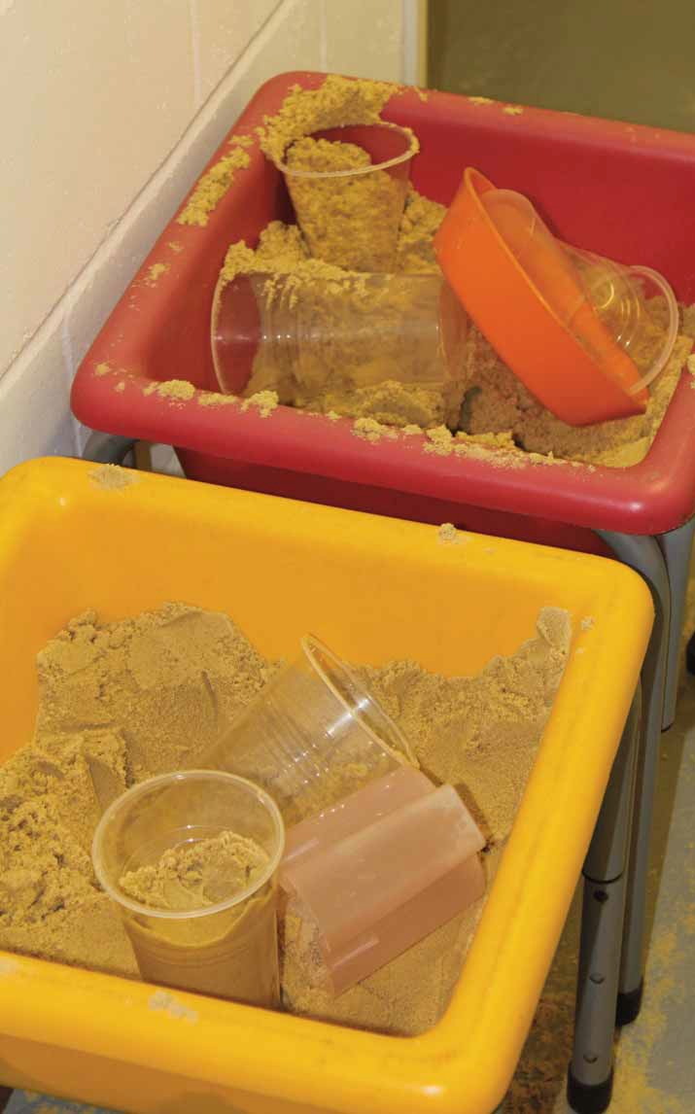
To reach the standard demanded by Ofsted, a group must cover the following criteria of the Early Years Foundation Stage & to be working towards the Early Learning Goals.
- Communication and Language
- Physical Development (fine and gross motor skills)
- Personal, Social and Emotional Development
- Literacy
- Mathematics
- Understanding the world
- Expressive Arts and Design

A wide range of activities are planned each term within the curriculum. These are designed to explore the elements of the above criteria on a daily basis. We aim to provide many new experiences and many diﬀerent resources for the children to use and explore!

Play and Learning at Stepping Stone

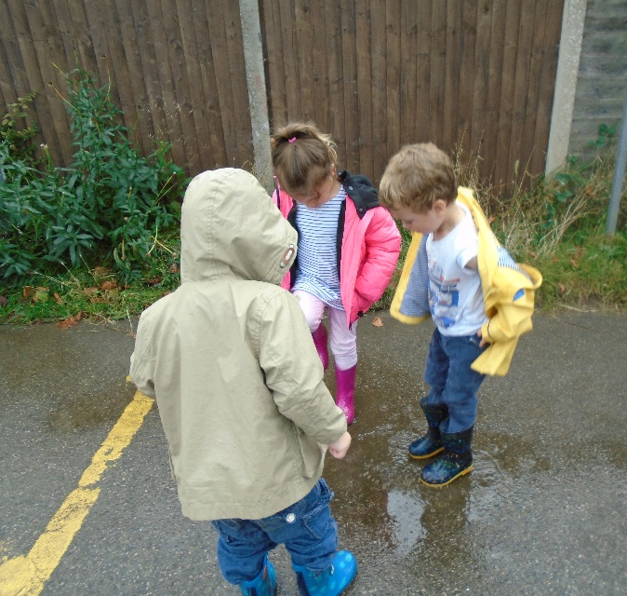

All Boys race, Sports Day

We occasionally take walks into to the village and often to the park that surrounds us. We use these opportunities to underpin the aspects of the Early Years Curriculum that we focus on and to encourage the outside learning for which are known.
Visitors occasionally come in to school and share their talents with us. We’ve had beekeepers, cake makers, the emergency services and postmen to name but a few.

Stepping Stone PreSchool Prospectus 02
April 2022

Sessions at PreSchool
At two years, two sessions per week are suﬃcient. We usually take our 2 year olds on Tuesday and Thursday mornings if fees are payable but are flexible with different mornings to suit you, funded 2 year olds may be able to attend 15 hours a week. We provide a ratio of one adult to four children for these sessions, as required by Ofsted. The curriculum for these sessions has an emphasis on the child feeling comfortable and secure when away from their parent/guardian. The foundation stones of social behaviour are laid down, time is spent getting to know each other, interacting, building trust and, of course, having fun!
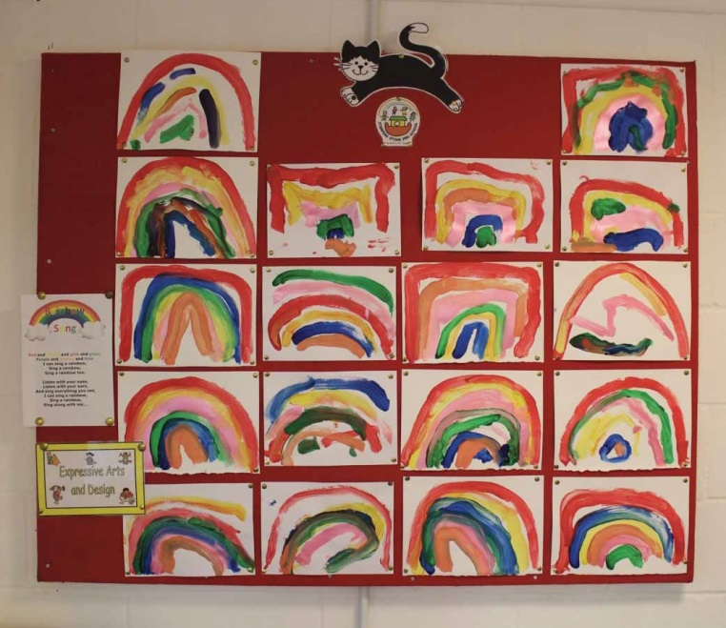
The term after your child turns three they become eligible for ‘funded sessions’ and they will have progressed into 15 hours.
These sessions are flexible hours and can be five sessions or four sessions and three lunch clubs. This is when the curriculum starts to place more emphasis on the criteria laid down by Ofsted for the ‘Early Learning Goals’.
For the last three terms of preschool (Nursery sessions) children have a total of five sessions per week in the afternoon. During these sessions we have regular additional activities such as, music,
cooking, yoga, ballet, sewing and science at no extra cost. We aim to provide an all-round and complete balance of experiences in order to ready your child for the next step; Primary School. As most of our children go on to Knebworth Primary School we have close links with them and have regular participation with the teachers from the reception classes. We have always arranged settling sessions with all of the schools Stepping Stone Nursery children move on to. Places are limited for our Nursery sessions and are allocated separately from morning sessions. Please see our admission criteria at the back of the prospectus and check with the preschool for cut oﬀ dates.

Lunch Club
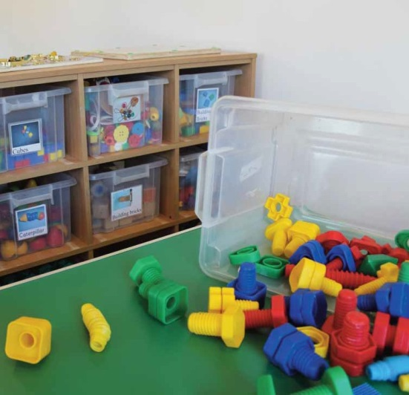
We run a lunch club daily between the morning and afternoon sessions staﬀed by faces familiar to the children. All children are welcome to come to lunch club. This enables parents to extend their child’s session by one hour. Parents provide lunch and afterward there is time for fun and play. Sessions may be booked a term in advance, although we oﬀer flexibility at short notice subject to availability. The current cost is £6. You will be advised by the preschool manager if you are entitled to any funded lunch clubs as part of your two, three or four year old free entitlement.

Stepping Stone PreSchool Prospectus 03
April 2022

Arrival and Collection of Children
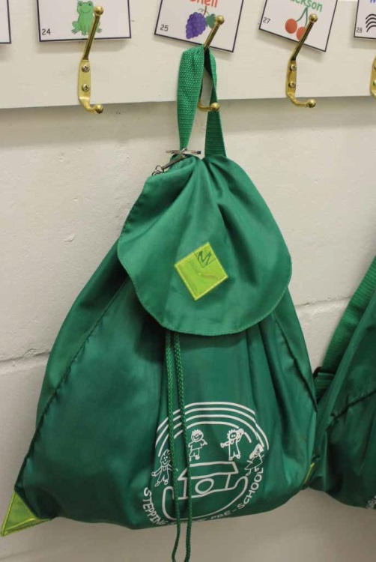
The morning pre school session starts at 8.30am and ends at 11.30am. The afternoon nursery session starts at 12.30pm and ends at 3.30pm.
The children are signed in on entry using only the main door to the pavilion. In reverse the children are signed out on exit and the same system operates. The back door must not be used. Please be aware that children can only be collected from school by a parent or guardian or person known to us. If there is any alteration to normal arrangements we must be notified in advance. We reserve the right to refuse to allow a child or children to be removed from school premises by persons not named or authorised specifically by a child’s parent or guardian. We are sure that you appreciate the importance of this policy.

Drinks and Snacks
We provide a small snack with milk or water for your child during the morning session only. The cost is 20p which will be added to your monthly invoice. Water bottles are provided for the children, this will be refilled, if necessary, during the session.

Illness
We all suﬀer from illness from time to time and little children are no exception. If you are keeping your child at home due to illness, please call in and tell us; we need to make a note of this on the register.
Likewise, if we feel that your child is under the weather, we will contact you. It is our firm belief that poorly children should be at home! Not only does this reduce the risk of cross infection but far kinder to the child.
There are some illnesses that require exclusion from school and a recognised period of absence before returning. The most common of these are:
- German Measles (Rubella)
- Chicken Pox
- Measles
- Mumps
- Whooping Cough
- Glandular Fever
- Impetigo
- Ringworm

Head lice and conjunctivitis are not recommended for exclusion but here at Stepping Stone, any child with either of these will be sent home to minimise the risk of ‘sharing’ the complaint.
Stepping Stone PreSchool Prospectus 04
April 2022

Members of Staﬀ
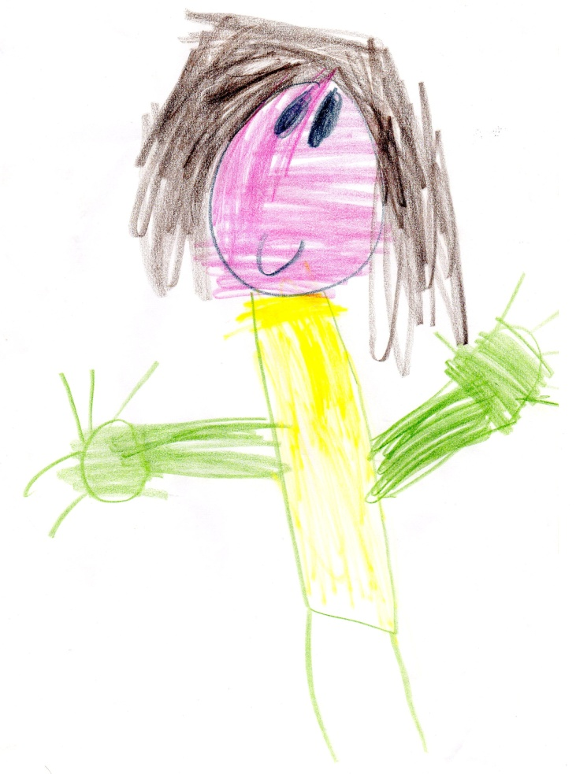

Lisa Geary

EARLY YEARS MANAGER, Level 3
Safeguarding Officer
Special Educational Needs Support

Terri Williams

EARLY YEARS DEPUTY MANAGER & ADMINISTRATOR, Level 3
Safeguarding Lead
Student Liaison
Special Educational Needs Coordinator

Jodie Green
EARLY YEARS PRACTIONER, Level 3

Billie Ellis
EARLY YEARS ASSISTANT, Level 2 Student

Liz Carter
EARLY YEARS ASSISTANT, Level 3 Student

Kristy Barton
EARLY YEARS ASSISTANT

Parents and Guardians

We encourage parents and guardians to help within preschool. This helps to bond the pre school with home, is great fun and provides an important insight as to how the school is run. If you would be interested in spending a session with us, please just come in and talk to the staﬀ. We would be very pleased to have you join us!

PreSchool Management Committee
Stepping Stone PreSchool is governed by an elected Management Committee. The Committee is a team of people made up of parents, past and present, and dedicated individuals who give of their time and skills to help manage the preschool, manage the finances and make sure the staﬀ and preschool follow procedures laid down by the relevant bodies. The Management Committee also has responsibility for, organises and manages fundraising events and activities that provide vital income for the preschool. All parents are welcome to join the committee and thus have a voice in the running of the Stepping Stone.

Stepping Stone PreSchool Prospectus 05
April 2022

Clothing
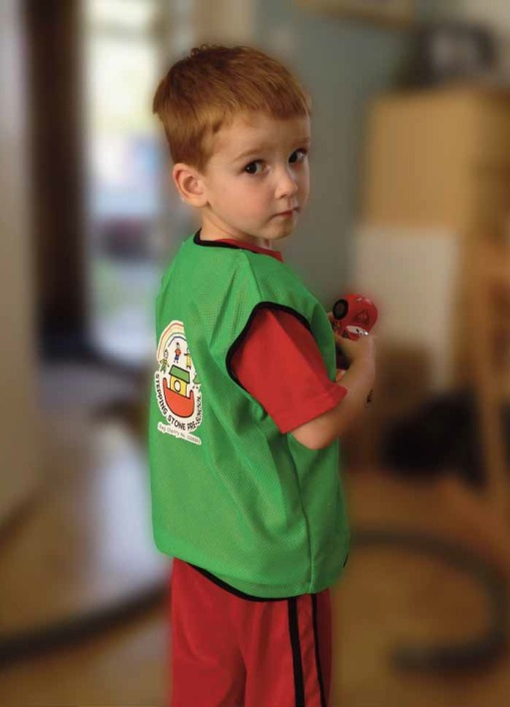
Stepping Stone children do not have a uniform. On our outings each child wears a distinctive Stepping Stone tabard and on starting every child is given the unique Stepping Stone bag. You have opportunity to buy sun hats and canvas tote bags sporting our logo.
As we do a lot of art and messy play we ask that your child be dressed in sensible clothes, washable, easy to wear and that you provide spare clothes in case of little accidents. We appreciate you providing a packet of baby wipes with these spare clothes. Shoes should be sturdy; no crocs or opened toe sandals as they inhibit running and climbing. In wet weather we ask that you provide a second pair of shoes for inside use. Spare shoes are also required if wellingtons are worn.

Jewellery
We would ask, from a safety point of view, that children do not wear jewellery. Chains, watches and earrings can get caught and cause an injury or accident. The only exception is for religious requirement.

Fire Drill
In order for the children to be familiar with how to evacuate the building in case of fire in a safe and controlled manner the procedure is practiced on a regular basis. Care is taken not to alarm the children during this practice and usually ends with an outside activity.

Risk Assessment
We perform a daily risk assessment. Observations are recorded and those that require urgent attention are acted on immediately.

Safeguarding Children
The staﬀ are always ready to discuss with you any concerns you have about your child. Our first responsibility is to the children in our care. If we have any concerns about the welfare or safety of a child, we have a duty to share these concerns with the appropriate authority.

Stepping Stone PreSchool Prospectus 06
April 2022
Summative Assessment
The Early Years Foundation Stage (EYFS) require early year’s practitioners to review children’s progress and share a summary with parents at two points.

- In the prime areas between 24 and 36months
- At the end of the foundation stage (EYFS) profile.
EYFS guidance might be used by early year’s settings throughout the EYFS as a guide to making best fit judgments about whether a child is showing typical development for its age, may be at risk of delay or is ahead for their age. Summative assessment supports information sharing with parents, colleagues and other settings.
Discipline
A child’s behaviour is usually governed by those around him or her. The need to be liked and accepted by his or her friends, more often than not, outweighs the need to misbehave. We aim to encourage the children to respect one another and their surroundings. If necessary their parents or guardians will be informed discreetly of any major incidents.

Equal Opportunities
At Stepping Stone PreSchool we believe that no child, individual or family should be excluded from the group’s activities on the grounds of gender, class, family status, means, disability, colour, ethnic origin, culture, religion or belief. We aim to ensure that all who wish to be involved with Stepping Stone Pre School, whether it is a child wishing to attend or a volunteer wishing to help, have an equal chance to do so. All children will be respected and their individuality and potential recognised, valued and nurtured. Activities and the use of play equipment oﬀer children the opportunity to develop in an environment free from prejudice and discrimination.
Opportunities will be given to children to explore, acknowledge and value similarities and diﬀerences between themselves and others.

Stepping Stone Policies
Our policies have recently been reviewed in line with the Pre School Learning Alliance standards and we regularly review and reassess our policies. A full set of school policies is held in the Pre-School and is available to view on request. This is to make sure you have access to the most recent versions of our policies If you need a copy of our policies, these can be provided upon request.

Complaints
From time to time issues occur. We would appreciate that initially any complaints be taken to the PreSchool
Manager who will advise you as the whether the issue needs to follow our Complaint Procedure.

Stepping Stone PreSchool Prospectus 07
April 2022

Come & see us!
We hope that you will choose Stepping Stone to help make these early learning and exploring days of your child’s development a happy and rewarding time. We’d love to hear from you to discuss your requirements and answer your questions and to arrange for you to visit us!
If you wish to register your child please fill out a registration form and return it to us as soon as possible as we have a long waiting list and we’d hate you to miss out!

And finally...

Fees
If your child is joining Stepping Stone PreSchool before the qualifying term for the three and four year old Nursery grant fees are £19.50 per session for 2 year olds, £18.00 for 3 & 4 year olds (term after 3rd birthday), £6.50 per lunch club and 20p for snack.
Fees are due half term in advance
Historically payment plans have been arranged to spread payments. If you wish to discuss the possibility of a payment plan please let us know.
The Nursery grant funds 15 hours per week. You may top this up with additional lunch clubs and we offer 30 hours funding for 3 to 4 year olds, subject to availability.
School terms are:
Autumn (birthdates September to December) Spring (birthdates January to March) Summer (birthdates April to August)



Stepping Stone PreSchool Prospectus 08
April 2022
Stepping Stone PreSchool (open 8.15am to 3.45pm) Knebworth Sports Pavilion
Knebworth Recreation Ground
Watton Road, Knebworth, SG3 6AH

(01438) 813070
info@steppingstonepreschool.org.uk www.steppingstonepreschool.org.uk

Applications, Regulatory and
Contact (ARC) Team
Ofsted
Piccadilly Gate
Store Street
Manchester, M1 2WD

(0300) 123 1231
www.ofsted.gov.uk/early-years-and-childcare

Stepping Stone PreSchool Prospectus 09
April 2022

